KANSAS MAIL CARRIER

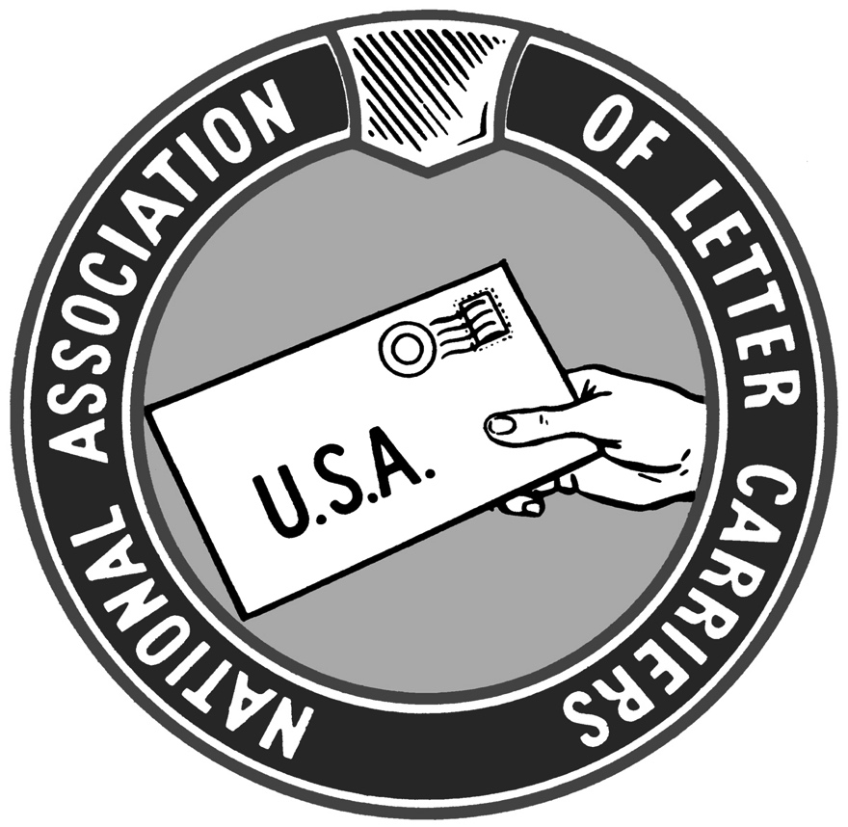

WINTER 2019

Return on Investment

On November 6, 2019 4th District LCCL Bob Davidson, Branch 201 President Pat Hill, and myself met with Debbie Luper, the District Director for Rep. Ron Estes. We discussed with her the importance of the NALC legislative agenda to the 4th District. Among the topics we discussed at length were the importance of door delivery and ending the devastating PAEA pre-funding requirement. Later that day, I drove to Salina to meet with Katie Sawyer, District Director for Rep. Roger Marshall along with KSALC Director of Retirees Mike Wamsley and Salina Branch 486 President Brad Johnson. The following week, Congressman Marshall signed on as co-sponsor to HR 2382, the USPS Fairness Act, which is the NALC’s main legislative priority.

I also recently had the privilege to attend two days of meetings at NALC Headquarters in Washington, DC along with 21 other State Chairs. NALC President Fred Rolando and EVP Brian Renfroe spoke to us about the NALC’s legislative agenda and prospects as well as other pressing issues.

At that time our number one priority was to get 290 co-sponsors for HR 2382. The bill relieves the USPS of the crippling burden imposed on it by the PAEA pre-funding requirement. Today, we achieved that super-majority with 300 co-sponsors. That means that the Bill will now be scheduled for a floor vote in the US House of Representatives, where it will pass. The Bill’s future gets murkier in the US Senate even though a bi-partisan companion bill (S. 2965) was just introduced there as well.

The reasons the NALC has achieved widespread bi-partisan support in Congress are first, the Letter Carrier Political Fund has allowed us access to educate elected officials on the essential work the USPS preforms for our economy and our Nation. The necessity of our work as letter carriers is not always obvious, even to those who set policy--hence our need to educated them. Secondly, it is the time and effort put forth by NALC activists.

Legislative tides turn rapidly and sometimes unpredictably. Our legislative priorities must also turn rapidly, where needed, to avoid being swamped by those tides. Thankfully, in Kansas, we have experienced wide support from our Representatives and Senators in both parties.

President Rolando briefed us on other matters including interest arbitration: we are actively in the process of selecting an acceptable neutral arbitrator as the mandatory 60-day mediation period has passed. While we continue to bargain in good faith, we will not delay presenting our case in arbitration. The first day of the national level grievance on consolidated casing was heard on November 22. The next date is scheduled for December 18 with future dates scheduled if needed. Hopefully, a favorable arbitration decision will put an end to that bit of postal madness. He also told us that PMG Megan Brennan didn’t jump into retirement—she was pushed.

2020 will bring a lot of excitement and drama. The NALC is staring at arbitration in the face of continued financial losses at the USPS. For most of those years the losses were exclusively or almost exclusively a product of the PAEA. In 2019 the business of the post office managed to lose money by any standard. As my friend Rod Holub has mentioned many times, collective bargaining negotiations tend to go better when the company in question is making money.

Despite those headwinds, I have ultimate confidence in the NALC bargaining team and lawyers to expertly present our case in arbitration. We usually seem to come out slightly better than our sister postal Unions do in arbitration. That’s not an accident.

My bigger fear is that our collective bargaining rights are meddled with legislatively or by executive authority. Again, this reinforces why we need to keep our legislative allies informed and educated. Any loss of rights, even if they are incrementally chipped away, is still a loss of a right.

As an example of the power of legislation and politics, FedEx paid a tax bill to the IRS of $1.5 Billion in 2017. FedEx has a lobbying budget of around $10 million a year. FedEx lobbied hard for corporate tax cuts and their efforts were rewarded by the 2017 tax cut law. In 2019 FedEx paid no federal taxes to the IRS. The FedEx lobbying budget paid huge dividends. It was worth every penny and then some to FedEx shareholders.

For perspective, the LCPF lobbying budget is approximately one-fourth the size of FedEx lobbying budget. With those limited resources we have staved off five-day delivery, postal privatization, service reductions in the form of mandatory centralized delivery, contract delivery, and attacks on our collective bargaining rights. Now, mostly through NALC/LCPF efforts, we have actually put forth a bill to achieve super-majority status in the House. We have contributed financially to Representatives and Senators of both parties as well as from across the widest possible range of political ideologies.

LCPF provides return on investment as well. Most of those returns have been in the form of protecting the NALC and its members from harm. We have been under attack since PAEA became law in 2006. That represents over half of my 22-year plus career, for context. We now have the opportunity to go on the offensive legislatively as evidenced by the Super-Majority support behind HR 2382. In order to do that we need to close the gap between our PAC and the PAC’s of our competitors. To those who grumble about the dirty game and decry the role of politics and legislation, just remember that we have well-funded competitors who welcomes your apathy.

I am also happy to welcome Miranda “Randie” Illoldi aboard as the new Editor of the Kansas Mail Carrier and Assistant LCCL for CD-1. Randie is a CCA and member of Branch 1412. She will be a tireless advocate on behalf of Kansas Letter Carriers.

Andy Tuttle,
President KSALC
232 Dakota
Lawrence, KS 66046
785-979-9974
astuttle4611@gmail.com

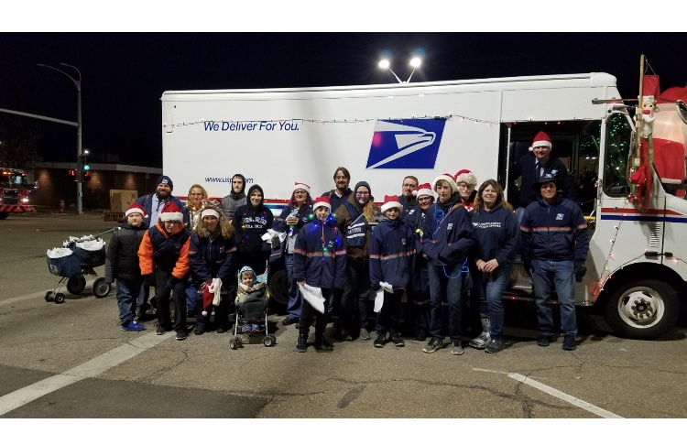
Branch 10 Topeka at the Miracle on Kansas Avenue Parade

My name is Miranda Illoldi. I started my postal career at the beginning of 2016, after an arduous application process, which began in November 2015. My first office was Oakley, Kansas, at the intersection of I-70 and US 83, in the middle of NW Kansas. I was the second CCA in an office with one full-time regular route and an auxiliary route. This meant I was lucky to get 20 hours a week. I quickly learned that hustling to get loaned out to other offices helped me get hours. However survival required that I work a second job.

In December of 2016 on the 20th day, a nasty slushy roads type day, I set out to deliver the mail. As I was passing a mailbox, on the way to my park point, the slush pulled me sideways. I turned my wheel and removed my foot from the brake and the gas. Nothing worked, and the slush pulled me into a curbside box. The box connected with the bottom side mirror and slammed it back into the truck, breaking the mirror. No damage was done to the box. I called my postmaster immediately and she told me she had no clue what to do and just keep delivering and she would call me back. To make a long story short, after another hour they called me back to the office and I was placed on emergency leave. My boss said that termination was a possibility. I immediately found and contacted my NBA office and with them and a steward from a couple hours away I was able to save my job and get paid for the two days I was out on emergency leave. Thus began my involvement with the NALC.

I have transferred twice and thus knocked myself out of the two mass conversions to PTF, so I am still a CCA, going on my fifth year in another month. I am a shop steward in Ulysses, KS, and our branch Trustee. I attended the 2019 National Rap Session in Denver in August as a delegate from branch 1412. I look forward to working on this publication and in Congressional District 1 to further the cause of the NALC and protect the USPS as a federal institution and work toward causes that are mutually beneficial to the USPS and the letter carrier craft.

One of the things that Andy has asked me to do is to set up an email list of KSALC members who wish to receive the Kansas Mail Carrier. Obviously, we would prefer to mail a printed newsletter to the membership but that is no longer economically viable.

Personally, I am a wife and a mother of 4 natural children and 4 step-children and bonus mom to 3 foreign exchange students now. In my spare time I like to read, have a beer or two, and go camping and fishing with my family.

Miranda Illoldi,

Editor, Kansas Mail Carrier~mirandailloldi@gmail.com

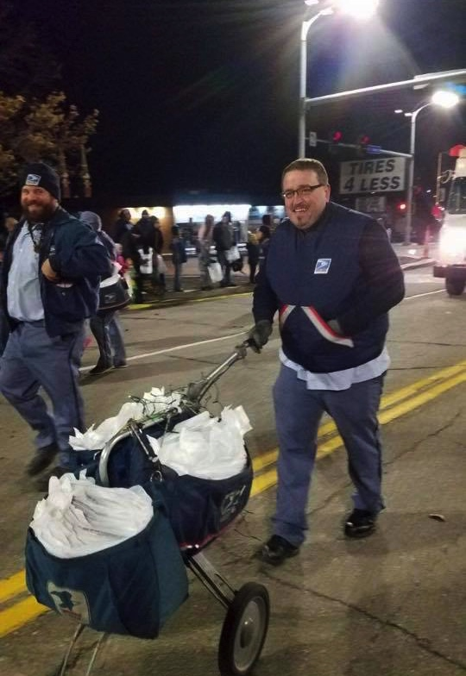

Notes From the 2019 Kansas AFL-CIO Convention

Happy New Year! 2020 will be an important election year. In November, I attended the Kansas AFL-CIO Biennial Convention as a delegate. Many interesting people spoke at the convention.

Mike Louis is the Missouri AFL-CIO president. He spoke to us about labor’s path to power and the need to elect those who are labor friendly, especially those of us that we know who run for office. His emphasis was on electing union strength, and that it had to start at the lowest levels – at the municipalities.

Usha Reddi is a Democratic candidate for the U.S. Senate. She lives in Manhattan and is a former teacher and a former union president of NEA Manhattan-Ogden USD 383. Usha’s experience as a union leader helped her make the decision to jump into politics. Education is an important topic to her, as is healthcare, including mental health, substance abuse and prescription drugs. Usha supports Medicare For All. She believes that right-to-work works against the economy and that the workers become the losers. Usha has served as a Manhattan City Commissioner since 2013 and was mayor in 2016-2017. More information about Usha can be found at ushareddi.com.

Barbara Bollier is also a Democratic candidate for U.S. Senate. From Johnson County, she is currently a member of the Kansas State Senate, having been elected in 2016. She changed from Republican to Democrat in 2018. Barbara is a retired doctor, saying she went into medicine to help people and she is still helping people through her political work. Healthcare is an important issue to her, and while she supports Medicaid expansion, she does not support Medicare For All. She believes that union health insurance is one of the most important benefits that we bargain for and that we must keep. Barbara is also concerned about pensions, believing that all pensions are at risk and need shored up. She is a union supporter and is against right-to-work.

Both of these women have a long hard road ahead of them. Some of the other guests at the convention were Governor Laura Kelly, KS-3 Rep. Sharice Davids, Kansas Department of Labor Secretary Delia Garcia and Senator Anthony Hensley. It will be an interesting political year. I urge you to stay informed of all races in your area, even those at the lowest levels. Like Mike Louis said, labor’s path to power starts with electing union strength at the lowest levels.

Michelle Jellison,
Vice-President/Director of Education
KSALC
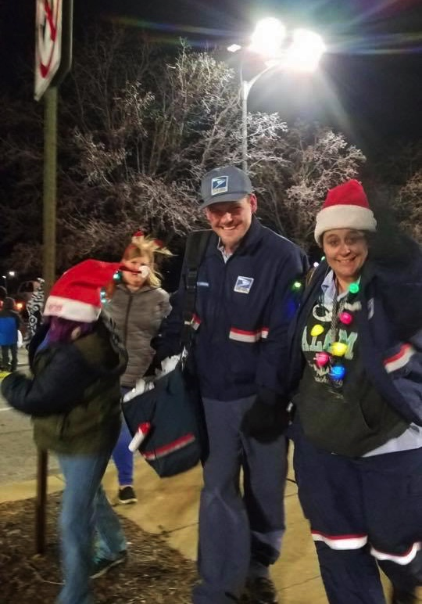

Branch 10 Miracle on Kansas Avenue, November 30, 2019

Upside down and backwards

By Rod Holub

March 17, 2020 will mark the 50th anniversary of the Great Postal Strike. Most of us have viewed the NALC documentary that tells the story of the courageous union letter carriers that risked their jobs to stand up to a federal government that took their public postal service for granted. While the video tells the personal stories of rank and file letter carriers risking everything to change the way American viewed their Postal Service, it barely mentions the reason why March 17th, 1970 was the best time in history for the strike to be successful.

President Tuttle has graciously allowed me to conduct a session at the 2020 State Training in Wichita. In that session, we will be exploring some of the ideas that drove iconic leaders to accomplish historic changes. In many cases, the reasons why history-changing events like The Great Postal Strike were ultimately successful was the timing. In 1970, America was in the early stages of a technological revolution. As a result of this revolution, the way America conducted business would be undergoing irreversible change. If the Postal Service would continue to be a major player in this new business world letter carriers would have to change the way that Americans viewed their Postal Service.

Vincent R. Sombrotto, who was not an NALC officer at the time, believed that the only way Americans would ever truly appreciate their public postal service was to give them a taste of what it would be like to not have one, so he launched a wildcat strike in an effort to shut the postal service down. Through a huge leap of faith, union letter carriers in the major eastern cities followed Sombrotto’s lead and went out on strike. It only took 8 days for the country to realize that its new business model could not succeed without a communications and delivery network that spanned the entire country and force Congress to completely overhaul our public Postal Service. That reorganization included giving the National Association of Letter Carriers a voice in how the new Postal Service’s employees were treated by legally recognize the union’s collective bargaining rights.

Why was the timing of the strike so important? Before the 1970s, most business was conducted locally. Most employers still handed out paper checks to employees at their workplaces. Employees then drove their endorsed checks to their banks to deposit them. When shopping, consumers handed either cash or a check to the cashier at a local store to purchase their goods and then transported those goods home in the family truckster. At the end of the day, businesses would take a zippered bag full of cash and checks to the local bank for deposit. At that point in time, the predominant role of the postal service in business wasn’t financial transactions, but simply to deliver advertising to the consumer through ads in the local paper, or direct-to-mailbox marketing.

In the 1970s however, business finances were rapidly extending far beyond the local bank and trust. National credit cards were now being used instead of cash and checks to purchase goods and services. Instead of taking a zippered bag full of checks to the local bank for deposit, a national credit card economy required somebody to transport business documents to entities somewhere across the country. Sears and Roebuck was no longer the only major catalog retailer that required someone to deliver goods purchased from their catalogs and those businesses needed a cost-effective way to get their products from warehouses to customer’s houses.

If the postal service didn’t provide the services needed by a rapidly changing business environment somebody else would, but in 1970 the business world didn’t have many other options. The best opportunity for a strike to be successful was the time between business realizing it needed a truly national delivery network and the time when some other entity could be developed to provide that service. The actions of the strike showed America that it already had the perfect delivery network. The timing of the strike temporarily reduced the incentive for private delivery companies to try establishing a nation-wide door-to-door delivery network when one already existed. However, once the country learned that its business could be shut down by a few disgruntled postal workers, it started working overtime to ensure that the strike scenario could never be repeated and private delivery companies and their allies in Congress have been working tirelessly to develop alternatives to the Postal Service ever since.

Today’s electronic hi-speed world of business still needs a reliable and secure national delivery network. Unlike 1970, it has many other options besides the Postal Service. If a public Postal Service is to survive long enough for today’s new hires to reach retirement age as letter carriers, NALC leaders and activists must understand that how consumers use delivery networks is now upside down and backwards from the reality in 1970. If we are no longer the ONLY option for e-commerce business, we must become the BEST option. We must stop fighting against the technological changes that consumers will require and increase our efforts to help guide the new technologies in the direction of improved service. Just as importantly, we must continue to fight against a postal management structure that truly believes the only way for our company to survive is to decimate the actual service we provide. Lastly, we must aggressively engage and elect members of Congress who believe in our public postal service because those same members of Congress are being offered tens of millions of campaign dollars to dismantle our public postal service and open the door to privately-owned competitors. Success on those fronts depends on not only changing how we operate, but also how we think. Embrace the need for change and turn what seems upside down to a new right side up!

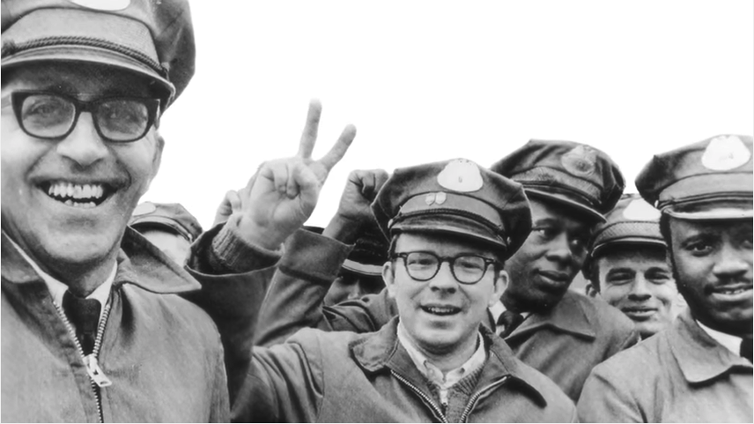

NALC on Strike in 1970

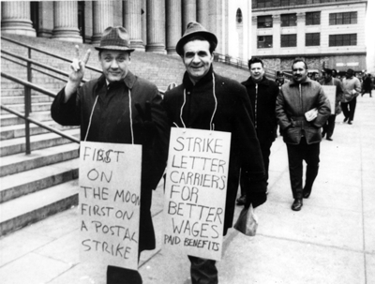
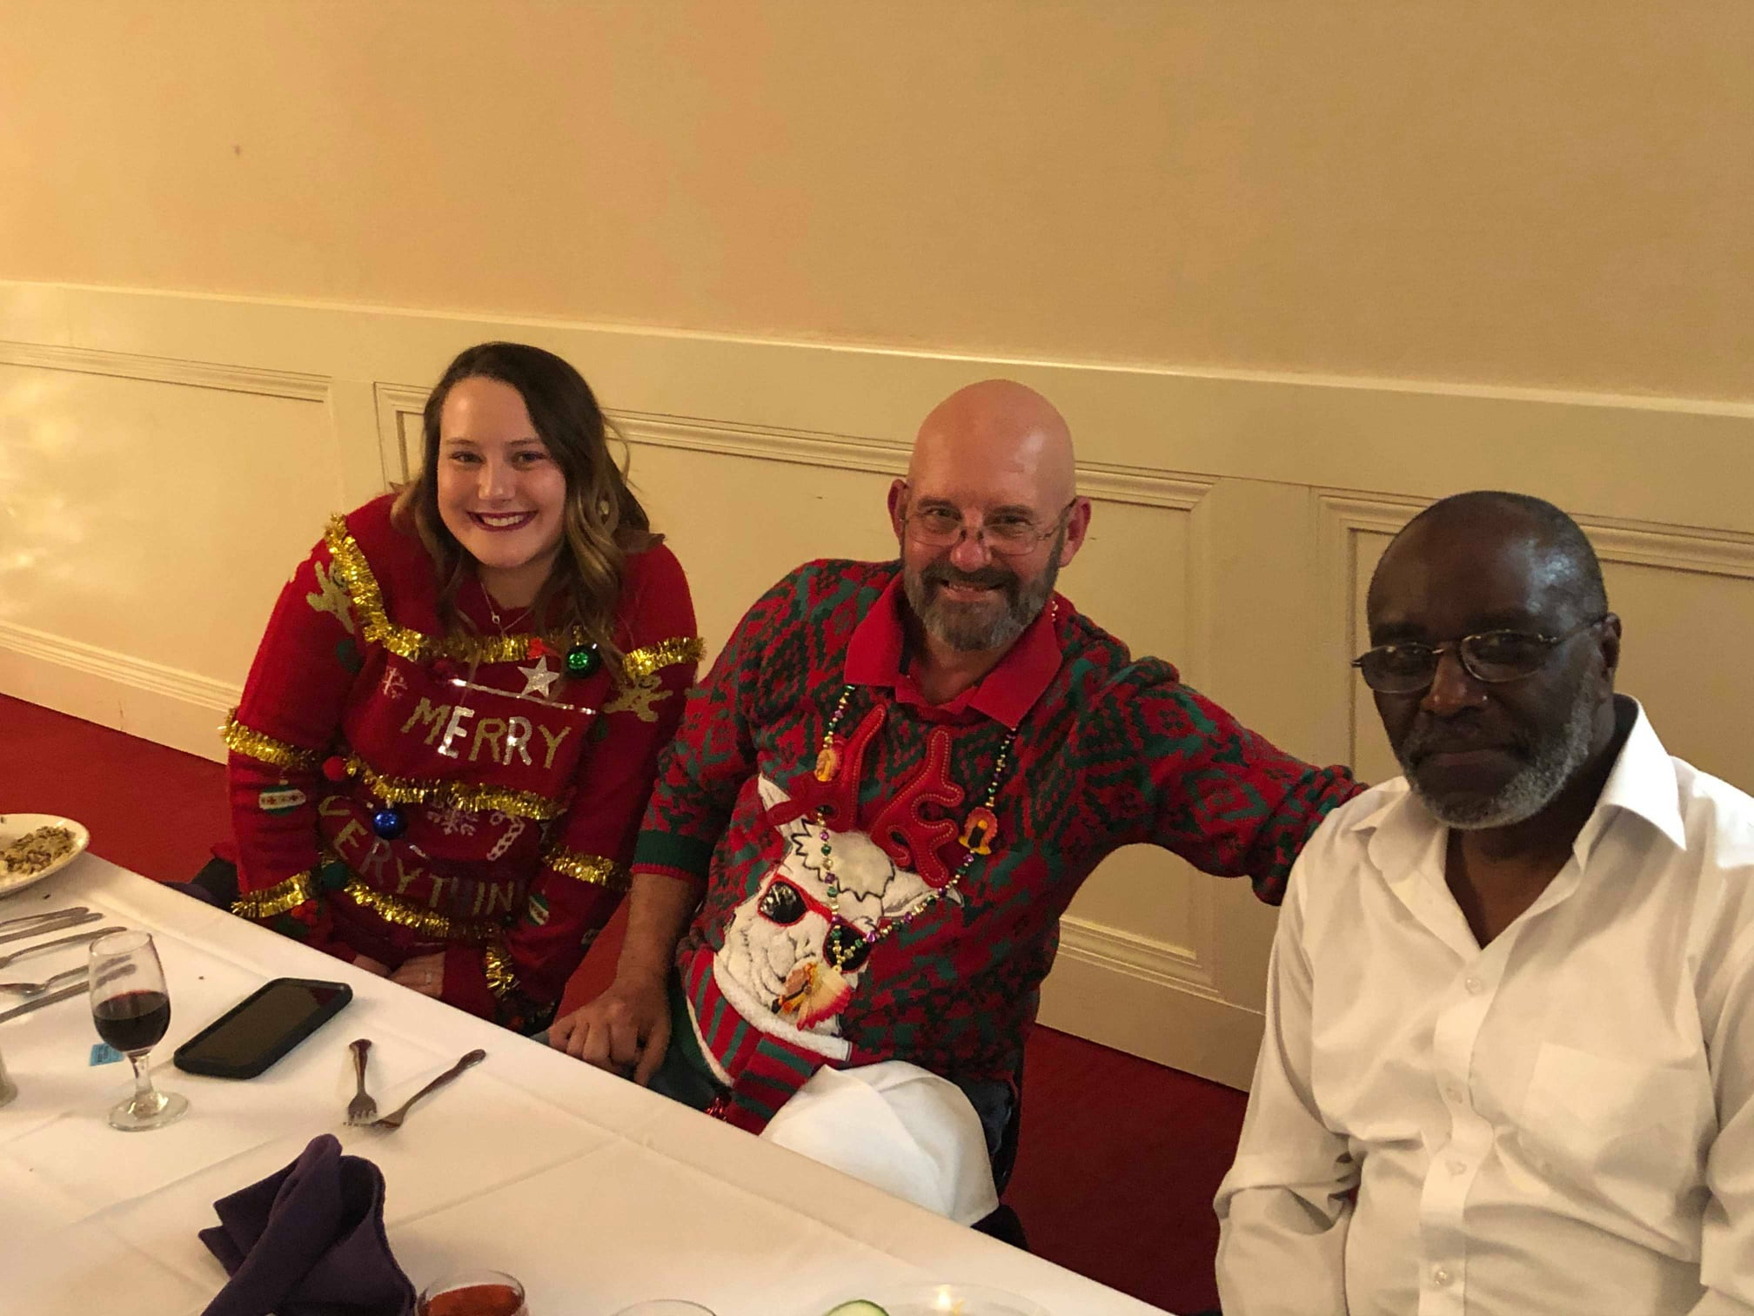

Randy Dunlap and daughter Haley along with Larry “Mister” Williams at Branch 1018 Installation Dinner in Manhattan

RETIREMENT AND THE HOLIDAYS

Happy Holidays to all my Brothers and Sisters out there, especially the active carriers struggling through this crazy season. We know that this will be a financially rewarding time of the year due to the hours that the Post Office works its Carriers but that doesn’t help the feeling of exhaustion many Carriers get from struggling through this time of year. Be sure to do you jobs in a safe and professional manner that you do all year round. May you and your families have a great Holiday Season!!
You can be sure that our retired Carriers all remember the rush at this time of year and are glad that they aren’t in the middle of it now!!! Some of you are probably thinking of joining the retired ranks in the near future and I would like to give you a few tips on how to look at this event. First, you need to find out when you will be eligible to retire. We have 2 retirement systems presently in our craft.

1.Civil Service Retirement System (CSRS) and 2. Federal Employees Retirement System (FERS). CSRS is a single pension that is based on your years of service and your high 3 years of salary. FERS is based on a single pension, investments in the Thrift Savings Plan and Social Security. I am not going into the specifics of each plan today, but if you have questions, you can contact your Branch retirement representative or call or email me. I am Mike Wamsley and my phone # is 785-587-7085 and my email is pmwwldkat@cox.net

First: AM I ELEGIBLE TO RETIRE? In Civil Service cases, the minimum for a regular retirement is at age 55 with 30 years of creditable service. In FERS, each Carrier has a Minimum Retirement Date (MRD) based upon your date of birth. This date as well as your number of service years will let you know if you are eligible to retire. Again, as with the CSRS, I am speaking of a regular retirement, not medical or other types of retirements. The big thing here is to determine your number of creditable years of service. Some of our carriers have PTF time in which they didn’t work a full year of work hours. This time is prorated but doesn’t count as a full year. Another item to look at is military time. You can count military time if you have made a deposit (money for the military time that you didn’t pay Social Security or Medicare taxes—CSRS-7%/FERS-3% of your base military pay for when you served. Also, if you don’t pay it off within the first 3 years after being discharged, you will have to pay interest for the time gap between discharge and when you started paying the deposit) for the ability to count it as being eligible to retire or for getting paid in your annuity. Make sure that you get a complete readout from HR as to your number of years of service. If you disagree, you can go to LiteBlue and check your work history to see if you can find the point of disagreement. If you do, contact them and discuss the matter. You should do this sooner than later as it could take some time to correct if you are right. You don’t want this slowing you down if you are ready to retire.
I will go into the other areas of deciding if you want or can retire in my next articles. In the meantime, HAPPY HOLIDAYS to you and all your families!!!

Mike Wamsley,

Director of Retirees
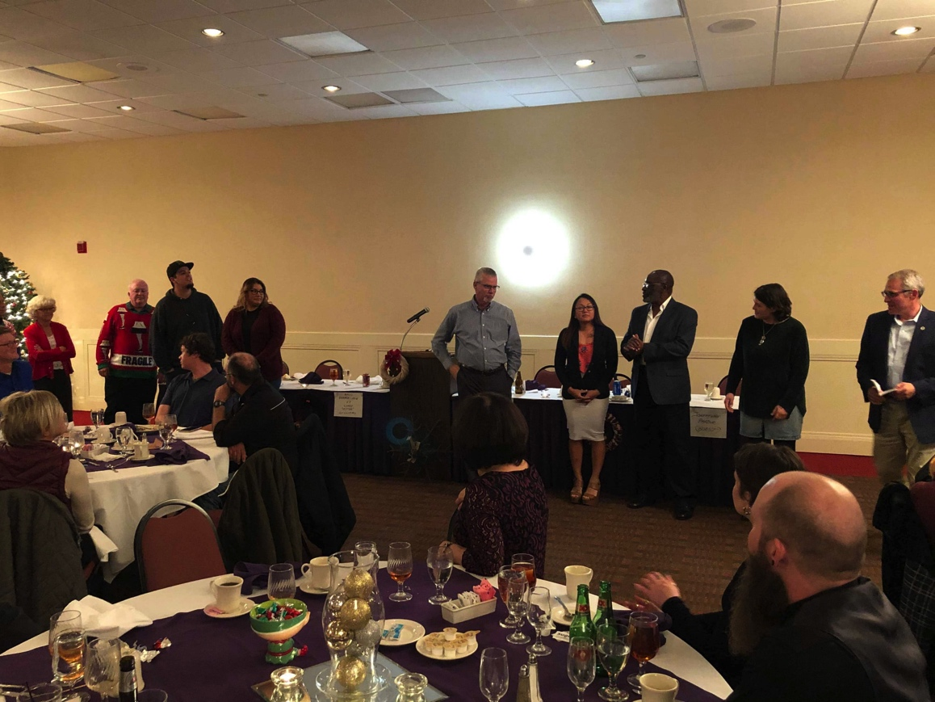

Branch 1018 Officers Installation Dinner

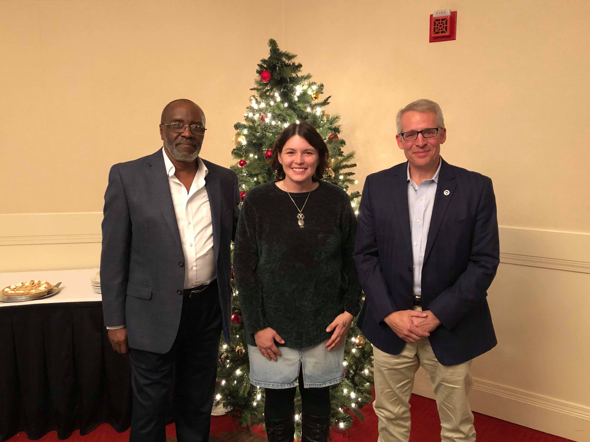
Branch 1018 President Jennifer Ryland and VP Larry “Mister” Williams

House Resolution 2382 USPS Fairness Act

HR 2382, the USPS Fairness Act was introduced by Representative Peter DeFazio, a Democratic representative from the 4th district in Oregon. It was introduced on April 29, 2019. This act would repeal the USPS mandate to prefund the retiree health benefits for 75 years worth of benefits, effectively moving the USPS from a negative financial growth and back into a positive financial standing.

In the months since the resolution was introduced by Representative DeFazio, it has gained steam and garnered support from many representatives across the country. As of December 23, 2019 the resolution has signed 301 cosponsors, including 3 representatives from Kansas. Steve Watkins, a Republican Representative from the 2nd congressional district of Kansas signed on as a cosponsor on 30, 2019. Sharice Davids, Democrat 3rd district signed as a cosponsor on September 21, 2019 and Roger Marshall, Republican 1st district was the latest Kansas cosponsor, signing on November 20, 2019. Republican Representative, Ron Estes, of the 4th congressional district has yet to HR 2382 in support of fair funding requirements for the USPS.

The latest action on the bill, as of December 4, 2019, Representative DeFazio made a motion to place the bill on the consensus calendar to schedule it for a vote in the House of Representatives and then send it on to the Senate.

This bill is simple and straight forward with no additional riders on the bill. The only purpose is to the amend title 5 and repeal the USPS requirement to prepay retiree health benefits.

Currently it is being asked that you contact your representatives and inform them of the bill and ask them to vote in favor and protect the postal service as it is, a free service and guaranteed right of the American people.

Miranda Illoldi,

Editor, Kansas Mail Carrier,
Assistant LCCL-1

mirandailloldi@gmail.com

Just Say No to a Pro-Privatiztion PMG

Greetings from the Big 1st District. This time of year, carriers are extremely busy at work and at home. It is easy to want to forget about what is going on outside of their immediate world. Many things are going on that effect city carriers as well as other postal employees. Our current Postmaster General is retiring. Any carriers that were working before PMG Brennan, will remember that the Postmaster General before her was in the pocket of a couple of Congressmen that wanted the postal service out of business, and he was trying to do just that. We need a Postmaster General that believes in the Postal Service, and making it better, not tearing it apart. I hope everyone signed the petition that the NALC is sharing. We also have a contract that is going to arbitration, and many think there’s little we as carriers can do in this process. The one thing we can do is continue to educate Congress to keep them on our side, so they don’t get involved in our contract process. We also have a companion bill introduced in the Senate that the House has over whelming support for to repeal the pre-funding that is crippling the Postal Service. We now need to get our Senators to support this bill. We as carriers have more power together than many people seem to understand. I hope everyone has a very Merry Christmas and a Happy New Year.

Kent Chestnut,

LCCL-1
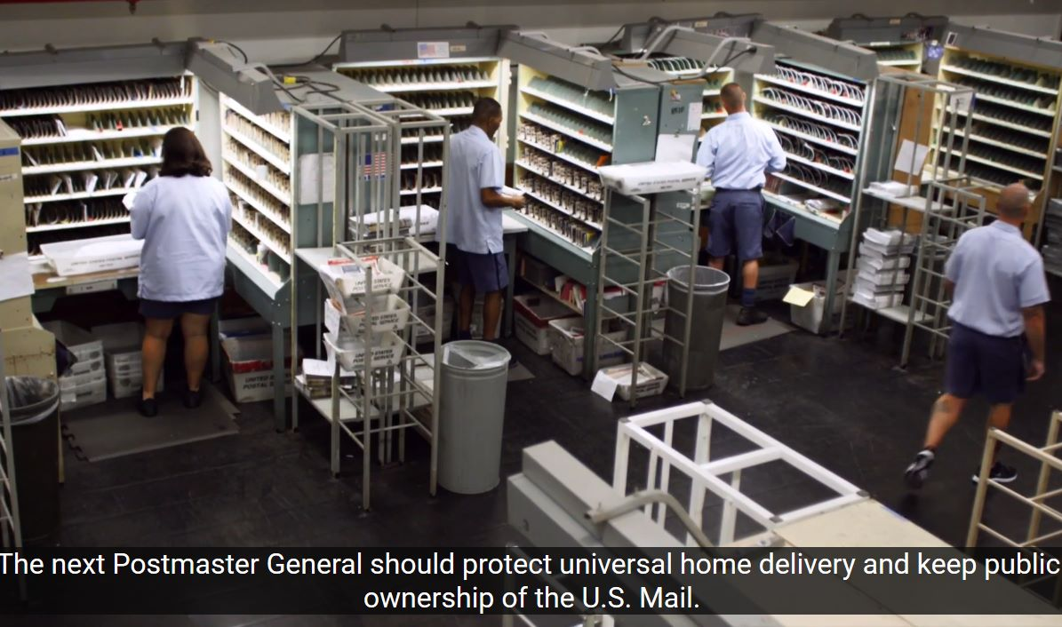
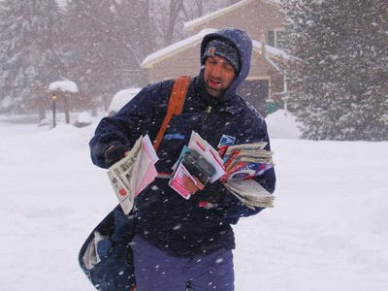

Terry P. Gets Sentimental for Christmas

T’was the day after Christmas and all through my pad, most the relatives were gone and the trash throughout was bad. Actually I am late with my state article this month, and I ask our good president, Andy Tuttle, for forgiveness. I don't want to talk about the Postal Service this month. Actually it was a great Christmas day. As we all formed a circle, holding hands to say grace, siblings, nephews, cousins, nieces, grandkids, great grand kids, to the yet unborn, it hit me. I was the oldest of the Millers left. All these people were decedents of me. The meaning and importance of family is something many of us take for granted. If I was stranded or in trouble in any part of the country, it is family, people in this room, who I could depend on, as I have them, and that is a blessing. It was a humble moment for me, as I thought of parents, grandparents, and other uncles, aunts, and cousins, who have passed before me, but forever engrained in this family tree. They always said thank you Jesus for the reason for the Season, and thank you God, for family.

Terry P. Miller,
LCCL-2

‘Tis the Season

Like you, I am a Full Time City Letter Carrier. It’s December 1 and the season is here, according to the upper levels of management at USPS. I know that because like you, I got a message on my scanner last week telling me. My response to that message is not printable.

From where I stand, the “season” started to ramp up the day after Veterans Day, almost 4 weeks ago. I saw a noticeable increase in mail, parcel and spur count. And that was in early November. Where were these “rocket scientists” from USPS back then? Most likely on a conference call with some want to be District Manager trying to earn his black belt in ineptitude.

I just got off the phone with my brother, Charles Jonscher, the new President of Branch 499 up in KCK. He just pulled over a 12-hour shift yesterday. There will be more of the same today. I am on AL this week. Why did I take this week? Read the second sentence in this paragraph.

Between Thanksgiving and Christmas is considered by most people to be a wonderful time of year. Reflections of the past year and why you should be Thankful and the grandiose ideal od Peace on Earth and Good Will towards Men.
Bah Humbug!!!!!

We can’t blame our customers. The reality of today is on-line buying. Which is great. I buy on-line too. Ask the City Carrier, Jennifer, who delivers to my home. Why do I add to the load? Because I’m too freaking worn out to go shopping after humping mail all day long. Ask me what the reality of those 4-5 weeks is like. You don’t need to ask. You live the life every day. You’re a City Carrier. Leave home in the dark and get home when it’s darker.

Time with your family? Sure, on Christmas Eve, if you’re lucky to get home before 7:00PM. Otherwise for the first 23 days in December, it’s early to bed and early to rise to make a “parcel run” and then return to deliver your route.
There is a point to this rant and I’m getting to it. I wanted to express the frustration every City Carrier feels right now.

Our jobs as City Carriers are under attack! From the current president, to the Senate, and the private sector.

UPS has hired seasonal delivery workers here in the Olathe area and I’m sure in other cities throughout Kansas to deliver their parcels. No benefits, no future, nothing. Delivering out of personal vehicles. Same thing with Amazon drivers, there are plenty of blue vans thru my route and my own neighborhood in Olathe. And in the last 2 weeks, Amazon has been sending out drivers in their own vehicles, again.

Give one present to yourself this year. Donate to the Letter Carrier Political Fund. Your donation will allow the NALC to continue to present our views and positions to the right people in Washington.

It’s a bi-weekly present to you all year long.

Greg Wilson,

LCCL-3

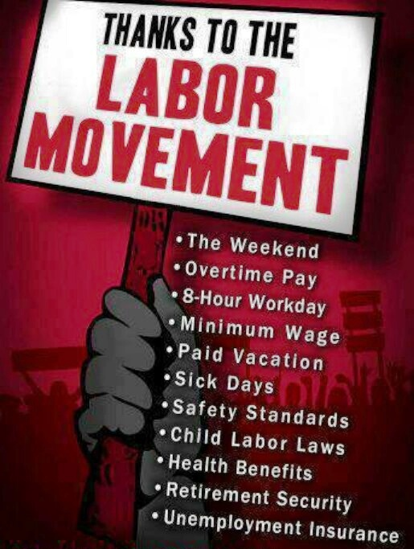

Greetings and Happy Holidays to all!

I want to first thank everyone for their hard work in getting everything delivered this holiday season.

On November 6th, President Tuttle, Branch 201 President Pat Hill and myself went to Congressman Estes' office. We visited with Debbie Luper and talked about HR33 (Privatization), HR54 (6 day delivery), HR23 (maintaining door delivery) and HR2382 (pre-funding. She was very knowledgeable and had sat in on some meetings about door delivery versus NDCBU delivery. I feel like it was a very productive meeting. The Congressman has now co-sponsored 6 day delivery and hopefully will co-sponsor the remaining ones.

Thank you to both President Tuttle and President Hill for taking time out of their schedules to visit his office.

Again, Happy Holidays to all!!

Bob Davidson,

LCCL-4

~The labor movement did not diminish the strength of the nation but enlarged it. By raising the living standards of millions, labor miraculously created a market for industry and lifted the whole nation to undreamed of levels of production. Those who attack labor forget these simple truths but history remembers them~

~Dr. Martin Luther King Jr.

Article 14, Safety and Health, begins as follows:

It is the responsibility of management to provide safe working conditions in all present and future installations and to develop a safe working force. The Union will cooperate with and assist management to live up to this responsibility.

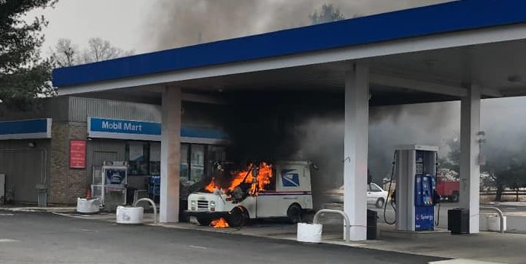

I have co-chaired the Mid-America District Joint Safety Task Force for the last couple years. One thing that has become obvious to me is that the NALC and postal management come at safety from very different perspectives. Management views safety almost exclusively through a lens of what safety rules employees follow or don’t follow. They are very concerned with whether we wear our seatbelts, set our brakes, curb our wheels, secure our vehicle, have green-tagged shoes, and don’t put rubber bands on our steering columns—and rightly so.

However, their actions indicate they are less concerned with institutional safety. We were supposed to have new vehicles by 2019 but 2019 has come and gone and the winning bidder for the new vehicle contract has not even been chosen yet. I will give credit where credit is due, however. The post office did begin to take heat safety seriously but only when they were forced to by multiple heat-related carrier deaths and OSHA fines.

To be absolutely clear, these rules are very explicit and valid and all of us have an obligation to follow safety rules at all times. Any of us who have worked at the post office for more than a couple of minutes are aware of these rules and our decisions to follow or not follow these rules is entirely in our power. Should we choose to break them then we will be forced to deal with the consequences. And as long as the management’s actions are corrective and not punitive we deserve it. These rules are well established, they exist for a reason, and following them may well save your life and limb as well as a good work record.

In my opinion however, management wears blinders regarding the hazards we face every day in our jobs. Flaming LLV’s, FFV’s and Promasters. Working excessive hours. Carrying after dark for extended periods of time. Extreme weather. Being struck from behind while working out of the back of our vehicles because management has determined that park point to be the most efficient park point. Being assaulted by dogs. Being assaulted by humans. Blighted and substandard buildings—both postal and private. Our facilities, vehicles, equipment, and working conditions subject us to danger every day. Management is loath to address the very real hazards we face every day. Instead they choose to focus employee compliance to safety rules.

To be clear, there isn’t an answer to many of the hazards we face. Ours is a hazardous occupation. Still, it would help if management made an open acknowledgement of the hazards we face every day. But they don’t. So the emphasis remains on our behavior and adherence to safety rules rather than anything that would require the institution to address itself and it shortcomings. Act accordingly.

Andy Tuttle

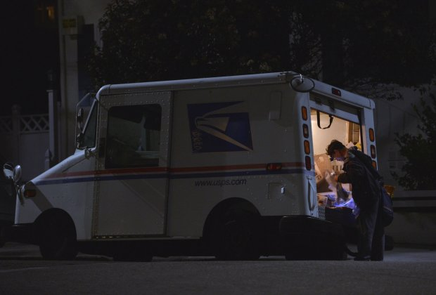

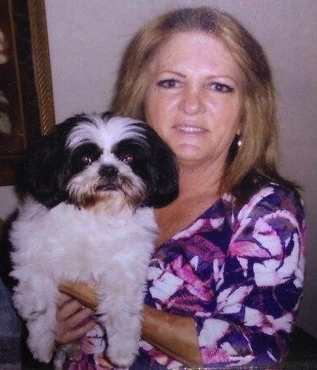
Peggy Frank of Woodland Hills, CA died of heat exposure in July 2018

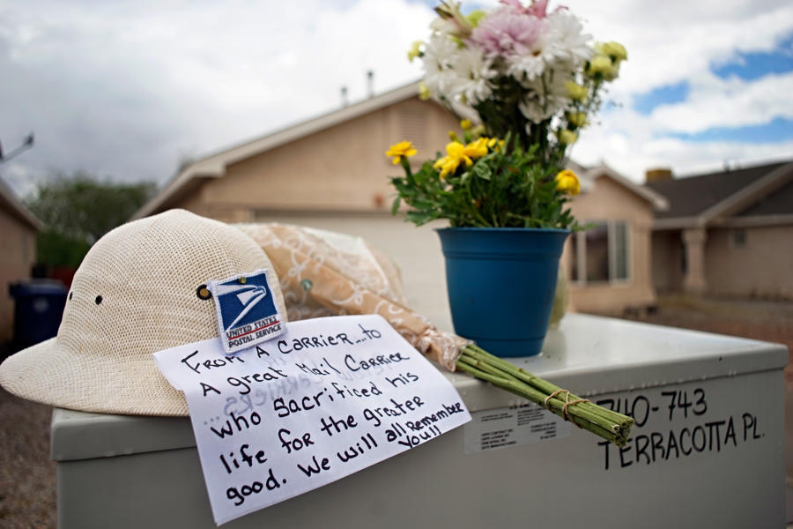

Jose Hernandez of Albuquerque, NM was gunned down on the job in April 2019

Mary Granados was murdered by a mass shooter in Odessa, Texas, in August 2019

Antonio Williams of Shreveport, LA was murdered on the job in June 2019
