**KANSAS MAIL CARRIER**

**Fall 2019**

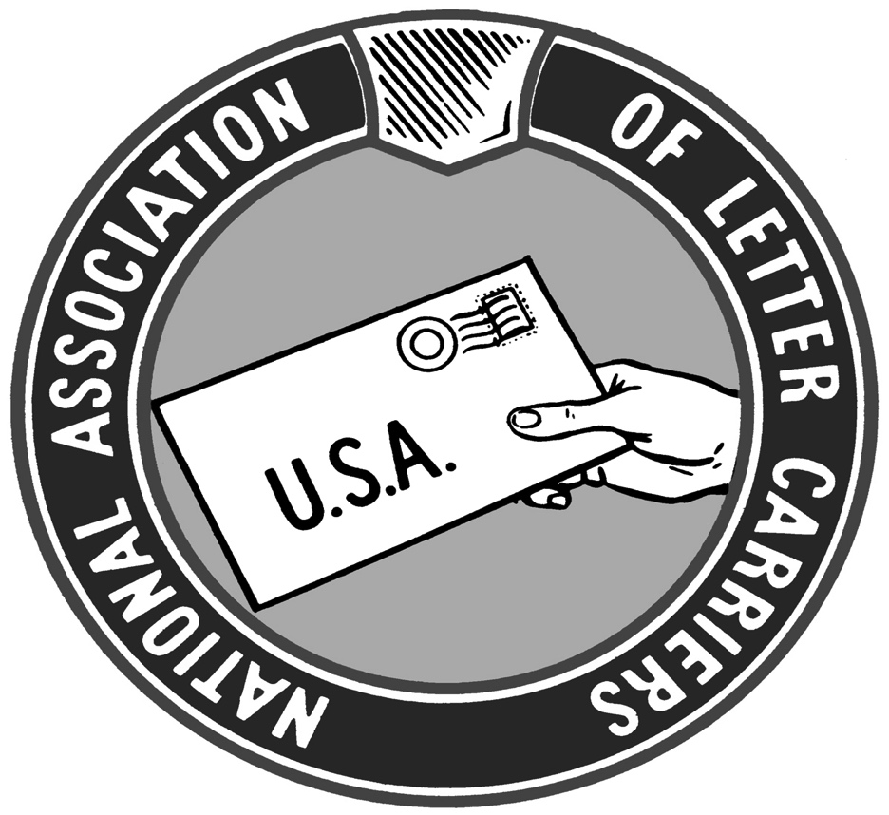

Recently Bob Rivera and I had the honor to walk the picket line with UAW members at the GM Fairfax Assembly plant. The workers are striking GM, which made over $8 billion in profit last year while paying their CEO $22 million. GM now wants the employees to accept more temporary workers, higher employee share of health benefits plan, and more plant closures. The UAW made givebacks between 2007-2009 when GM received a taxpayer-funded bailout. Now that the company has returned to financial health with record sales and profits, the workers want the company to recognize their essential sacrifices and they want their reward. GM just wanted more

In the end the UAW won significant gains as a result of the month long strike, the longest against the auto industry in 50 years. There have been several other important victories for organized labor in recent years as well.

There are similarities and differences between the respective situations of the NALC/USPS and UAW/GM. Both industries took a beating during the great recession. Both times employees were forced to make concessions. The NALC got the CCA classification and a two-tiered wage system. The UAW got largely the same thing: a “temporary” workforce being paid a lower wage for the same work. The difference is where the companies themselves are situated. GM is making record profits. The USPS is laboring under the same pre-funding yoke that has been killing us since the law was passed in 2006. The UAW workers bargained from a position of industry strength while we bargain under a dark cloud of regulatory uncertainty.

The success of the UAW against GM mirrors the uptick in public support for Unions. Support for Unions is at a 20 year high. Working Americans are seeing record corporate profits while worker wages and benefits remain flat. The job market is basically at full employment. This should be time when workers leverage the demand for our labor by demanding decent wages from our employers.

Our own contract negotiations at hand and our prospects are murkier. We are currently at impasse and in a federally mandated 60-day period of mediation. It’s not likely that anything will come from the mediation process. We are likely to go to arbitration when the mediation process runs its course on November 20.

Of our sisters Unions at the USPS, the Rural Carriers are the only Union with a contract. They agreed to very modest raises and seem to have endorsed the USPS’ desire for more use of non-career employees (currently, over half of rural carriers are RCA’s, not career employees). This sets a bad precedent of the other Unions.

The APWU is in arbitration as we speak. The USPS is portraying the clerks and maintenance employees as over-compensated. The USPS will no doubt compare letter carrier work to that of pizza delivery or a newspaper route or other occupations that pay less than what our Collective Bargaining Agreement pays us---as they always do.

The Mail Handlers have extended negotiations with the USPS. Their contract expired the same day ours did.

We have a situation where most of the bargaining unit employees at the USPS are working under the conditions of expired contracts (NALC, APWU, Mailhandlers). PMG Megan Brennan has announced her retirement effective January 31, 2020. The pre-funding requirement that set the USPS back $5 billion plus every year remains in place for now.

Perhaps an even greater threat exists in the form of an Administration that has shown unprecedented hostility towards the federal workforce and in particular towards federal union. Executive Orders are now in place severely restricting Union representation and due process for employees represented by most non-postal federal Unions.

The Trump Administration has appointed anti-labor nominees to important positions such as Secretary of Labor Eugene Scalia and William Emanuel, John Ring, and Marvin Kaplan to the National Labor Relations Board. All these men previously made their careers as employer-side attorneys for prestigious Union-busting law firms.

In America we see greatly increased support for Unions among people who actually do the work of the Nation and who have to live within a budget. We are also seeing greater and more forceful opposition to Unions from the self-styled Masters of the Universe, be they titans of industry and finance, or those who run the government. They are intent upon destroying Unions, be they public or private. There’s a lot of money to be plundered after all.

Thankfully, Congress is mostly in the NALC’s corner—at the moment. We have a majority of co-sponsors for the most important NALC-backed legislation and Resolutions. We have had generally strong support from the members of our Kansas delegation. Rep. Sharice Davids has co-sponsored everything, Rep. Roger Marshall everything except HR 2382 (pre-funding), Rep Steve Watkins, everything except H Res 23 (door delivery). Rep. Ron Estes has yet to co-sponsor anything.

On the Senate Side, both Senators Jerry Moran and Pat Roberts have co-sponsored S. Res 99, opposing privatization of the USPS. Sen. Moran was an original co-sponsor of the Resolution and has been a consistent ally.

With that in mind, I am asking those of you who don’t currently contribute to LCPF to do so. It’s easy and the investment has worked in our favor, believe it or not. We would be in a world of hurt without the buffer zone created by friends on both sides of the aisle in Congress. We have a whole lot riding on where our contract ends up.

Long-term the most persistent, big-picture question remains whether or not we can continue to fight off the persistent drumbeat to privatize the USPS and sell us off to the highest bidder. Privatization would leave most of America high and dry—with an over-priced and dysfunctional post office. We can’t let America or ourselves down. Support the NALC and give to LCPF.

**Andy Tuttle,**

**President**

**Some basic realities and bargaining positions that President Rolando discussed during National Rap include the following:**

* **The non-career workforce has no place in the city letter carrier craft**
* **CCA attrition is still very high**
* **There needs to be a joint safety program at a national level**
* **‘City letter carrier work is more difficult and demanding than it used to be and is more difficult than other craft work**
* **Contract compliance is not a management priority**
* **USPS has little interest in addressing the toxic workplace environment**
* **USPS has no will to grow the business, nor to innovate and expand the business**
* **USPS isn’t concerned with clock ring fraud and wage theft**
* **USPS isn’t concerned with letter carrier uniform issues**
* **USPS wants to eliminate office time**
* **NALC seeks to phase out the CCA position and fix it in the short term**
* **NALC seeks general wage increases**
* **NALC seeks continued COLAs**
* **NALC seeks to retain no layoff clause**
* **NALC seeks no subcontracting**
* **NALC seeks more letter carrier self-management**
* **NALC seeks a better workroom floor environment**
* **NALC seeks a joint route adjustment process**
* **NALC seeks to make the DRT/Arbitration process more efficient and fair**
* **NALC seeks to have updated uniforms made with better material**

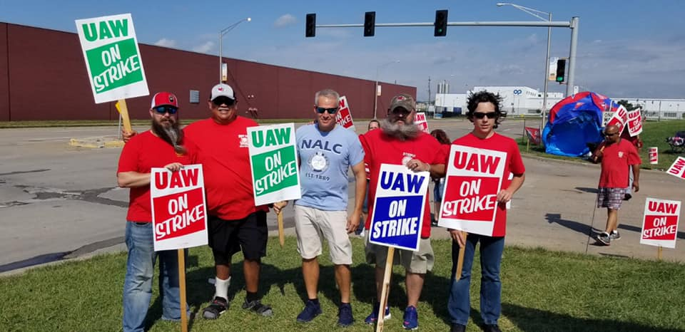

**Branch 499 President Bob Rivera and KSALC President Andy Tuttle supporting striking UAW autoworkers at the GM Fairfax Assembly Plant**

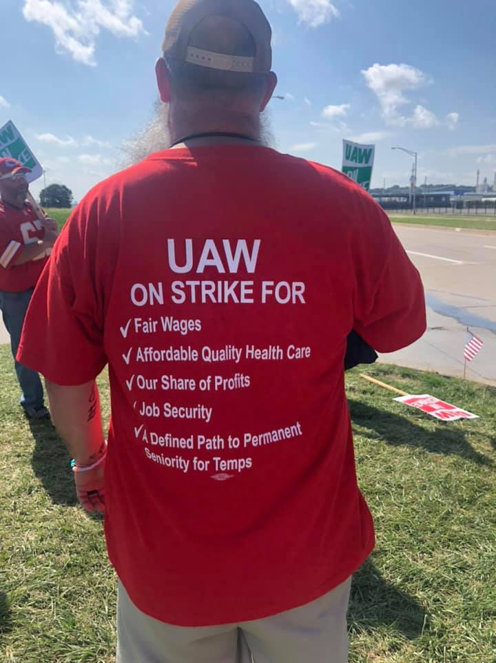

**Protect our COLA!**

Career carriers, do you realize you just received the seventh COLA of the 2016 contract in the amount of $624? It became effective on August 31, 2019. Go look at your paycheck. CCAs, do you realize that you receive an extra raise every November to make up for not receiving COLAS? The union fought for and won you the $624, plus every other benefit that you have. Did I mention that this was the **seventh** COLA of this contract? That’s not counting all the other raises your union negotiated for you. Postal reform is looming large and scary over our heads right now. We need to make sure that it happens in favor of not only letter carriers, but all postal workers and especially the American public. We can do that by donating to the Letter Carrier Political Fund (LCPF). Most carriers are concerned about their rights on the workroom floor and on the street, but do you realize we can lose so much more than that through postal reform and the actions of Congress? Do you like your hourly wage? Would you be willing to do this job for half of what you now make? I doubt that many of us would. Yet what are we doing to prevent that from happening? The NALC cannot use dues money for legislative purposes. For that reason, we have a separate fund, LCPF, that we use for these kinds of activities. If we all gave $5 every pay period, only the cost of a fancy coffee, we would be a force with which to be reckoned. It’s a sad reality but money talks in Congress. Now is a good time to think about donating to the letter carrier political fund. By donating $5/paycheck, you will be making a huge difference but you won’t feel any pain in your wallet because of the increase you just received. It is easy to donate to LCPF. You can have the money automatically deducted from your paycheck in any amount that you choose, starting at $1.00. There are several other ways to donate and you can stop your donations at any time. Please, if you are concerned about the future of your job and your **retirement,** become a LCPF contributor. I would be glad to help you get signed up. It takes less than 10 minutes. You only need to make sure you know your PIN. If you do not, request it be mailed to you and the problem is solved. The future is very scary. Do your part to help protect it before it is too late. For more information, go to the NALC website ([www.nalc.org](http://www.nalc.org)) and click on GOVERNMENT AFFAIRS.

**Michelle Jellison**

**Vice President**



**KSALC Vice President Michelle Jellison and Branch 104 member Sherrard Washington at MDA Fundraiser.**

**ANOTHER YEAR, ANOTHER ASSAULT ON YOUR RETIREMENT**

Well, here we are in the fall of 2019 and we are still fighting off attempts on our

retirement. In addition, the NALC is now waist deep in fighting for a new

contract. As you have heard, we have reached impasse with the Post Office and

are going to mediation. In terms that we can all understand, the Post Office has

said that they will not consider some parts of the NALC’s proposed contract at all.

This could be about wages, benefits or contracting out or something else. But the

key here is that the USPS has said absolutely not. If you remember the last

contract and what our President, Fred Rolando, said to us during negotiations. He

said that as long as they don’t completely turn down our key proposals, the NALC

would continue to negotiate. It took over a year but we negotiated a good

contract that was fair to us and the USPS. However, now, with the USPS being

pushed by the present administration to cut employee’s wages, benefits and

other items, it appears that they are falling in line with the rest of the Corporate

groups and going after those earned items that have produced a good paying

middle class job.

So you say, that effects the active carriers but not me, I’m retired. Not so. As I

have pounded the drum for the last year and a half, they are after your

retirement. For the FERS carriers, they propose going after your FERS supplement

(for those retiring before 62), they want to remove the matching part of your

Thrift savings plan-if not delete it all together, and they want make your FERS

pension based on a high-5 average instead of high-3. In a nutshell, they want to

leave you with a lower pension and your Social Security payment. For FERS

Retirees, they want to eliminate your Cost of Living Adjustment (COLA). And for

Civil Service (CSRS) retirees, they want to cut your COLA to almost nothing.

Retirees who don’t understand the COLA, will say—So What? It doesn’t affect

me! But it does. You must remember that this is the only adjustment to our

retirement pensions once we have retired. It helps us keep up with inflation and

over the years (for the average retired carrier) it could cost you in the thousands

of dollars.

These are the reasons that you need to stay active with the NALC in contributing

to the Letter Carrier Political Fund (LCPF). It allows us to help the Representatives

and Senators who back us and our jobs.

Another thing to be on the alert for is the administration’s going after our

Collective Bargaining. This is where we negotiate with the USPS for our National

Agreement. At present, the administration is pushing for the removal of the

collective bargaining. They would love for us to have go back to the old

“collective begging” system we had before. One where we did as we were told

and shut up. We have already seen the Department of Labor, who used to the

defender of worker’s rights, destroying the safeguards that were in place from

previous administrations—both Republican and Democrat—and we can expect

more attacks.

Sisters and Brothers, we must support our Union as never before. Stay up on all

legislation that impacts your job and company. Then, contact your representative

or senator to tell them to vote for the legislation that supports our jobs. And vote

in all elections. Vote for those who support your job and your well-being.

**Mike Wamsley,**

**Director of Retirees**

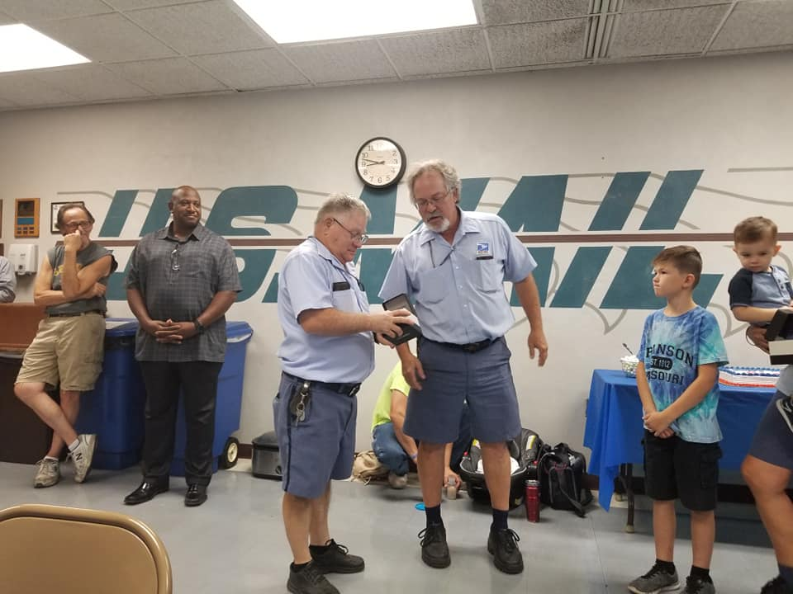

**Branch 10 Past President Bobby Potter retirement ceremony with Topeka Main steward Mark Harlow**

**To strike or not to strike**

As I write this, unionized auto workers are entering the second week of their strike against General Motors. The motivations of both management and labor at GM are in many ways the same motivations that appear to be driving contract negotiations between the NALC and Postal management. During the great recession around 10 years ago, the automakers had badly misjudged what the market for automobile buying would be. As a result, local dealer’s lots were full of cars that consumers weren’t interested in buying.

In the end, the federal government had to step in and make loans to some of the automakers to keep them from going out of business. However, the loans came with a caveat. Management of those receiving government loans would have to restructure the companies, eliminating wasteful and needless overhead. As part of the restructuring, members of the United Auto Workers union also agreed to some collective bargaining concessions to help the automakers through the restructuring and restore the company to profitability. In the end, all the restructuring was successful, and the government loans were paid back with interest. The automakers are back to turning huge profits on the products they sell.

Sounds like all is great in autoworld, right? So why are their employees on strike? It comes down to the current business and political philosophy in this country. Every publicly traded company (a company that the public can buy stock in) should have two sets of priorities for returning any profit made. One is the return to investors. If you bought stock in GM you basically bought an I.O.U. saying they can use your money to grow the business, but if the business turns a profit you want your money back with interest in the same way the government wanted its money back from the bailout.

Since its return to profitability, GM has made good on its promise to investors. While GM stock took a beating during the bailout and restructuring, owning shares of stock in GM is back to being profitable again. So, the government had its loans repaid and investors had their loans repaid. I mentioned that every company should have two sets of priorities for sharing profitability though, investors and employees. The current prevailing political philosophy in this country, however, believes that employees play no role in the success of any business. Labor is viewed simply as an expense, like door mats and toilet paper. You really need them but would like to spend as little on them as possible.

In this case, the members of the UAW finally decided that they were tired of being walked on and treated like shit. (get the door mat and toilet paper reference? sorry I couldn’t resist). GM repaid the loans it got from the government and its investors but is refusing to acknowledge that it also received huge loans from its employees in the form of collective bargaining concessions. As it turned out, GM apparently never had any intention of repaying the loans it got from its employees. GM has fallen in line with the current political climate and now the company that was once the gold standard for valuing its employees now considers treating employees like door mats and toilet paper to be part of its basic business plan. As a result, the UAW had no other choice but to go on strike to try and collect on the employee loans it made to the company.

That brings us to the current state of collective bargaining between the NALC and the Postal Service. Like GM, the Postal Service was teetering on the verge of bankruptcy around 10 years ago and like GM it was mostly a crisis of its own making. Since Postal management was completely consumed with engineering the inevitable destruction of the company it was supposed to managing, it took the view that all its employees would eventually no longer be needed. So, management’s collective bargaining goal for the last 10 years has been to get rid of the “career” classification for its employees and replace them with “non-career” employees that would sooner or later be laid off as the company went out of business. To keep the company afloat through those tough times an arbitrator granted the Postal Service a new “non-career” workforce classification. The NALC has always considered that the Das arbitration award clearly implies that the CCA classification was meant to be temporary until the Postal Service returned to profitability.

Because it was so single-mindedly driven by its idiotic obsession with its own destruction for the last decade, the Postal Service got blindsided by a market-changing monster that everyone else, including the NALC, saw coming, Amazon. Instead of a delivery company that had spent years planning for the time it no longer needed letter carriers to deliver grandma’s birthday cards, the Postal Service now finds itself needing to hire a lot of new letter carriers to deliver grandma’s online shopping purchases. With a company that is expanding rather than contracting, the labor/management relationship should return to being mutually profitable, except for that one notable exception to the GM situation coming into play.

In the GM restructuring, the federal government saw that it was in the best interest of the country to provide loans to the company to help its restructuring. In the case of the Postal Service the government did just the opposite. In 2006, the federal government enacted a law that, in effect, required the Postal Service to provide a multi-billion-dollar interest-free loan TO the government. It did that by requiring the Postal Service to send money to the US Treasury that couldn’t be recovered for a least a decade. Since everyone would see the scam in demanding the Postal Service give the federal government an interest-free loan, the government decided on a very clever marketing strategy.

Law makers would say that the government’s only interest was insuring that postal employees would always have access to the health-care they had earned, so the law would require the Postal Service to “pre-fund” its future retiree health care obligations for the next 75 years in advance while also paying its current retiree health care obligations as they came due. Now that’s a sales pitch any used car salesman would be proud of (pun intended). The shadow that currently hangs over our current collective bargaining process is that fact that the government hasn’t called off its demand for the loan. Keep in mind that the government is not trying to collect money it has loaned TO the Postal Service. It is still demanding to collect a loan FROM the Postal Service.

As a result, our current contract talks are at an impasse. The NALC has taken the position, like the UAW, that Postal Service delivery operations have returned to profitability and NALC members should be repaid for the concessions they made to get the company through the roughest of times by returning all city letter carriers to “career” status. Postal management has taken the position that, although letter carrier productivity is up and delivery is profitable again, it is still on the edge of bankruptcy and NALC members should be the ones to cover the government’s demand for a loan by making further bargaining concessions. The sides are so far apart philosophically that it seems likely that a neutral arbitrator will again have the final say. Keep the faith and stay strong in solidarity and the truth will eventually prevail.

**Rod Holub,**

**President Emeritus**

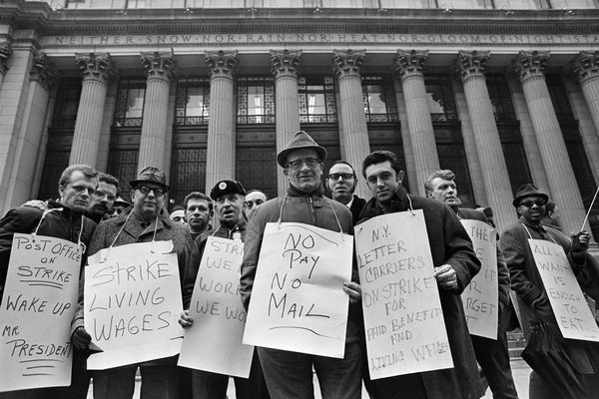

**Striking New York City letter carriers in 1970**

Greetings from the Big 1st District Back in 2006, when General Motors was heading for bankruptcy (GM) placed the average labor cost for UAW-represented workers at General Motors at $73.26 an hour. What they did not make known to the public was that includes the hourly pay, plus the benefits they’re receiving and all the other costs to General Motors, including legacy costs – retirement costs, pensions, and so on – so in looking at the total labor costs per hour worked for workers,” included the costs of nearly half a million retirees in its calculation of labor costs. Including the cost of benefits paid to or for current retirees it made the total cost of every expense the company has, as part of the hourly wage cost. The problems with the inaccurate reporting was that it made people believe that the workers were being unreasonable, and that the workers were the reason that ( G M ) was going bankrupt .In reality , according to several sources, the hourly wage of the average UAW worker going into the 2007 negotiations was about $28, and fringe benefits added another $10 or so to that figure. The average wage and benefits are $38.00 an hour. $38 times 2080 hours = $ 79,040 a year. $38.00 x 8 hours is $304 a day, $304 x 50000 workers on strike = $15,200.000 a day. I saw on the news where GM is losing $100,000,000 a day while workers are on strike. These workers are making GM around 85 million dollars a day after their pay and benefits are taken out of the total money made in a day. A manager at General Motors can expect to make an average total pay of $155,323 a year. These workers took pay cuts because Congress would not give a bailout thinking that the GM reported $73 an hour was breaking the company, and never questioned pay of management. Our contract negotiations have already gone to impasse. If you have paid attention to what the Postal Service offered APWU, you know that the Postal Service is offering nothing, as always, but this time seems like they are more serious. Management never takes a cut in pay. and as this chart from 2012 shows what management took in just pay (there are no benefits included) in 2012.

|  |  |  |  |
| --- | --- | --- | --- |
| Position | Number in group | Average Salary |  |
| Top 300 salaries in HQ | 300 | $151,210 |  |
| Vice Presidents | 28 | $189,000 |  |
| District Managers | 49 | $163,135 |  |
| Plant Managers | 57 | $143,101 |  |
| Combined list | 415 | $152,428 |  |

The 415 top management people in the postal service took $63,257,620 from the postal service in the year 2012. These are the people wanting to cut your pay by various changes to our contract. And as shown to be the case with the strike at GM, the people that make the money for the company are the first to get attacked. Congress seems to be hearing what we are telling them and that helps to keep postal management working on their own for now, without congress agreeing with management. But we need to keep congress on our side to keep from losing what we have earned. Keep working to educate your representatives in congress.

**Kent Chestnut,**

**1st District LCCL**



**Branch 104 MDA Golf Tournament**

Can you believe it? Winter is just around the corner. Just as carriers face challenges of working in summer, those of us who do the work of delivering mail know the challenges of doing so during winter. However many of stupidvisors don't want to acknowledge what we deal with. Don't be goaded into running your route under any conditions, much less during incumbent weather.

We have a contract, and often, especially in smaller offices, management choses to ignore it. This comes from the local level, up to and including what is called, MPOO's. They just make stuff up to fit their needs. More often than not, spouting new rules and what they want to claim as policy that effect our jobs. Don't take this jargon as facts. If you don't know better, ASK somebody! It's been my experience this is being used to try to change what the contract says when it comes to sick leave, annual leave, pecking order for overtime and holiday scheduling, leave and street times, etc. I had a call from a carrier who said management to them when they could go to the bathroom according to "regulations". Unfortunately these turkeys will still be around after Thanksgiving, my favorite holiday.

In spite of all the drama politically and at work, lets give thanks in this day and age, a letter can still get from point A to B thanks to people who actually touch the mail.

**Terry P. Miller,**

**2nd District LCCL**

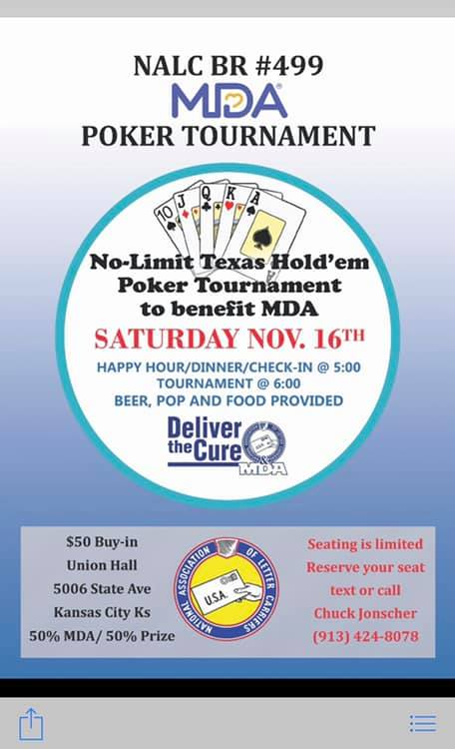

Besides being the Letter Carrier Congressional Liaison **(LCCL)** for the Kansas State Association of Letter Carriers, I serve Branch 5521 as an Officer. Nothing unusual about that, many of our officers in the State wear multiple hats in their service of the NALC. As the Financial Officer for Branch 5521, Shawnee Mission, Olathe and Gardner I think in numbers all day long. Not just delivering my route, but early in the morning checking balances, later checking accounts payable and accounts receivable.

The point is numbers. Ask Ike Donn, our Secretary Treasurer for the State. He knows numbers.

The two numbers I keep coming back to every day are 43 & 5. Pretty obscure numbers to be thinking about every day. Ask each one of the following State Officers a question. What is the relevance of 43 & 5?

Ask my buddy Rod Holub. He’s done too much to list here. He knows. Ask Andy Tuttle. Current State President, former Branch 104 President and a 5521 advocate. He came to our branch earlier this year to serve our members. He knows. Ask Michelle Jellison, Vice-President of the State Association and President of Branch 10. She knows. Ask Chris Mayo, at large **LCCL** for the State Association and President of Branch 5521. He knows. Ask Blake Rockers, President of Branch 104, Ask Bob Rivera and Chuck Jonsher from Branch 499 in KCK. They know.

Yeah, yeah, Greg, what’s the point? The point is numbers. Ask Ike Donn, our Secretary Treasurer for the State. He knows numbers. He knows.

We’ll start with 43. Kind of an odd number, but 43 is a Prime Number.

The simple reason 43 is important is this. There are 43 Articles in our current contract. The 43rd is the least understood and yet the most important. Article 43 says a lot, but I’ll boil it down for you.

With a signature, it’s over. Bye-bye, hasta la vista baby, sayonara, adios, etc. Our contract is essentially null and void.

You think it’s a coincidence that our contract ends on a Prime Number? The definition of prime is this “of first importance”, “of the best quality” or used as noun, this definition “a state or time of greatest strength, vigor, or success in a person's life.”

Article 43 should be considered Article 0.1 Just to get every carriers attention.

The second number I mentioned is 5. We’re asking for 5 dollars every 2 weeks.

I hear the voices, I can’t I need every dime, I bought a car, house, boat, motorcycle, etc.

Let me ask you a question, when Article 43 gets signed and our contract is null and void, how big of a boat you gonna be able to buy while making $11.00 and hour at Walmart? You won’t be able to buy the anchor, let alone the boat.

$5.00 per paycheck. That money goes to making sure your voice is heard in Congress. The House and Senate. We have friends in Congress.

We can always use more friends. Your $5.00 will help your brothers and sisters in the NALC reach 435 members of the House and 100 U.S. Senators. Both sides of the aisle. Left, Right, Middle.

If that member is for NALC, we’re for them. Can you direct your contribution to a specific member? Nope. Me neither. Somebody with a much bigger title in the NALC makes that decision.

Your decision is easy, 43 or 5.

**Greg Wilson,**

**3rd District LCCL**



**Golfing For a MDA**

Greetings from Newton. Summer has finally ended and fall is in the air! I visited with Roger Erickson from Congressman Estes' office. We talked about  H. Res. 33 which call for Congress to ensure that the Postal Service remains an independent establishment and not subject to privatization; H. Res. 54 which continues 6 day delivery for all customers; H. Res 23 which maintains door delivery  and H. R. 2382  which would repeal the pre-funding mandate.  I asked Roger why Congressman Estes, as of yet, has not co-sponsored any of these. He is going to try to find out and let me know as soon as possible. I will let everyone know if and when I hear something. Have a great holiday season and be safe.

**Bob Davidson,**

**4th District LCCL**

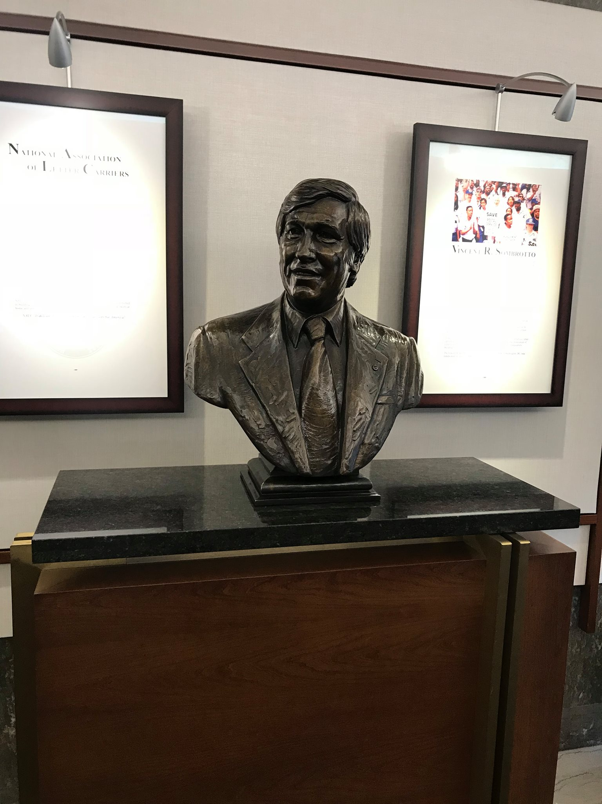

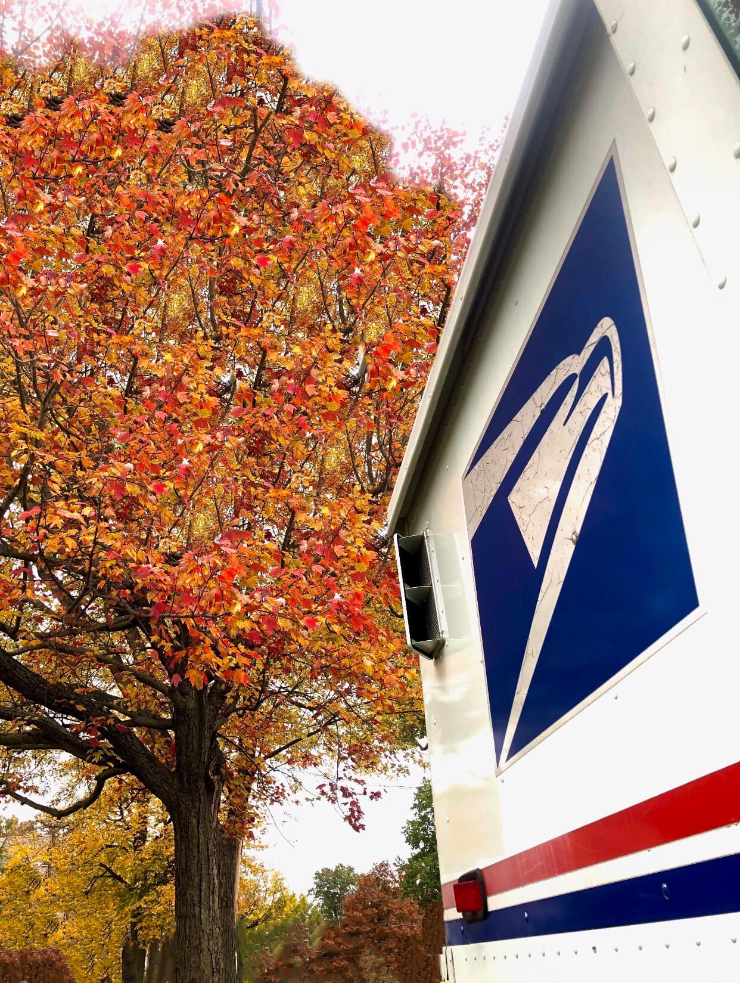

I had an opportunity to sit down on August 19th, 2019 with staffer Mike Williams with House Representative Sharice Davids office in Kansas City Kansas. Obviously, Congresswomen Davids has been a great supporter for Letter Carriers on recent House Resolutions and this is a big opportunity for her to show up big for us on H.R. 2382. On September 24th, 2019 Sharice Davids signed onto the bill becoming only the second Co-Sponsor in Kansas and the fourth in the Kansas-Missouri area. At this point we have gathered 260 Co-sponsors and are so close to the 290 mark that we can smell it. Keep working on the other Congressmen and women that we still need and let's get this bill through the finish line...

Chris Mayo,

At-Large LCCL

|  |  |  |
| --- | --- | --- |
| |  | | --- | | https://mail.google.com/mail/u/0/images/cleardot.gif | |  |

**The 2020 Region 5 Rap Session:**

**Saturday & Sunday, February 22 – 23, 2020.**

**The Double Tree by Hilton**

**10100 College BLVD**

**Overland Park, KS.**

**913-451-6100**

**Rooms will be $122.00 per night plus tax for a single (King) and $126.00 for double (Queen).**

**Reservations can be made online at:**

**http://group.doubletree.com/NatlAssocLetterCarriers**

**2020 KSALC State Training:**

**April 23-25, 2020**

**Hotel at Old Town**

**830 E 1st St N**

**Wichita, KS**

|  |  |  |  |  |  |
| --- | --- | --- | --- | --- | --- |
| **Room Types** | **Thu**  **4/23/20** | **Fri**  **4/24/20** | **Sat**  **4/25/20** | **Standard Rates** | **Offered**  **Group Rate** |
| **Queen Studios** |  |  |  | **$199.00** | **$100.00** |
| **King Studios** |  |  |  | **$209.00** | **$110.00** |
| **Queen/Queen Studios** |  |  |  | **$219.00** | **$110.00** |
| **One Bedroom Suites** |  |  |  | **$399.00** | **$195.00** |
|  |  |  |  |  |  |

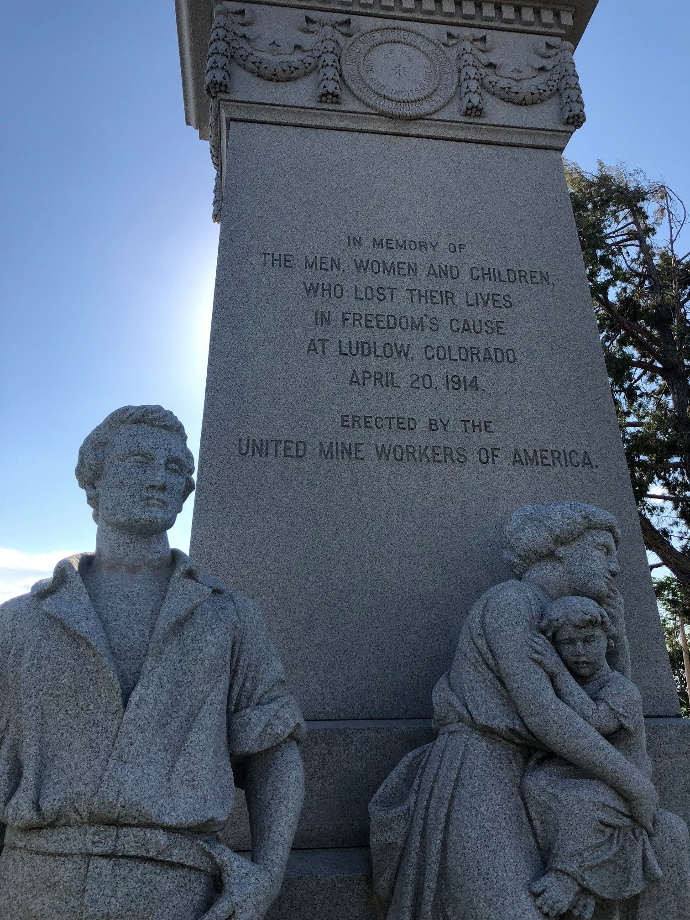





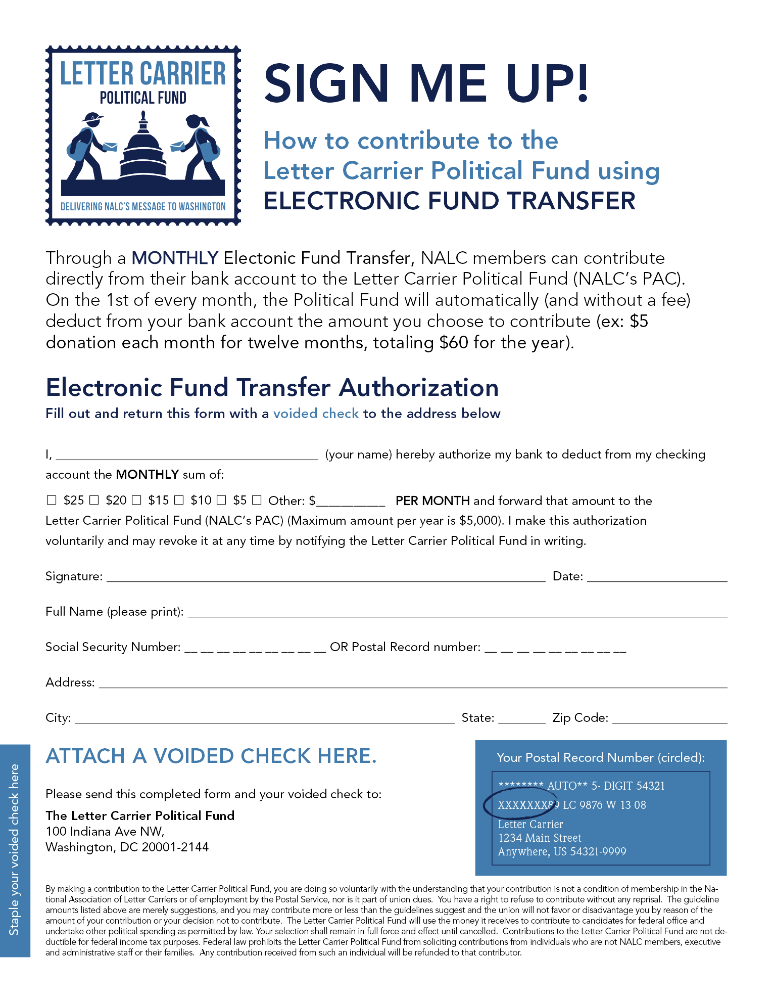

LCPF Disclaimer

By making a contribution to the Letter Carrier Political Fund, you are doing so voluntarily with the understanding that your contribution is not a condition of membership in the National Association of Letter Carriers or of employment by the Postal Service, nor is it part of union dues. You have a right to refuse to contribute without any reprisal. The Letter Carrier Political Fund will use the money it receives to contribute to candidates for federal office and undertake other political spending as permitted by law. Your selection shall remain in full force and effect until cancelled. Contributions to the Letter Carrier Political Fund are not deductible for federal income tax purposes. Federal law prohibits the Letter Carrier Political Fund from soliciting contributions from individuals who are not NALC members, executive and administrative staff or their families. Any contribution received from such an individual will be refunded to that contributor. Federal law requires us to use our best efforts to collect and report the name, mailing address, occupation and name of employer of individuals whose contributions exceed $200 per calendar year. Any guideline amount is merely a suggestion, and an individual is free to contribute more or less than the guideline suggests and the Union will not favor or disadvantage anyone by reason of the amount of their contribution or their decision not to contribute.