**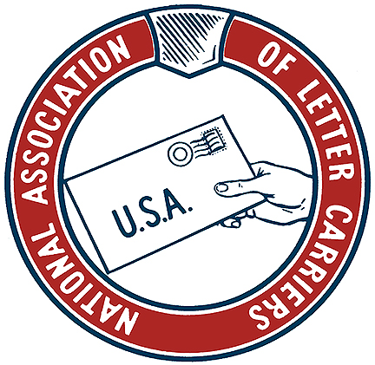**

**KANSAS MAIL CARRIER SPRING 2019**

**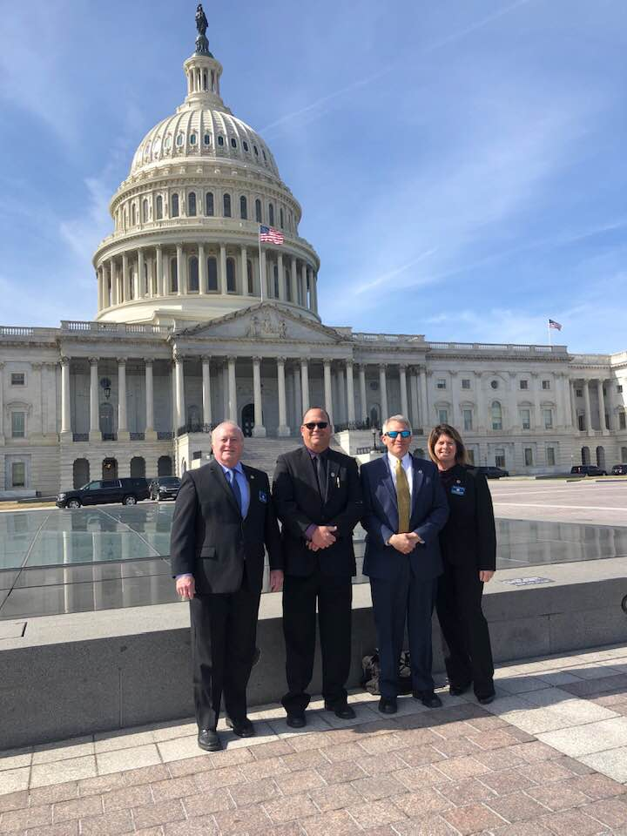**

**President’s Article Spring 2019**

I hope that most of you have survived this very long and particularly harsh winter in decent shape. I know carrying mail gets tougher for me physically with each passing year. We have a job that is far more dangerous than most people realize. We spend hours each day walking or driving in every imaginable location and variant of climate. The amount of time we spend on the street has risen dramatically over the years as well, increasing our exposure to hazards.

It’s been a busy few months for the KSALC. We have a new Congress and two new members of the Kansas Congressional delegation. I feel it’s important they know who the Kansas Letter Carriers are. On January 24 I met with Colletta Hummel, a staffer for newly elected 3rd District Representative Sharice Davids. We discussed Letter Carrier and postal issues and I did my best to educate her on our issues. Let’s face it, most people are aware of the Postal Service but have no idea how we operate or how deeply impacted we are by legislation.

On February 11, I met with Bill Roe, Topeka field office Chief-of-Staff for newly elected 2nd District representative Steve Watkins. Bill is a holdover from Rep. Lynn Jenkins, having previously served as her Chief-of-Staff. He had a pretty good grasp of postal issues and told me his father-in-law is a rural carrier. The next day, Rep. Watkins signed as co-sponsor to NALC backed resolutions, H Res 33, opposing a privatized USPS, and H Res 54, supporting 6-day delivery. We hope to get his co-sponsorship of H Res 23, supporting door delivery, and H Res 60, supporting a return to 2012 USPS service standards.

The NALC supports the legislation we support because we support legislation and resolutions that protect essential letter carrier jobs and help preserve the USPS as an indispensible component of America’s infrastructure that serves all our customers affordably and without discrimination based on geography. We have faced increased scrutiny over the last dozen years due to the unique and unfair financial burden placed on the USPS by the pre-funding requirement of the 2006 law, the Postal Accountability and Enhancement Act (PAEA). The perception of failure and financial ruin caused by the PAEA has caused manufactured panic from postal observers and a fire sale mentality within the USPS.

It is with that context that Vice President Michelle Jellison, Director of Retirees Mike Wamsley, Branch 486 President Brad Johnson, and myself went to Washington DC to lobby on behalf of Kansas Letter Carriers at the end of February.

First we met with 1st District Rep. Roger Marshall. He has been supportive of our Resolutions in the past and Brad Johnson has established a good relationship with his office. We actually had over 20 minutes of face time with the Congressman. He expressed continued support but also had some tough questions for us about postal finances. Rep. Marshall is currently co-sponsor to H Res 54, supporting 6-day delivery.

Next, we met with Dylan Jones, a staff member for 2nd District Rep. Steve Watkins who is in charge of postal issues. As previously mention, Rep. Watkins has co-sponsored NALC backed House Resolutions 33 and 54.

The next day we met with Sen. Pat Roberts’ staff. They made clear his opposition to a privatized USPS but also spoke favorably about many White House Task Force recommendations, including ending Tuesday delivery. While Sen. Roberts has co-sponsored S. Res. 99 (opposing privatization), he still has some pretty damaging notions about the future direction of the USPS. Sen. Roberts is retiring and will not run for reelection in 2020.

After the meeting with Sen. Roberts’ staff, we split up. Mike and Brad met with Sen. Jerry Moran. Michelle and I attended a lunch with new 3rd District Rep. Sharice Davids. Mike and Brad both write of their meeting with Sen. Moran elsewhere in this publication. They had a productive meeting and Sen. Moran later introduced bi-partisan S. Res. 99 along with Sen. Gary Peters (D, MI). Sen. Moran has been and remains a very good friend to Letter Carriers and we appreciate his support greatly.

Our lunch with Rep. Davids was very productive as well. She is a very engaging and wanted to know more about our issues. Her mother, who is retired from the US Army, is a clerk at the NDC in Kansas City, and is an APWU steward. All four from the Kansas delegation later met with Rep. Davids outside the House Chamber and discussed NALC backed legislation. So far she has co-sponsored H Res 54, supporting 6-day delivery. We hope to win her support on all NALC backed Resolutions.

Also on that Wednesday we attended a Rap Session at NALC Headquarters. President Rolando updated us on where we stand legislatively and also with regard to upcoming contract negotiations with the USPS. He seems pretty convinced that our next contract will go to arbitration. The NALC Executive Committee is gearing up for that fight at this very moment to put forward our best case in arbitration.

At this time I feel it’s important address the fact that a large number of CCA’s and former CCA’s are upset with the status quo. There is resentment of the fact that they do the same job as someone hired in before them who gets paid more than they do. They resent the fact that they are required to toil in second-class status for several years before even becoming eligible for career status and benefits.

What I can definitively say is that the entire CCA classification came around because of the financial crisis caused by the PAEA. Bad legislation caused those bad terms of employment! In 2012, the year before the Das Award, which established the CCA position, the USPS had a reported loss of $16 billion ($12 billion from the PAEA pre-funding mandate). That’s an impossible environment to in which to successfully bargain for better wages and benefits. In that regard, CCA’s and former CCA’s should be very aware of what they have to gain or lose as a result of legislation—having already lost a great deal because of legislation that harmed our employer and consequently—the NALC membership.

I also see and hear from members who hate politics or hate one political party or the other—or both parties equally. Please don’t make the conscious decision to bury your heads in the sand because you hate both sides. The problem with that approach is that the game continues to be played without you. You problems are compounded by your own absence. You disengage at your own peril.

That is why I consciously stay informed and proudly give to the Letter Carrier Political Fund. We help those who help us, regardless of political party. Kansas is an example of that. We can bitch about how much we hate the system but the system continues on and makes changes that affect us with or without our contribution. That’s why I feel my efforts and money are well worth it—it’s a small price to pay for our job security. I choose to remain engaged and to fight for what is ours.

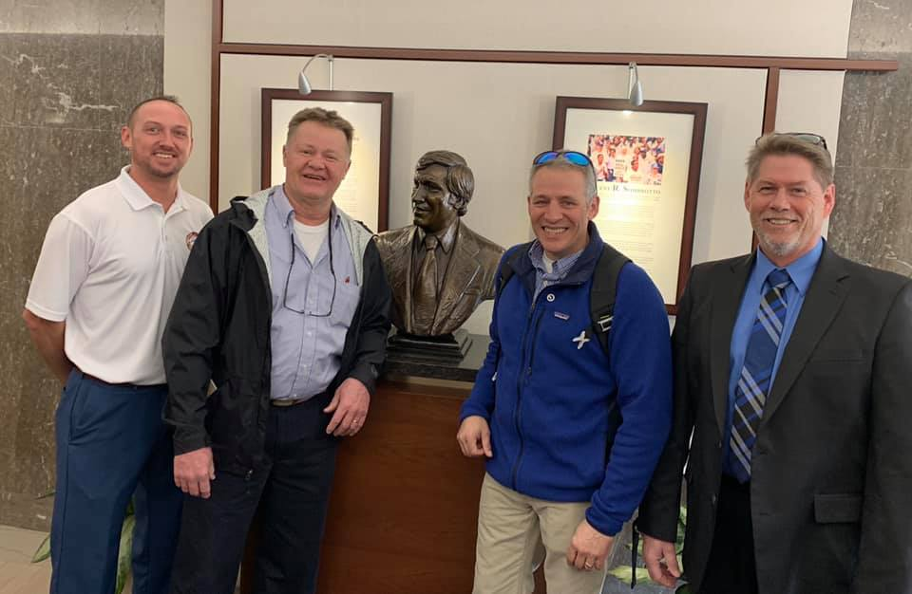

**Region 5 State Chairs From Left: Herb Copley (Iowa), Andy Tuttle, Kevin Holmes (Missouri), Jeremy Liebsack (Nebraska)**

**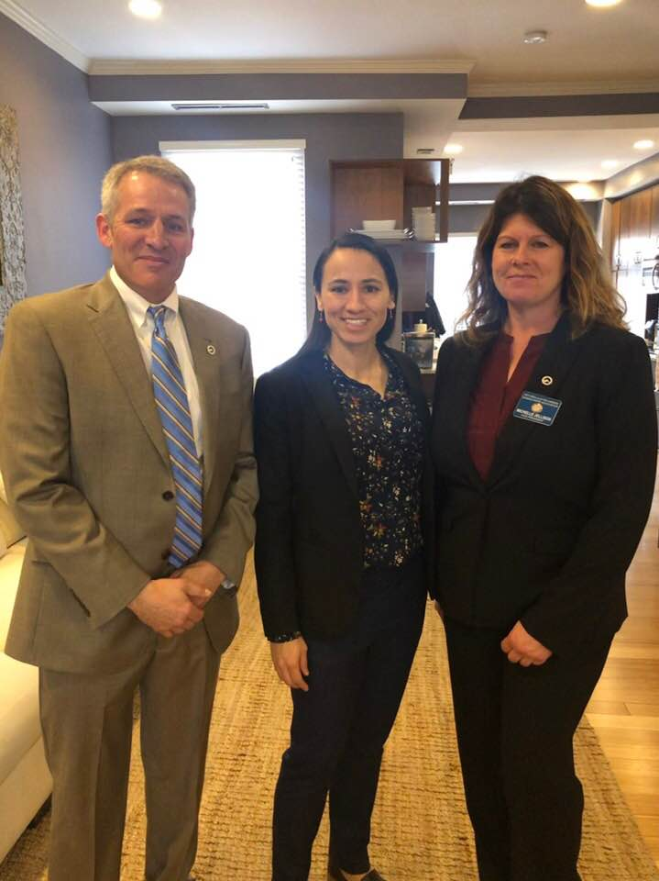**

**Rep. Sharice Davids with Andy Tuttle and Michelle Jellison**

**Michelle Jellison Vice-President/Director of Education**

After the Region 5 Rap session, I had the honor to travel to Washington D.C. and take part in the legislative trip. Andy Tuttle, Mike Wamsley and Brad Johnson also attended. This trip was exciting and very educational and hopefully very beneficial for Kansas letter carriers.

We began our work at NALC headquarters being briefed on current legislation. Later that evening, Brad Johnson was able to secure us a tour of the Capitol building thanks to his relationship with Representative Marshall. The representative himself gave us the tour giving us the opportunity to forge an even better relationship with him. The following morning, we met with Representative Marshall in his office. We had a lengthy conversation with him. Afterwards we made our way to Representative Steve Watkins office. To my great disappointment, we did not get to speak with Representative Watkins, but instead we spoke to one of his aides who was very well informed on postal issues. It may not sound like much but in the space of those two appointments, we walked 5.5 miles, which is a true feat in dress shoes! Capitol Hill may not be a big place but there is a lot of walking and time spent getting from one place to another.

The next day turned out to be very exciting. We headed to our appointment with Senator Pat Roberts. Again, we did not get to speak to the senator, but we had a great conversation with one of his aides. Next, we headed to Senator Jerry Moran’s office. Andy and I had to leave before we were able to meet but Mike and Brad handled the meeting quite successfully, getting to speak with both the senator and his aides. Andy and I were lucky enough to get into a lunch with Representative Sharice Davids. I was not sure of what to expect but certainly did not expect to be one of only 15 people present. We had about ten minutes with Representative Davids and I am sure that we made a lasting impression on her as she did on us. She is a very friendly, down-to-earth, caring person. Her mother is an APWU steward, so she is very interested in postal issues. Later that day, we had an appointment at her office. At that time, she was on the floor of Congress, so her aides took us to her. Walking through the tunnels and seeing the back halls of Congress was a real treat. While there, many well-known people walked past us, including Alexandria Ocasio-Cortez. It is a busy, fast-paced place. Even so, Representative Davids made time for us.

At each meeting, we spoke in-depth of current legislation and postal reform. We left a packet of information that included fact sheets and a copy of the Heroes magazine, similar to the Postal Record but containing stories of letter carriers performing heroic acts.

One of the questions asked of us in a meeting was, “What are we, as letter carriers, doing do become more efficient?” We all know that we are working harder than ever but because of the prefunding mandate, the post office shows it is losing money every year. Postal reform is going to be a big issue this year. It is more important than ever that all of us donate to the Letter Carrier Political Fund. It takes money to get our ideas to people in Congress. Our union is non-partisan and only deals with legislation affecting letter carriers. We have to start thinking with our wallets. Without money in our wallets, few of the other issues matter. Where does the money in our wallets come from? Our job. We must protect it. Five dollars a paycheck to LCPF will make a huge difference. If you do not know how to sign up or have questions about the Letter Carrier Political Fund, please reach out to Andy, me, or any state officer. Unfortunately, it takes more than a trip to Washington D.C. to get our agenda explained and accepted by those representing us. It takes money.

**Director of Retirees Mike Wamsley**

**RETIREES, POLITICALLY ACTIVE—NOT ME!!!! I’M RETIRED!!!!!!**

To all my retired NALC Sisters and Brothers, hello. My title of this article, unfortunately, is all to common among our retired members. They think that because we are retired, we are “SAFE”. We did our time and work and now we can sit back and watch the world go by and we are “Untouchable”. Nothing could be further from the truth. Everything that we have won and worked for could be gone in an instant if the politicians want to do it. It is because of this that I was a member of the delegation from the NALC Kansas State Association that went to Washington, D C in February. Along with State President Andy Tuttle, State Vice President Michelle Jellison and Salina Branch President Brad Johnson, I was involved in seeing and talking to 5 of the 6 Congress people from the state of Kansas. We were able to see Representative Marshall, Davids and Senator Moran in person. We were also able to meet with Representative Watkins and Senator Roberts staff members.

Our mission was fairly simple. We were to talk to these people from Kansas and ask them to support legislation that supports the Letter Carriers jobs and the Post Office. With our Representatives this included the following bills: HR 23—Door to Door Delivery; HR 33—Privatization of the US Postal Service and HR 54—6-Day Delivery. HR-23 supports the Post Office delivering to the residences of our patrons and no centralizing delivery to NDCBUs at the end of a block or the like. HR-33 asks for our government to NOT PRIVATIZE our Post Office. And HR-54 continues support for 6 day delivery. For our Senators, it wasn’t quite as easy because there were no bills at that time on the Senate floor that supported or hurt the Post Office. Since then, however, Senator Moran has co-sponsored a bill that opposes attempts to privatize our Post Office (one of the topics that we talked to Senator Moran about). We also talked to these people about reforming the Post Office. Doing away with prefunding the Retiree’s Health Benefits, supporting the retirement plans that benefit us and other topics were talking points that we used to ask for the support of our men and women who represent us.

Why are these bills important for me as a “Retired Letter Carrier”? after all, as a retired letter carrier, I am no longer a part of the Post Office—I was moved to OPM for my annuity—so nothing done to the Post Office can hurt me—RIGHT? **WRONG** . Congress can and has come after the retirement benefits that we worked for so hard for. In 2013 and 2014, Congress raised the employees contributions by over 4%. This means that those starting after those dates they had to pay out of their pay check, over 4% more that their other Brothers and Sisters, to receive the same retirement. In the budget that President Trump sent to the Congress, he wanted to remove the FERS special annuity supplement (replaces the Social Security payment for those retiring before age 62), cut the matching fund for the Thrift Savings Plan, as well as other attacks on the retirement system like changing your pension being based on your High-5 instead of your High-3. This deals with drawing out, longer, the time used to average your pension, thus giving you less. But again, why do I have to worry, I’m retired. It doesn’t affect me!!! Well, how about this: after retiring, we receive the pension that we were eligible for in the CSRS or FERS systems. That will no change by itself, **EVER.**  The one thing that dis help us out was a **COLA**. No, not Pepsi or Coke. This is a **COST OF LIVING ADJUSTMENT!** As inflation raises the costs of the world, we received an adjustment to our pensions to keep pace with the rising inflation. Seems fair, doesn’t it. Now, there are those in congress that want to do away with that for the present retired carriers. **THAT IS YOU AND ME, SISTER AND BROTHER RETIRED LETTER CARRIER!!** **Yes, they can and are coming after your retirement.** **OH, NO, THEY CAN’T DO THAT TO ME,** you say. **BUT YES, THEY CAN AND ARE!!!** This is why we can’t just sit here and do nothing **OR WE LOSE IT.** We must continue to support our active Brothers and Sisters in the political arena so we can support ourselves. We need to call the Senators and Representatives when we get a message that a bill in Congress supports or hurts the Post Office. We need to add our donations to the Letter Carrier Political Fund (LCPF) at our National Headquarters so that we can ask for and receive support from those in Congress. (Senator Moran is a leading example in Kansas. We have supported him in his bids for re-election because he supports the jobs of the Letter Carriers) This is why, I went to Washington, DC in February. To ask these women and men to support the jobs of our carriers and the retirement of our retirees!! Thank you for allowing me to represent you in this.

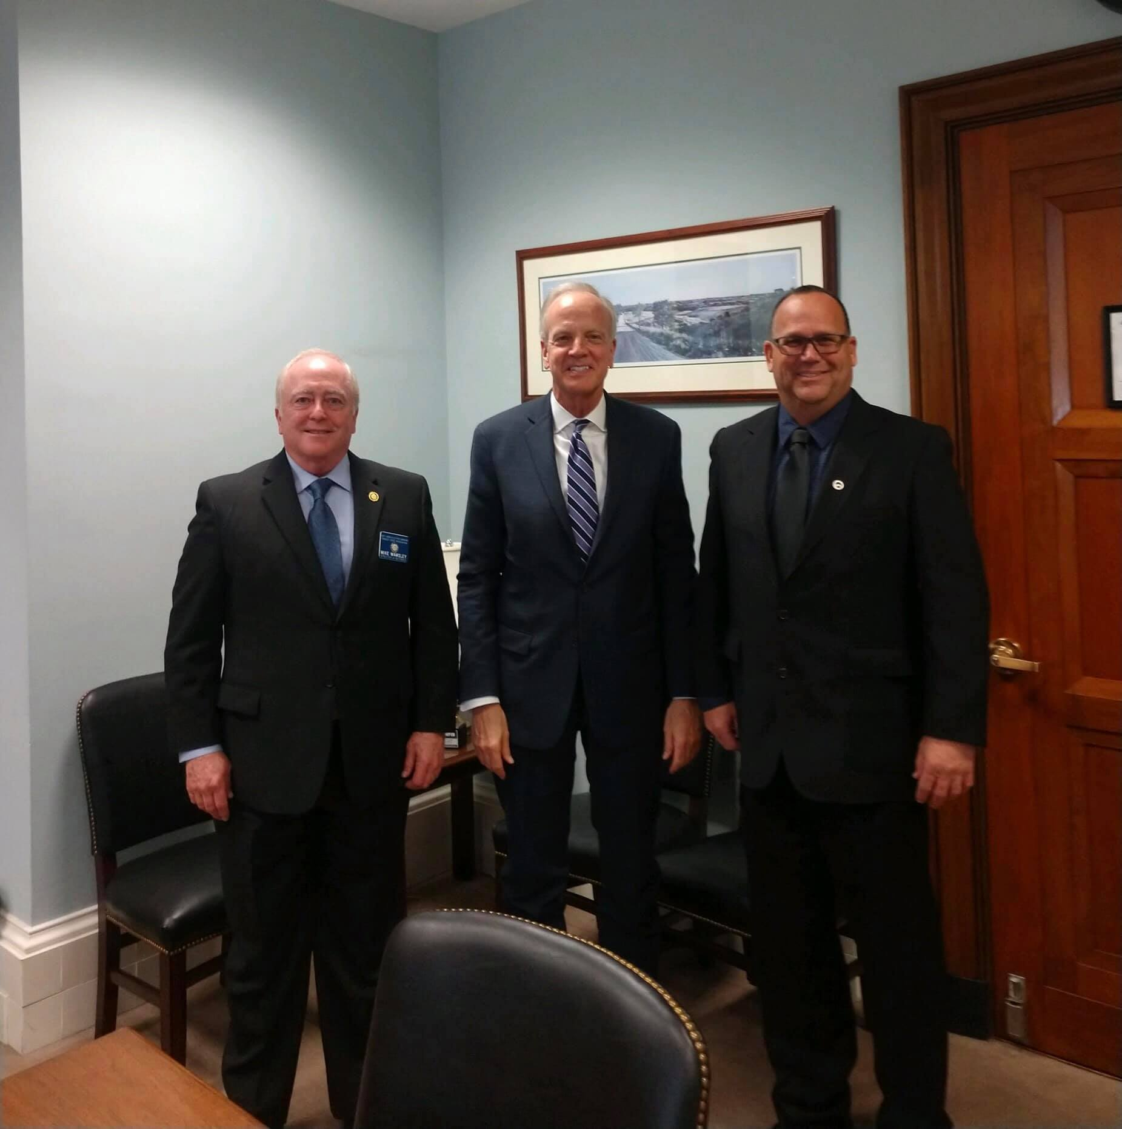

**Sen. Moran with Mike Wamsley and Brad Johnson**

**President Emeritus Rod Holub**

March 2019 Newsletter

Lately, I have been paying close attention to a couple of events that threaten the very foundation of our democracy. One of those events was the public testimony of Michael Cohen, Donald Trump’s long-time personal attorney, before a Congressional Committee. The other was a lobbying trip to Washington, DC by four of our state association’s most gifted spokespersons. Most letter carriers probably don’t realize there is a common theme binding those two events together: the concept of a country based on “we the people”,

There has been a lot of noise coming from conservative media concerning the Mueller investigation of potential ties between the campaign (and administration) of Donald Trump and agents of the Russian government. Conservative talk show hosts are trying their very best to describe the investigation as a bunch of crooked law enforcement professionals trying to slander Donald Trump because of differences in policy, like immigration, or taxes, or Planned Parenthood, or whatever it is that gets their viewers riled up. The continuing banter is good for their show’s ratings. I get that……..if ratings are the only thing that matters and to some it is.

The real importance of the Mueller investigation is much simpler, but much more critical than television ratings: Was candidate Donald Trump willing to trade the interests of “we the people” for personal financial gain. In other words, was Donald Trump (and his organization) willing to lift sanctions on the Russian government in exchange for financing and permits to build luxury hotels in Russia that would result in hundreds of millions of dollars in personal profit for Donald Trump. While we don’t know what that investigation will ultimately conclude, we do know that enough evidence existed suggesting it might be true to at least investigate. Donald Trump’s business and personal history (as described by Michael Cohen in his public testimony) is so full of evidence that he has been willing to swindle and cheat anybody in order line his own pockets that it is imperative to know whether the very foundation of “we the people” was being compromised during the 2016 presidential campaign.

So how is that investigation tied to an NALC political lobbying trip? President Andy Tuttle, Vice President Michelle Jellison, Director of Retirees Mike Wamsley, and 1st District CDL Brad Johnson recently spent time on Capitol Hill convincing our elected congressional representatives not to trade the common good of “we the people” for those who would stand to profit personally from privatizing the U. S. Postal Service. No privatization scheme ever put forward has suggested that privatizing our country’s postal service would provide better service to the public. Every scheme has been based on subjecting postal services to the “free market”. That’s code for big wall street investors profit – your mail service sucks.

The Constitution of the United States begins with the words “We the people” and in it’s first Article establishes a single, centralized postal system. In the centuries since it’s founding, our country’s postal system has been the very definition of “we the people” by being a service “of the people with equal access under law”, staffed “by the people who live and work in the communities they serve” and “for the people to use without regard to economic or personal status”. We should all be very grateful that skilled unionists like Andy, Michelle, Mike and Brad are sharing your very heroic stories of how our country is best served by a postal service “of the people, by the people, and for the people” and we pray for their continued success.

**Branch 486 President Brad Johnson**

I made my first trip to Washington DC for the Kansas State Letter Carriers Association to talk to our Representatives and Senators. We left right after the Region 5 rap session in Kansas City. It was an eye-opening experience.

On Monday we met with the legislative team at NALC headquarters so that they could spend some time going over the resolutions that we needed to talk about.

H Res 23,33,54 and 60. After going over the resolutions we had the opportunity to stay and get advice on how to conduct the meetings with the Representatives and Senators, for those who had never done that before.

Monday night we were able to attend a tour of the Capital conducted by Congressman Marshall. There were only about 20 people on the tour, and Congressman Marshall spent time answering questions during the tour.

On a side note, he is scheduled to talk to the delagates at the State Convention in Salina this May.

Tuesday was the first day of our meetings. We met with Congressman Marshall first. Last session he co-sponsored many of the resolutions that the NALC was backing. We expressed how important these resolutions were to his constituents and left his office very hopeful that he will be cosponsoring those resolutions again this session.

Our next meeting was with Congressman Watkins staff. They were also receptive to our issues and seemed interested in working with letter carriers to co-sponsor the resolutions.

On Wednesday we first met with Senator Roberts staff. There are no senate resolutions as of yet, so we discussed the importance of Postal reform and fixing the pre-funding issues were to the future of the Postal Service. They talked about signing on to any resolutions that might come up in support of Postal related issues.

Next, we met with Senator Moran’s staff to discuss the pre-funding issues with them. After about 25 minutes, Senator Moran Came in and we talked to him for another 20-25 minutes. He has always been a supporter of carrier issues and plans to continue to do so.

Lastly, we met with Congresswoman Davids. We talked with her just outside the House Chamber due to voting going on around the time of our meeting. She has a special interest on Postal related issues because her mother is a steward for the APWU. She sounded like her co-sponsoring the Resolutions would likely happen.

This was my first trip to talk to the legislators on behalf of the KSALC. It was interesting, and I hope it will happen again in the future.

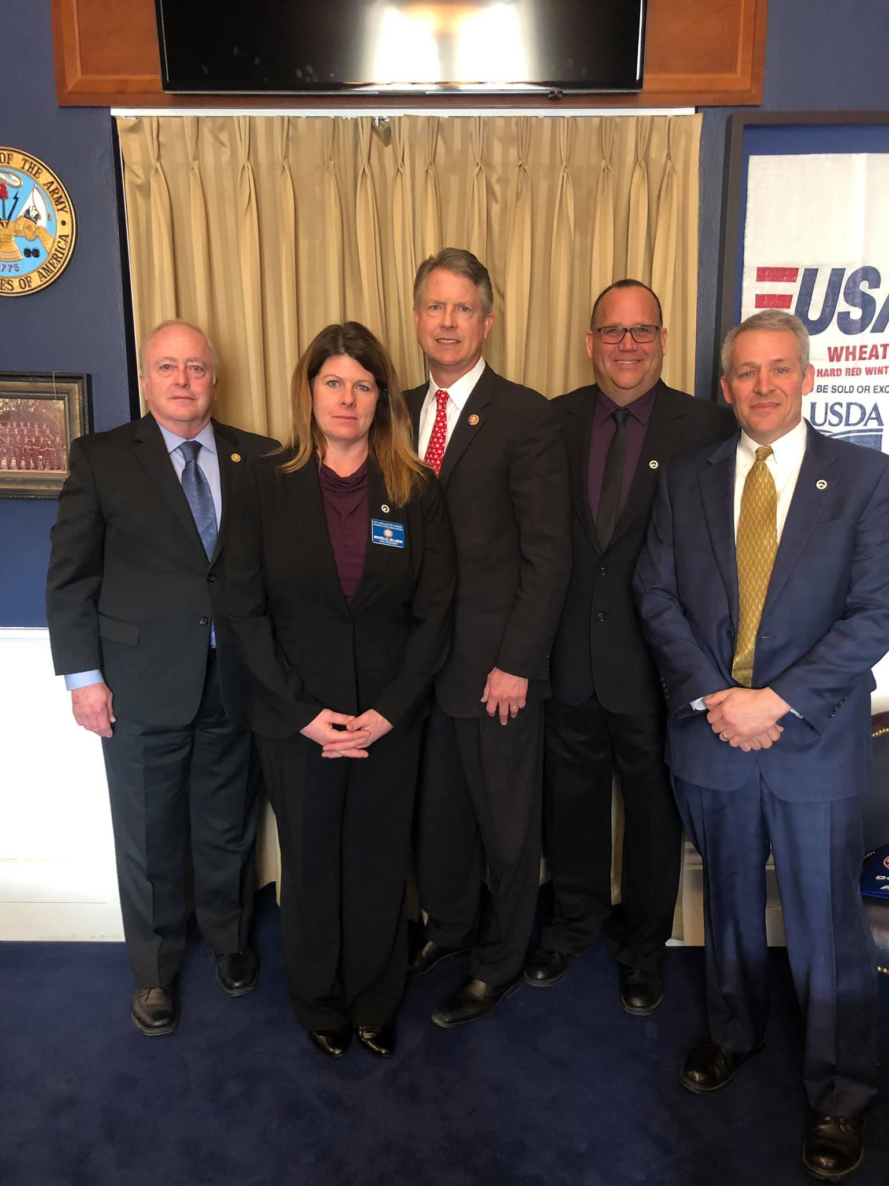

**Rep. Roger Marshall with KSALC Delegation**

**2nd District LCCL Terry P. Miller**

So much enjoy attending the annual Region 5 Rap Session in Kansas City. There is always plenty of info, break out classes, and events, plus I get to see friends from the entire region. President Rolando attending and giving the latest info on what is going on legislatively and contractually is another thing I look forward to. I hope to see many of you at the National Rap Session in Denver this August. If you attend the mile high city remember your their for the meetings, not just the other stuff you can now do legally in Colorado. ( I crack myself up)

In Independence, we are a gusting well with the after effects of our full route inspection. Management actually thought they were going to eliminate at least one route, maybe to. Well after the work was done, a route was added. I keep saying on of these days they will listen to us, but it will never happen. These people actually get paid good money for their stupidity.

Summer will be here soon, and remember to be safe. If you become ill on your route, inform your supervisor, get somewhere cool, and don't be bullied to work when you fill the symptoms of heat stroke. Also report the incident to your union representatives and they know to make a report to the Region Five office.

https://ssl.gstatic.com/ui/v1/icons/mail/images/cleardot.gif

**3rd District LCCL Greg Wilson**

As the sun rose this morning and I looked out the kitchen window, I was thankful It was Sunday. Not because I’m a religious man, more so since it was snowing, windy and cold. And I thought, we all need a break from this crazy winter season. Bitter cold is the forecast for Monday, March 4th. Oh boy, can’t wait. And I thought of our CCA’s out there delivering in a snowstorm. My heart went out to them, because I started as a CCA and can recall all too well the Sundays I spent delivering packages to our customers. Even though they are CCA’s, they are brothers and sisters. And then reality set in, as I fired up my computer and looked at an email from the boss, Andy Tuttle. Andy requested some information.

I stared at a blank white page, waiting for inspiration. And it came to me when I thought about the CCA’s delivering on this snowy, windy Sunday morning.

The 1st thing we have in common is that we are members of National Association of Letter Carriers. Regular, PTF, (yes, we have some again) or CCA.

The NALC accepts all. Fill out a PS 1187, sign it, you’re in.

There is no box to check if you are a Democrat, (nope) Republican (nope), Independent, Green Party, Tea Party or a Kegger Party. (Nope, although if there was a box for kegger party, count me in)

NALC accepts all who wish to belong and pay their share for the continuation of our contractual rights and privileges.

Why did I just reel off that information? Simple. The NALC accepts all, with out questions or conditions.

And that is how the Letter Carrier Political Fund allocates it’s resources to elected or hope to be elected officials. Right, Left, Centrist, Independent, Green, Tea or whatever party name they have been associated. The Letter Carrier Political FUND (LCPF) does not care either. Regardless of your views on social issues, economic issues, wall or no wall, truce or no truce, the LCPF looks at the voting record of incumbents, regardless of party affiliation. If you have supported the NALC, chances are good, we’ll support you. Can I commit to a donation? Nope. That decision is way above my pay grade.

Your bi-weekly donation to the LCPF will not go to just Democrats. Nor just Republicans. Your contribution of $5.00 per pay period will go to members of the House and Senate who support you!

Officials who support 6 day a week delivery, door to door delivery, keeping USPS out of private enterprise interests, keeping the mailbox you deliver to for mail and USPS packages, responsible postal reform and repealing the prefunding mandate.

I live and work in Olathe. It’s home. Not my hometown, but it’s home now and has been for 26 years.

I want to continue to work and live in Kansas.

I remembered driving through the Flint Hills for the first time in the middle of the day and the sky was thick with the smoke of the annual Prairie burn. And my thoughts were, Holy Shit, these people are nuts!

And driving through Southwestern Kansas in November of 2014 entering Kansas on Hwy 54 right near Liberal and continuing east towards Olathe. And then feeling like the road was moving, which it was because of the earthquake in Oklahoma. And every possible weather event or natural event in between. And like the rest of you, I stay. It’s home.

We live in the center of the country. “Flyover Country” is how Kansas is perceived to the East and West Coasters. Great. Come visit. Don’t let the door hit you in the ass on the way out!

That is the 2nd thing we have in common. We like our communities, cities, towns and metropolitan areas. Doesn’t matter if you’re a left leaning letter carrier like me or a right tilt carrier like many of my casemates in Olathe.

The point is this. You need to fight for your job, your career and retirement. A $5.00 contribution every pay period will help you, help your case mate, help a carrier in Topeka, Wichita, Lenexa, Gardner, Colby, Garden City, Manhattan, Salina, Lawrence or even here in Olathe.

**4th District LCCL Bon Davidson**

Hello Everyone,

     I hope everyone is well and looking forward to the spring season. February was a crazy month and it is raining hard as I write this.  I visited with Roger Erickson from Congressman Estes' office about some issues and concerns the NALC has about postal legislation. We talked about maintaining door delivery and how businesses as well as resident's support it. We also talked how letter carriers know their neighborhoods and how carriers are sometimes the only contact that shut-ins have on a daily basis.

     We also visited about how the NALC opposes privatization and supports HR 33, which calls upon Congress to ensure that we remain an independent establishment. We talked about the half million or more employees we have and how we go the "last mile" that the other companies don't and how many jobs could be jeopardized with privatization. I emphasized that we are much more than just a delivery service.

     We then talked about continuing six-day delivery HR54 for business and residential customers alike. I told him that no other company delivers important mail to every address in the nation. Small businesses rely on six-day delivery because they are able to serve their customers more quickly and reliably with the USPS than any other company.

     The last thing we talked about was the pre-funding and why it needs to be repealed.  I shared with him that the Postal Service would have recorded a surplus of almost 4 billion dollars since 2013 if the pre-funding was not imposed-and gave him the yearly statistics. I also reminded him that no other enterprise is mandated to pre-fund retirees benefits.

     That is all for now.  I will see you all in about a month in Salina!!

**At-Large LCCL Chris Mayo**

We have 3 major bills in the House that we need to bring attention to. H. Res. 23 that protects door-to-door delivery. The bill only has 107 Co-Sponsors and at this moment we do not have any Kansas Representatives signed on. We also have H.Res. 33 which is at the finish line with 204 Co-Sponsors to ensure that they take all measures to protect the Postal Service from Privatization. Only House Representative Watkins from the 2 District has signed on to the bill, but if we make a big push, we can get it through. And finally, the all-important 6 Day Delivery Bill, H. Res. 54. We have everyone on board except Representative Ron Estes in the 4th District. I’m including the contact information at the bottom of this article to make it easy for everyone to contact your Representatives. Even if you don’t live in the area please take a moment to call and voice your opinion.

[https://estes.house.gov/](https://estes.house.gov/" \t "_blank) [https://davids.house.gov/](https://davids.house.gov/" \t "_blank) [https://watkins.house.gov/](https://watkins.house.gov/" \t "_blank)

Wichita District Office 7325 W. 79th Street Pittsburg Office

7701 E. Kellogg, Ste. 510 Overland Park, KS 66204 1001 N Broadway St

Wichita, KS 67207 Phone: (913) 621-0832 Pittsburg, KS 66762

Phone: (316) 262-8992 Fax: (913) 621-1533 Phone: (620) 231-5966

Washington, DC Office 1541 Longworth HOB Topeka Office

1524 Longworth HOB Washington, DC 20515 3550 SW 5th St.

Washington, DC 20515 (202) 225-2865 Topeka, KS 66606

Phone: (202) 225-6216 Phone: (785) 234-5966

1205 Longworth HOB

Washington, DC 20515

Phone: (202) 225-6601

<https://marshall.house.gov/>

Garden City Office

816 Campus Drive

Suite 500

Garden City, KS 67846

Phone: 620-765-7800

Salina Office

200 East Iron Avenue

Salina, KS 67401

Phone: 785-829-9000

Washington, DC Office

312 Cannon House Office Building

Washington, DC 20515

Phone: 202-225-2715

Chris Mayo

**Jerry Totten, Branch 104 Lawrence**

I'm Jerry Totten, retired city carrier; I've been a member of the Lawrence KS NALC Branch 104 for 47 years.

This fall, Andy Tuttle asked me if I would work with the Letter Carrier Political Fund to help in regional political activities. I agreed, and communicated with Brent Fjerestad to get the paperwork done. When I was released to perform LCPF functions, I was connected with NALC Branch 30, KCMO, and got a schedule of times to go to the Branch 30 office.

The activities were simple enough; I spent time stuffing envelopes and putting address labels on them, hand-writing addresses, and making phone calls. The phone calls made me step outside of my personal fences; I've done a lot of volunteer work on political campaigns, but I've always avoided making phone calls. But I was making calls asking people to support Claire McCaskill in the U.S. Senate election. Thank goodness I was calling NALC Branch 30 members; only one guy said "Fuck NO!" and hung up on me.

The LCPF compensated me for mileage and time, so I got a paycheck! Haven't got one of those for 5 years, since I retired from the USPS. I really enjoyed meeting other NALC union activists in Kansas City, including Dan Pittman, Branch 30 past president, and Melvin Moore, Branch 30 current president. The only drawback to my LCPF activities was that I wasn't released earlier, so I only had a couple of weeks to be involved. In 2020, I hope to participate early and often in the LCPF activities.

**Editors Note: Branch 104 Trustee Jerry Totten, who retired in 2013, was part of the NALC release during the 2018 election. He writes about his experience working on the Clair McCaskill campaign.**





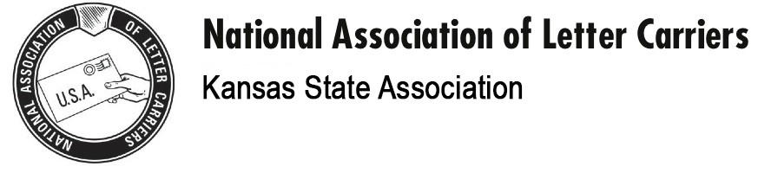

HOLUB FAMILY SCHOLARSHIP APPLICATION

Applications for the KSALC/Holub Family Scholarship must have all spaces below completed and must be postmarked by April 1, 2019. The name of the recipient will be drawn on Saturday May 4, 2019 at the KSALC convention. The scholarship award will be open to dependent children age 22 or younger. The applicant must be at least a high school senior entering an institution of higher learning or presently attending or planning to attend an accredited college or trade school. The winner will be ineligible for future scholarships. The check for the scholarship will be made out to the institution the recipient will be attending. An essay of at least 250 words on the meaning of unionism must accompany scholarship applications.

Name of Applicant:

Address:

E-mail Address:

Date of Birth:

GPA:

Name of School:

Name of KSALC Member:

Relationship of Applicant to Member:

NALC Member’s Branch:

Mail Completed Application to:

Andy Tuttle

232 Dakota St.

Lawrence, KS 66046