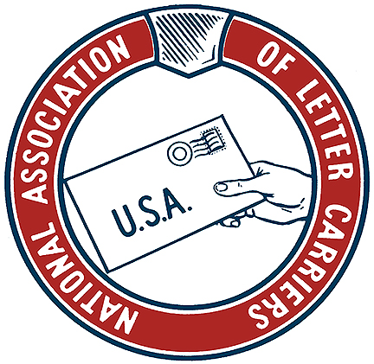

**KANSAS MAIL CARRIER WINTER 2018**

**New Year, New Congress, Same Priorities**

The 116th Congress will be convening within days. They will find themselves dealing with a partial government shut down and divided government when they assume office. There are two new members of the Kansas Congressional delegation, Sharice Davids (D, KS-3) and Steve Watkins (R, KS-3). Both Dr. Roger Marshall (R, KS-1) and Ron Estes (R, KS-4) were re-elected. Myself and a delegation of NALC members will be in Washington DC February 24-28, 2019 to lobby our Members of Congress on important interests to Letter Carriers, the USPS, and the American public. We successfully played defense during the 115th Congress and now we need to seize the momentum.

As always, foremost on the NALC legislative agenda during will be to enact meaningful postal reform. The last time there was significant postal reform enacted it was the Postal Accountability and Enhancement Act (PAEA) of 2006. They really got that wrong and the USPS has suffered under that bad legislation for the last dozen years. It has caused problems both seen (massive USPS debts caused by a crippling and unnecessary requirement to pre-fund retiree healthcare benefits, closed facilities, reduced service standards) and unseen (the inability to invest in and maintain our own infrastructure).

Any meaningful and effective postal reform needs to start with correcting the pre-funding requirement. That requirement is the source for most all of the problems that we face both short term and long term. The business of the mail is actually still doing pretty well. However, when the USPS begins every year over $5 billion in the hole, it’s hard to turn a profit. The press has for the most part been very lazy in its reporting on the USPS. The press focuses on debt without reporting on the cause (and stupidity) of the debt.

I recently had a conversation with a very wise veteran letter carrier. We spoke about the fact that we are both closer to the ends of our careers than the beginning. We discussed what the future will bring for letter carriers, the NALC, and the USPS. We talked about what our concerns are as letter carriers and how they differ from those who entered the USPS in the last decade.

Clearly, letter carriers who begun their careers in the last decade began as TE’s and/or CCA’s. They earn less, pay more for FERS retirement benefits, accrue less time towards those retirement benefits since their time as a CCA counts for nothing. These are huge issues and those carriers have a right to be pissed. Soon they will represent a majority of NALC members and their experience and unique concerns will shape the future for all of us.

Those of us who came in under the old system never had to worry about our pay and benefits. We got a pretty square deal. The new generation was forced to struggle much more—toiling for years under a lower wage structure with fewer benefits that they pay more for. The inequality was lessened in our current contract but the gap still remains. As long as it remains there will be issues related to it and those letter carriers have a right to be upset. The NALC will have to reckon with the fact that their needs and wants are different than what the needs and wants of the membership once were. The nature of our job and the business of the post office have changed and so have the composition of our membership.

Not a day goes by when there isn’t video of a letter carrier doing something they shouldn’t be doing: throwing parcels, having accidents, relieving themselves in a public place, getting a DUI, running drugs, throwing away mail. We all need to realize that we are constantly under surveillance in America in 2018 and we need to act accordingly. From doorbell cams, to security cams, to the GPS in our scanners, we need to realize that it’s not just us out there. Big Brother truly is watching. Act accordingly because when caught you don’t just bring disrepute and disgrace to yourself, it shines a negative light on all of us. Take pride in our uniform and realize that it is an honor to wear the USPS eagle.

**Andy Tuttle**

**KSALC President**

**~An injury to one is an injury to all**

**Welcome 2019!**

Do you make a New Year’s Resolution? The end of one year and the beginning of a new year is generally a time for people to reflect on the past and think about changes they would like to see in the upcoming year. Many people will make New Year’s resolutions. Commonly, these resolutions center on improving one’s health or financial situation. When thinking about ways you would like to better your life this year, remember your job and the benefits the union has fought for and how this affects every aspect of your life.

Make a resolution this year to increase the impact you personally have on your union. You do not have to run for an office. Nor do you have to commit to giving away all your free time. Little changes make huge impacts. There is a plethora of ways to give back to your union without committing to a huge amount of time or money. One of the easiest ways would be to pledge to attend more branch meetings. If you attended two meetings last year, commit to four meetings in 2019. Sign up to be on a committee. Many branches consist of a handful of people who end up doing 90% of the work. By making a commitment to be on a committee, whether it is for MDA fundraising, helping with the branch picnic, Food Drive, Labor Day activities or the holiday parade, you are contributing to the good of your union and helping to spread the work out more evenly. Volunteer to mop the floor of the union office or take the trash out. A few hours from a number of people makes a huge difference.

Another way to give back would be to sign up for the Letter Carrier Political Fund (LCPF). Some people give as little as one dollar per paycheck. Others give $20 or more per paycheck. Five dollars is the most common amount. This amounts to $2.50 per week or fifty cents per day. The presidential task force has suggested taking away our rights to bargain for our wages. This money helps educate our people in Congress as to the issues letter carriers face, so they can make informed decisions. Just as you have insurance for your vehicle and home, this is insurance for your job. Commit to a small bimonthly donation in order to keep the benefits for which we have fought so hard to win. It is easy to sign up. Every issue of the Postal Record has instructions. Contact any member of the KSALC board if you need assistance. We are always eager to help. You can sign up to have the donation taken straight from your paycheck, just like your dues. LCPF is necessary because it is illegal for union dues to be used for political purposes.

Our jobs, and the benefits for which our union fights, affect every aspect of our life. Instead of complaining about what you do not have, I challenge you to make a firm commitment to making your union stronger, no matter how small a commitment you are prepared to make.

I hope that you will look back on 2019 with pride at the difference you made.

**Michelle Jellison**

**KSALC Vice President/Director of Education**

NALC BRANCH 1018 INSTALLATION DINNER

**BRANCH 1018 INSTALLATION DINNER MANHATTAN, KANSAS**

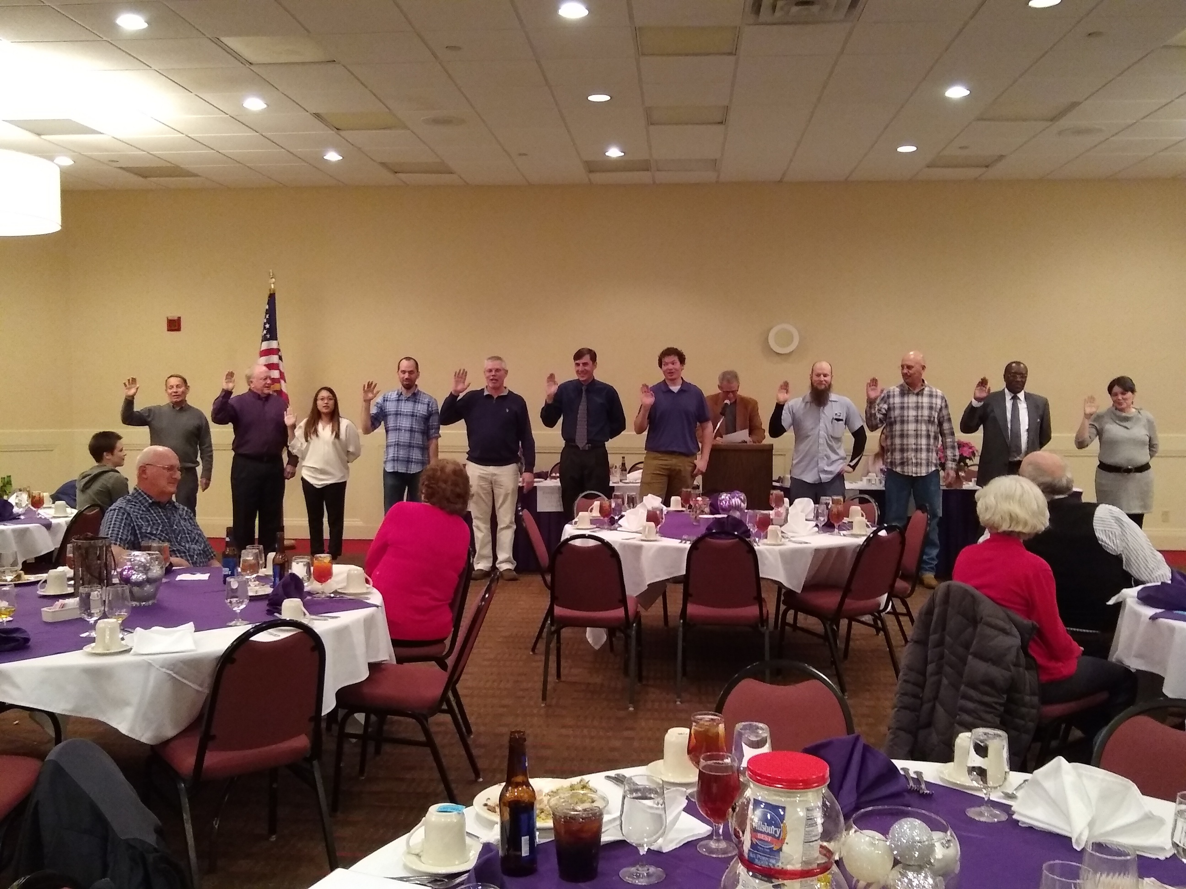

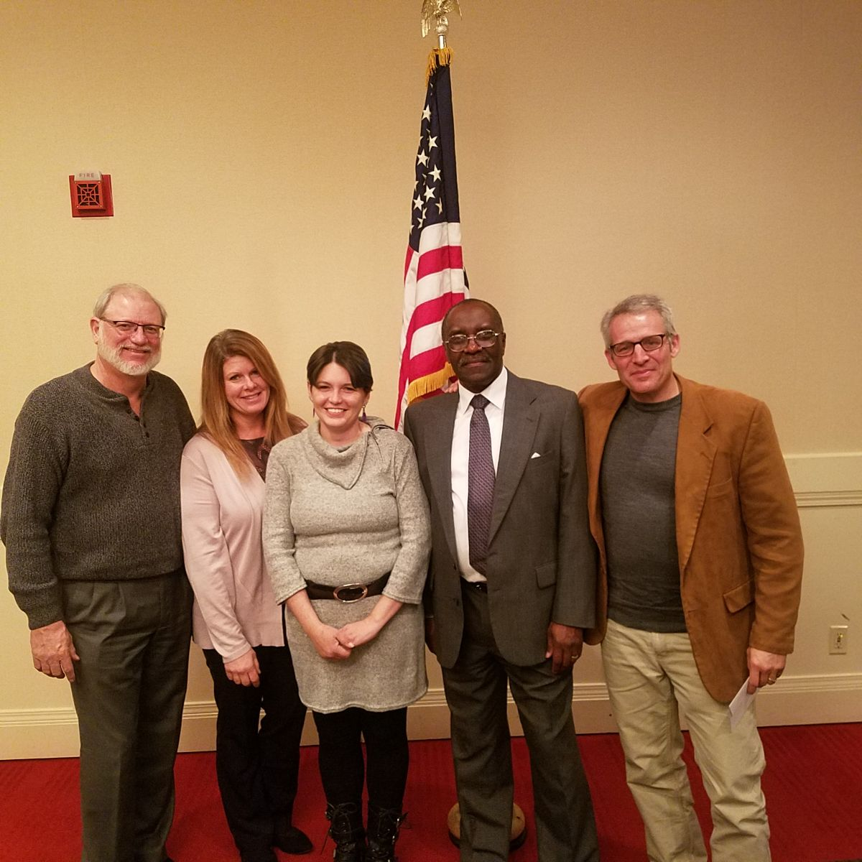

**RETIREMENT: CAN I; WILL I; DO I WANT TO?**

As your State Association Director of Retirees, I get loads of questions about should someone retire (I know this is where you say “DUH!!!”—after all he is the Director of Retirees) but the questions that I get show that we don’t have the enough information out to our Carriers so that they can make that decision. Believe me, the information is out there, we just need to let our members know where it is. We have FERS and CSRS booklets available for our members so they can see what they need to do to get ready to retire. We have pamphlets that also give additional information on this topic for the asking. But let’s look at some beginning subjects that you may want to consider when thinking about retiring.

1) Are you eligible to retire? CSRS has minimum age and years of service: starts at 55 years old and 30 years of service. FERS uses a minimum retirement age (based on when you were born) and years of service. Both types of retirement are based on creditable service. There can be some confusion here because and PTF time that is not a full year may not be counted as a year and could set your actual service time back. LWOP usage can also cause problems with service time because if you use over 6 month of LWOP, you can’t count that year in your total service time (Both cases can be counted only as the actual percentage of the year you worked.

2) Will I make enough to retire? This depends on you and what you want to do. Do you want to retire and work part time; retire and not work; retire and travel; all of your plans must be taken into consideration. To get start here in finding out how much you will make you need to go to Lite Blue and under retirement, request an annuity estimate. They will ask you for a time of retirement (usually a month and year). You pick a month in the time frame you are considering retirement and request an estimate. You can request 1 estimate per day and you have to come back in 24 hours to get the results. Now this is just an estimate for your annuity. If you are CSRS, then this is your entire retirement from the Post Office. You must also consider Social Security (if you qualify) and any investments you may have. For FERS, your estimate is for your annuity only. There are 2 other legs to this retirement. Social Security and Thrift Savings plan. You need to look at those areas to get a true picture of what you will get in retirement as well as any other investments you have. This is why the annuity for FERS is substantially lower than that of a CSRS retiree.

One of the first things that I urge all considering retirement to do after getting the estimates is to talk to your spouse and then your financial advisor to get a picture of where you stand. You need to have a budget made out to showing how you want to live in retirement (travel, work part-time etc.) so you can see what you need to live the way you want. Once you do this, then you can go the questions of: CAN I? WILL I? DO I WANT TO? So you see why I get these questions over and over. They are important and impact on your retirement. Remember: RETIREMENT is not an entitlement, YOU EARNED IT BY YOUR HARD WORK! NOW USE IT LIKE YOU WANT!!! Retire well my Sisters and Brothers.

**Mike Wamsley**

**KSALC Director of Retirees**

As most of you have heard, the Senate finally reached the majority with 51 votes on S. Res. 633.  This is a big win for Letter Carriers because the Senate is controlled by Republicans.  Of course, to pass legislation we need both sides of Congress. So, with H. Res. 993 in the House which has already reached a majority with currently 239 it shows that there is solid support in Congress to keep the Postal Service free from people who want to dismantle it by privatizing it.   The White House Postal Task Force finally released the report that they have had since its August 10thdeadline.  The report calls for massive service cuts allowing The Postal Service to reduce the frequency and quality of delivery services, which would result in huge job losses for city letter carriers. The one positive was that it finally would address the Pre-funding Future Health Benefits dilemma.  Please continue to follow the information out there.  It’s during these times of the year when legislation gets snuck in because people get busy and don’t pay attention.  We must always be watching out!!!!

**Chris Mayo**

**At-large LCCL**

2018 is coming to a close and 2019 will be a year probably like no other.  One thing I'm sure of if nothing else. America will survive the political buffoonery we saw in 2018 and so will the NALC.  My opinion is politicians seem hell bent on screwing up the country as do postal management the post office. In spite of their efforts, we are still here, and by striving to do the right thing, we always will be.

As always, if you like eggnog, try it with your favorite rum. Mine is coconut, relax a little, and be thankful to be an American and a job with benefits that most don't have. The ole timers in our office use to say it's better to be safe than letting your feet be fleet on the street. Amen! Merry Christmas and Happy New Year.

**Terry P. Miller**

**2nd District LCCL**

**A fair day’s wage for a fair day’s work; it is as just a demand as governed men ever made of governing. It is the everlasting right of man.**

**--Thomas Carlyle**

Over the last 242 years, critics and advocates of our political system have said “It’s Broken”. Maybe it is, maybe not. I’m not nearly smart enough to answer that question. What I do know is this. “It’s our system and it’s not going anywhere anytime soon. No matter what the current occupant of the White House believes. He wants to be a dictator emperor & king, all rolled into one. We’ve seen this act before, 45 years ago. I remember coming home from school and turning on the TV, (all 3 channels) and finding nothing on but the coverage of Congressional hearings on the Watergate break in as well as the subsequent conspiracy. Those in power forgot the golden rule, “The Cover-Up is Always Worse Than The Crime”

A popular president tried to circumvent the system and the law.

Flash forward to December 5, 2018. Ring any bells? Sound familiar? Is it snowing hard enough, do you get the drift?

Have you read the news today? You should have. Did you check out the post the Andy Tuttle posted this morning on the KSLAC Facebook page? I did and it was interesting, to say the least. The report from the “White House Task Force” was released this morning. And by “White House Task Force” , I’m referring to the “Donald”

They ignored the major issues and decided that the way to save the Postal service was to lower service standards, cut pay and benefits. If this is a shock to you, you have not been paying attention to our message for the last two years.

And now you’re thinking, great Greg, what does “Broken” and our current political state have in common?

Here it is. It’s not broken. It has evolved and metastasized to this point in 2018. The political pendulum always swings from left to right, then left, then right, you get the idea. The problem is this, how much damage can be done the to NALC, our jobs and future while the pendulum is to the right? Read the report. You won’t have a career to worry about if this B.S is acted upon.

Is there hope? Yes. In the Kansas 3rd District, which encompasses all of Johnson , Wyandotte and a bit of Miami County, a Democrat, Sharice Davids, was elected to serve in Congress. You ask how big of a deal is that? It’s huge. The 3rd is 82% white, 8% black, 6.8% Hispanic, 2.6% Asian, .06% other. Ms. Davids represents the .**06% other** in the 3rd. She is a member of the Ho-Chunk Nation, A Native American tribe in Wisconsin.

How did it happen? Good question. A good message, sure. Cash. Lots of it. That’s where we’re at in 2018. How do you get your message out? Cash. How do you beat the other candidate? Cash.

There, I said it. As Puff Daddy said, “It’s About the Benjamin’s” I can write another 5 pages on the virtue of a viable candidate, but the bottom line is: Cash!. We need it. The Letter Carrier Political Fund needs it. And we need it now. You know what the first job of a newly elected official is, “Get Re-elected”. That started two weeks ago here in the 3rd. She won’t take office until January 3, 2019, but I guarantee, she has already formed a committee to re-elect.

Your contributions will allow the LCPF to contribute to candidates that support NALC and postal reform.

**Greg Wilson**

**3rd District LCCL**

     Greetings from Newton!  I hope that with all the hustle and bustle of the Christmas holiday that you have time to eventually slow down and enjoy time with your friends and family and have a Merry Christmas!

     I spoke with Roger Erickson from Congressman Estes' office.  I shared with him a couple of items that we would like for him to share with the Congressman. One is from the business mailer's perspective panning proposals in the White House USPS task force to reduce service and to overhaul rates. The coalition for a 21st century postal service leaves no doubt that any postal reform needs to begin with the addressing of the pre-funding mandate beings that is where the debt comes from.

     The other item is how badly the task force proposals would harm rural Americans with the higher prices and reduced service.  Roger told me that when you talk rural American it hits home with Congressman Estes.  I told him that if the business community opposes these proposals and if it would hurt rural Americans than surely these aren't good ideas for Kansans.

     He told me that he would share our concerns with the Congressman and that we would talk again soon. A big thank you to all the letter carriers for all the hard work that was done during the Christmas holiday.  Merry Christmas and Happy New Year!

**Bob Davidson**

**4th District LCCL**

https://ssl.gstatic.com/ui/v1/icons/mail/images/cleardot.gif