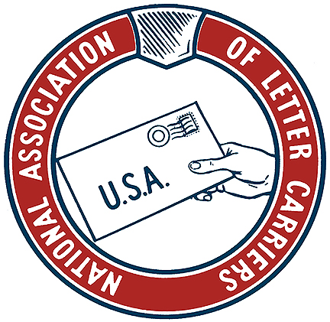

**KANSAS MAIL CARRIER**

**Fall 2018**

**ELECTIONS AND REJECTING PRIVATIZATION**

We have an election staring at us in the very near future. I hope that you all have voted. It’s our most sacred right and duty within our representative democracy. You can’t win if you don’t play.

On October 8 the NALC and other postal unions rallied against proposals to privatize the USPS. Rallies were held across the Nation including events in Topeka, Wichita and Kansas City, Missouri. So many gave of their own time to add to our collective voice when they could have stayed home and enjoyed a paid holiday. Special thanks to Michelle Jellison and all those from the NALC, APWU, and other non-postal unions who showed up and made their voices heard loud and clear.

Why is privatizing the USPS a bad thing for America? Well, we know for a fact that privatization of Western European and Asian postal services resulted in higher prices for businesses large and small as well as every day mailers, service was reduced through less frequent delivery and increased use if centralized delivery, and jobs, wages, and benefits were slashed within the now privatized postal services. But a small concentration of wealthy interests made out quite nicely at the expense of everyone else in those countries.

The Trump Administration officials who have lent their names and support to this scheme are Treasury Secretary Steve Mnuchin and OMB Director Mick Mulvaney. The report they have issued to date uses the privatized postal services in European Union and Asian nations as a model for privatizing our own postal service. The irony here is that the America First crowd is using the EU and Asian nations as examples of what America should aspire to! No, we are the United States of America, we lead—we don’t follow.

The publicly owned USPS is a vital and irreplaceable part of the American infrastructure. Businesses large and small rely on our inexpensive and reliable service to enhance and grow their businesses. Private citizens across the nation rely on us to deliver their prescriptions and consumer goods, to receive and pay their bills, to provide their periodicals and to provide that service each and every business day—to their front doors!

I also want to recognize Branch 486 President Brad Johnson, steward Mark Turner, and 1st District LCCL and Branch 486 steward Kent Chestnut for meeting with staffers from Rep. Roger Marshall’s office recently. Rep. Marshall has supported the NALC on our most important House Resolutions including 6-day delivery, door delivery, and opposing privatization. That support is due in large part to the efforts of Brad, Mark, and Kent and the relationship they have built with his staff.

Our busiest season is now upon us. Political mail volume has increased dramatically in recent election cycles. This is emblematic of two factors off the top of my head. First, the fact that political candidates are awash in money like never before and they’ve got to spend all that cash on something. Secondly, political mail works. Candidates, political parties, and interest groups know that spreading their message through the USPS is effective.

After the election we enter our prime time for the holidays. Please take the time and make the effort to work safely. Many of us will find ourselves delivering after dark after already working long hours during the daylight. While the USPS doesn’t always practice what they preach as far as safety goes, we who actually do the work can never lose sight of our responsibility to work safely for our families, the public we serve, and ourselves.

Andy Tuttle

President KSALC

#NotForSale

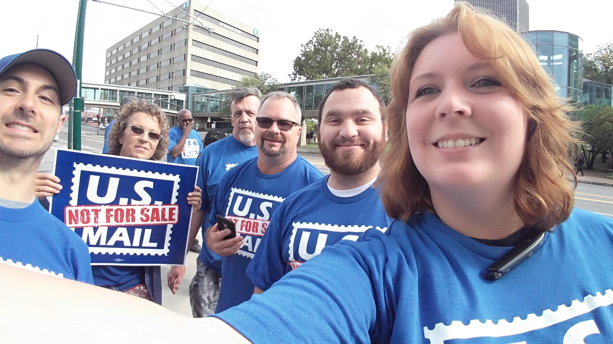

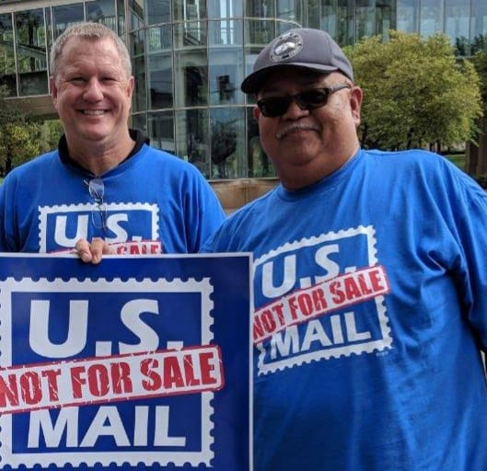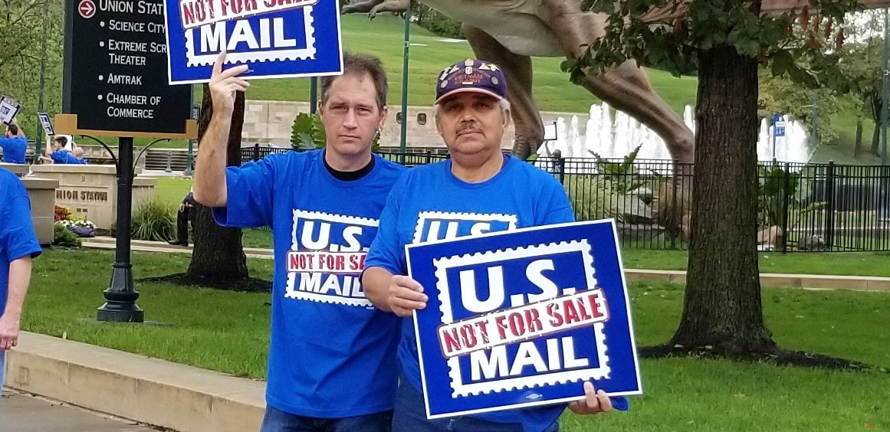

**ACTIVISM AND MEMBER ENGAGEMENT IS KEY**

Monday, October 8th, we held the *U.S. Mail Is Not for Sale* Rally in Topeka. Although the day started out rainy, it cleared up just before 10 am, in time for the rally. We had t-shirts and signs for everyone who came out to support us. And what a turnout it was! 50 - 60 people come out to help us. Members and family of Topeka’s Branch 10 and Lawrence’s Branch 104 gathered in front of the downtown Topeka post office and even Branch 1018’s President Jennifer Ryland drove in from Manhattan. Along with letter carriers, Topeka’s APWU Local #270 and Western Area Supply Center Area Local #6862 (from the Material Distribution Center) came together in force! WASC #6862 stole the show when they came marching down the street with their banner chanting “US MAIL IS NOT FOR SALE!”

Reaching out to my labor contacts across the city and speaking about the rally at meetings paid off. With help from Kansas AFL-CIO, Topeka Federation of Labor, Working Kansas Alliance and United Way, we had members from several non-postal unions show up to support and help us spread the word, including: the United Transportation Union, Northrup Grumman, IBEW Local #304, and Teamsters #696.

Why is this significant? We are not in this fight alone. It is not just about us. This is a fight for labor and the middle class. We need to stand together with all unions to have our collective voices heard.

Unions are not a spectator sport. It is not enough just to pay your dues. Unions require member participation. A union grows in strength as more members actively participate. Just like in sports, you are not in the game if you are sitting on the sidelines. This is your future that is being impacted, and that of your children. We all do so much so that our children have a better life. Why do we not take action to guarantee there will be good jobs available for them?

Being involved does not have to mean holding an office or being a steward. Taking two hours of a day to attend a rally can make a huge difference. These rallies only happen when there is a real threat looming. The last rally was several years ago. How many people realize the threat of privatization?

President Trump created a task force to evaluate the postal service’s operations and finances. Although the results will not be officially released until after the elections, the task force’s plan calls for eventual privatization. This places USPS’s universal service obligation (which requires it to deliver to every address in the nation for the same low price) at risk. Privatization would sacrifice a fundamental public service that is in the Constitution and instead line the pockets of the highest bidder. American businesses, particularly small and medium-sized businesses, the elderly, those in rural and lower income areas would be harmed. The nation’s election system depends on a public USPS as tens of millions of people vote-by-mail or through absentee ballots, with that number growing daily. Veterans would also take a hit, as the postal service is the largest civilian employer of military veterans.

At the rally, we handed out flyers explaining the issue of privatization to those walking and driving by. No one was familiar with our plight. We must continue to spread the word. The people I spoke with were very disturbed by what they were learning. They were not aware of this threat. We cannot sit by idly and expect this issue to disappear or for someone else to take care of it.

We had members of other unions supporting us at our rally. We should also be backing them up in their fights. Yet most of us will not take one hour a month to attend a union meeting. Or go to the branch picnic. Or the golf tournament, bowlathon, etc.…

We will never live in a trouble-free world. Eternal vigilance is necessary. It is worth it to be involved. And, you never know, you just might have fun. Thank you to everyone who came out!

Michelle Jellison

Vice President/ Director of Education

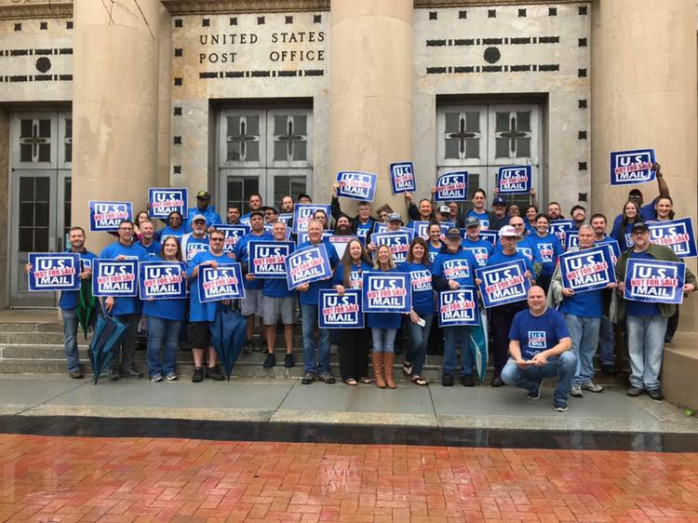

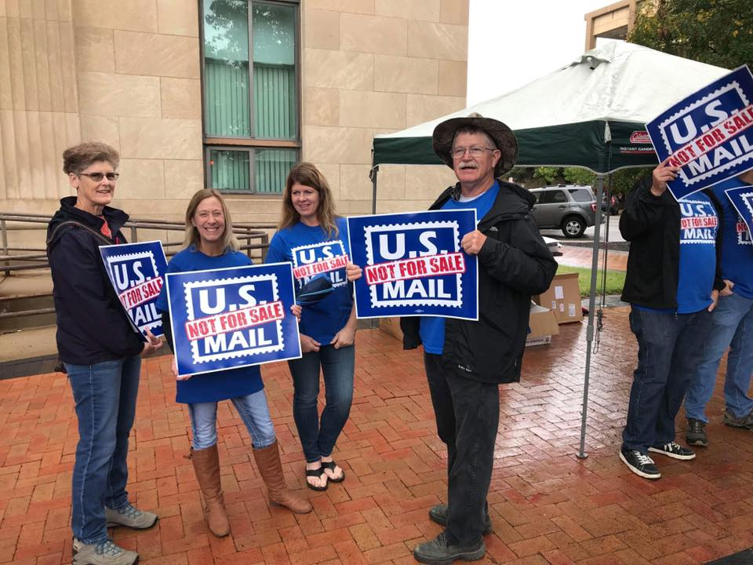

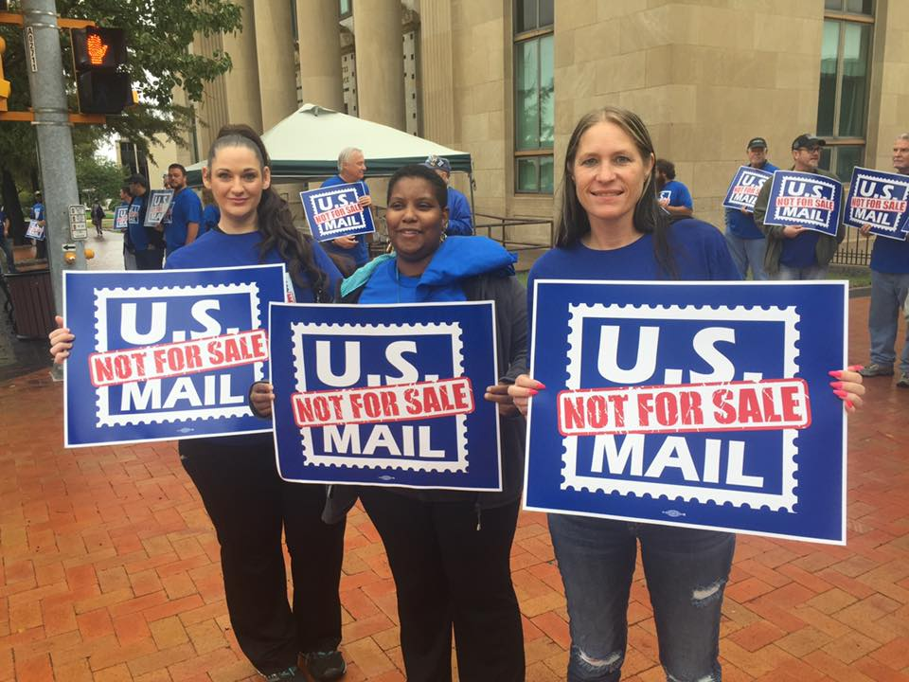

**RETIREMEMENT IN 2018 AND BEYOND!!!**

Hello my Union Brothers and Sisters. Here we are in 2018 and just about every Letter Carrier in the USPS has a goal of one day being able to retire and enjoy life after work. **RETIREMENT IS NOT AN ENTITLEMENT!!**! It is a benefit that we work long hours through rain, snow, sleet, hail, tornados, hurricanes, summer sweltering heat, family crisis, job crisis, injury, illness, and a couple hundred other items that affect our ability to work. It is a **BENEFIT** our Union has negotiated for us so that we can look forward to someday, not having to work ourselves to death. It is part of your **BENEFIT PACKAGE** that you earn with your paycheck. **IT IS NOT AN ENTITLEMENT!!!**

However, **YOUR RETIREMENT IS NOT GUARANTEED!!!** Your retirement is debated, talked about and attacked multiple times each year. Those who are on FERS (which started in the 1980s) have had changes made to their plans by our congressional leaders. In 2013 and again in 2014, Congress raised the new workers contribution to their retirement. This means that new Carriers who began working after 2013 and after 2014, had to pay more of their paycheck into retirement than did their Sisters and Brothers who began working before those times. They pay more but don’t receive any additional benefits. It costs them more than it does for the older carriers and for doing the same work.

Why is this important? Because this year, our retirement was again attacked! The administration, in its proposed budget, wanted to change the retirement structure for FERS and the COLA (cost of living adjustment) for CSRS. What did they want to do with FERS? 1.) They want to change your high 3 year average to a high 5 year average. This lowers you overall average and pays you less in retirement. 2.) They want to do away with the matching fund in your THRIFT SAVINGS PLAN. Again, this lowers your amount available to you in retirement, significantly. 3.) In FERS, if you retire before age 62, you receive a FERS supplement (approximates the amount you would receive from Social Security at age 62—early withdrawal) paid by OPM, not Social Security. This supplement ends at age 62 when you can start your Social Security payments. The plan here was to remove this supplement entirely. Again, the amount of your retirement money goes DOWN.

Are you seeing a pattern here? The present administration is trying to get out of the RETIREMENT BUSINESS! Like most of the private corporations and companies, your retirement is now on your shoulders almost entirely. Now, I must say that this budget did not pass in Congress, due to our friends (Senators and Representatives which our Union supported in their elections or reelections) telling the current administration an emphatic NO! But that was not the end of the game. The President instructed his Director of Office of Management and Budget (OMB) to initiate conversations with Congressional Leaders to begin proposing legislature that would do this to you. That is still ongoing. And now the President has put a commission together to look at **PRIVATIZING THE USPS.** Granted that this is because of his ongoing feud with Jeff Bezos and Amazon, but it still directly affects the Letter Carriers. Again, our friends in Congress are rallying to our defense but we will need all the help we can get.

Which brings me to **YOU.** What can you do? I know that politics is a very touchy subject. But look at it from your JOB and RETIREMENT side for once. In November, all Letter Carriers must vote. Choose the candidate who supports your job. Of course, it is not that simple because of the other issues in the election but think of it like this: If I have a good job and retirement, I can make my stance on issues known as those issues come up in congress. If I don’t have a job and/or retirement, then my ability to make my opinions known to our Congressional Leaders is impaired. I am too busy thinking about how I can stay fed, clothed, housed and the same for my family, to be involved in our Country’s policies. VOTE FOR THOSE WHO SUPPORT YOU AND YOUR JOB AND RETIREMENT.

Mike Wamsley

Director of Retirees

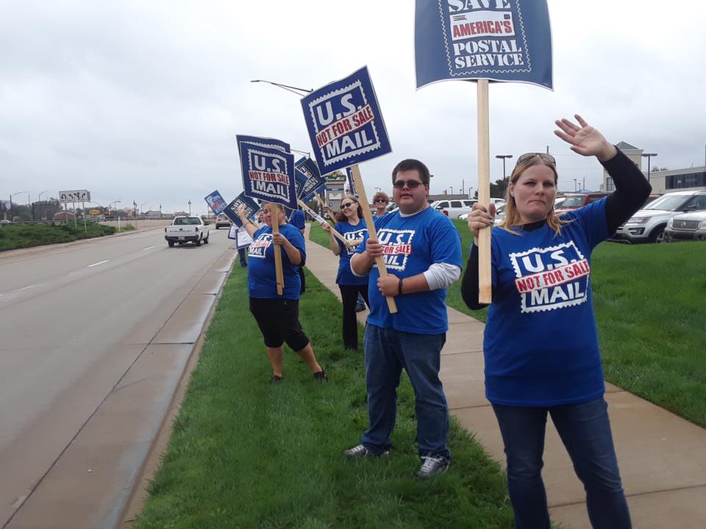

**Greetings from the Big 1st District**

I am sure many carriers get tired of hearing State Officers talk about the importance of giving to the Letter Carriers Political Fund. Back several years ago, National president Young changed what the responsibilities of the state associations were, from education to legislative. Andy and all past presidents since this change have been tasked with getting carriers to understand the importance of legislation to our survival. The state associations are always being asked what we are doing to get more carriers involved with legislation, to help save our jobs from the many bills presented in congress. Sometimes I believe that our national officers don’t understand the divide in this country over politics. I know many carriers that will not give to the political fund because it gives money to both political parties that support our issues, and they absolutely will not give to a fund that would help the other party get elected. They do not put their job above all else, and will not give even if it will help save their pay, benefits or even their jobs. I don’t really feel that ether party is doing what is best for me and my family all the time , so I have to do what I can to look out for me and my family .I gave because I know that this money helps get carrier’s interests heard by people that control what can be changed or taken away. As I write this article the midterm elections will be here in a few weeks .we have a president that created a task force to look at the Postal Service, and then did not wait for their report before stating that the Postal Service should be privatized .this should worry every carrier, because if we elect a few people that feel the same way, we have a president that would sign it into law. If you feel that protecting your livelihood is the most important thing you care about then you should want to give to the NALC political Fund.

Kent Chestnut

1st District LCCL

**YOUR RETURN ON INVESTMENT DEPENDS ON YOU**

Today’s topic is investing. Aw snap, I just lost half of you. Rest assured, I’m not going to ramble on about APR vs APY rates, assets, expenses, blah, blah. blah. As the Secretary Treasurer of the KSALC, it is my brother, Ike Donn, whose job it is to provide you the numbers and verbiage to put you to sleep.

My job as a KSALC Officer is to wake you up. So, let me begin by throwing a bucket of cold water over your head.

As I told my daughter for years, “Be aware of your surroundings” Not wanting to scare her to death, I taught her to look all around. No matter if you’re walking, jogging, driving or hanging out with friends. Be aware of any potential threats. Every parent out there reading this can relate to that advice.

So here is the question. Are you following your own advice? Are you, as a member of the NALC, The KSALC and a proud member of your local branch, aware of your surroundings? And I know the next statement, “Yeah, Greg. I know my route. Or I know my routes if you’re a T-6.”

Time to think a bit outside that box.

Are you aware of your surroundings?

* Do you know the current president wants to privatize the USPS?
* Do you know the current president wants to curb your wages?
* Do you know Union jobs are under attack in all 50 states?
* Do you know USPS and NALC are targeted by all 3 branches of the Federal government?

If you don’t know, the answers to all the above are **YES**.

So, here we go back to the investing topic. What are you doing individually or as a branch to recognize these threats? We can’t react. A reaction puts you on the defensive. We must ACT. The best defense is a good offense.

Are you investing in your future? Are you investing in your daughter’s future? Are you investing in your granddaughter’s future?

You can invest in your future in a couple of ways.

* Sign up for the 12-hour ODL list.
* Get a part time job.

Those are short term solutions. What about the long-term solution?

* Come out and stand with your sisters and brothers on 10/08/18, to say the U.S. Mail is not for Sale. A National Call for Action Day.
* Send an email to your House Representative or the 2 US Senators from Kansas to support legislation opposing the privatization of the USPS.

Some days that is too much. Because, you have lives. You have commitments. Soccer on Saturday afternoon. Cheerleading practice. Football games. Baseball tournaments. And we have not begun to speak about your own life. When you can spare it, maybe throw a few darts at the local pub, volunteer at the local food bank, religious services on whatever day you worship or maybe, just maybe, a night with your family. Or if all the planets are aligned correctly, an evening alone with that someone special in your life. And because I live in the Kansas City area, maybe a chance to talk about the Chiefs or Royals with my fellow Officers or Stewards, rather than the daily B.S. of the USPS. Like you, I relish those moments in my week. They come few and far between.

So now you find yourself between a rock and a hard place. What do you do? Very simply, invest in “job insurance”. By contributing the Letter Carrier Political Fund (LCPF), you are investing in your future and your family’s future. Don’t have time to send an email. Great. I get it. Already have plans for the day on 10/08/17. Got that too. Then decide right now to go on the offensive for your career and contribute $5.00 every 2 weeks to the LCPF. It’s easy, it’s simple. As members of the NALC, we all got 2 COLA raises in 2018. We’re due for a 2.1% increase on 11/24/18. You’ll never notice the deduction after your raise in November. It’s easy to sign up. It’s even easier if you call Andy Tuttle and have him help you.

At the 2 year mark of Trump, mid-term elections are around the corner, we have seen this administrations agenda. And what they want and what the NALC, KSLAC and your local branch want are two completely different things.

Greg Wilson

3rd District LCCL

**Greeting from Newton!**

I hope you all had a great summer and are doing well. I visited with Roger Erickson from Rep. Ron Estes’ office (KS-4) on a couple of occasions recently. I spoke with him about H. Res 993 and the importance to our district of Rep. Estes signing on as co-sponsor. Roger relayed that information on to Rep. Estes. Roger knows of the importance of not privatizing the USPS as his son carries mail. As of this writing Rep. Estes has not signed on. I will continue to follow up on this. As the holidays approach enjoy each one and be safe!

Bob Davidson

4th District LCCL

**ALL HANDS ON DECK!**

Thanks to everyone who came out to support Letter Carriers on the Day of Action on Columbus Day.   The weather didn't spoil the turnout and we had a Special Guest with Representative Emmanuel Cleaver who is also up for Re-election.  Although we have more than 218 Co-sponsors for HRes 993 we still are short in the Senate.  Please continue to push on passing it to give Letter Carriers a solid stance on what Congress wants for a vibrant Postal Service.

HRes 993 237

SRes 663 43

And finally,  Make sure that you Vote!

 ALL HANDS ON DECK...

Chris Mayo

At-Large LCCL

**Things all members can easily do that strengthen our Union.**

1. Make sure your local and the national has your email and cell phone number to stay connected and active.  
2. Go to your union meetings and union activities.  
3. If you are a retiree, help start or become a member of a retiree chapter in your local or state, and/ or offer to mentor a young postal worker.  
4. Volunteer to help the union – there are many kinds of activities to choose from, find something you like, try something new.  
5. Be the eyes and ears for your union representatives on the workroom floor, be a witness for your coworkers who are being harassed, or stand up for yourself and get the union representative involved when harassed so that we can work together to make our workplace healthy and safe.  
6. Help to mobilize other members in your work area and share issues of concern. Ask your local union to provide educational materials on workers’ rights. Help get members to stand together in your work section.  
7. Help communicate our issues with other community organizations who can be an ally in our fight to stop privatization and help us expand postal services for the good of the community.  
8. Get involved in the political process, build a relationship with new politicians, help get candidates in office that will fight privatization, support expansion, and support vote by mail.