**KANSAS MAIL CARRIER SUMMER 2018**

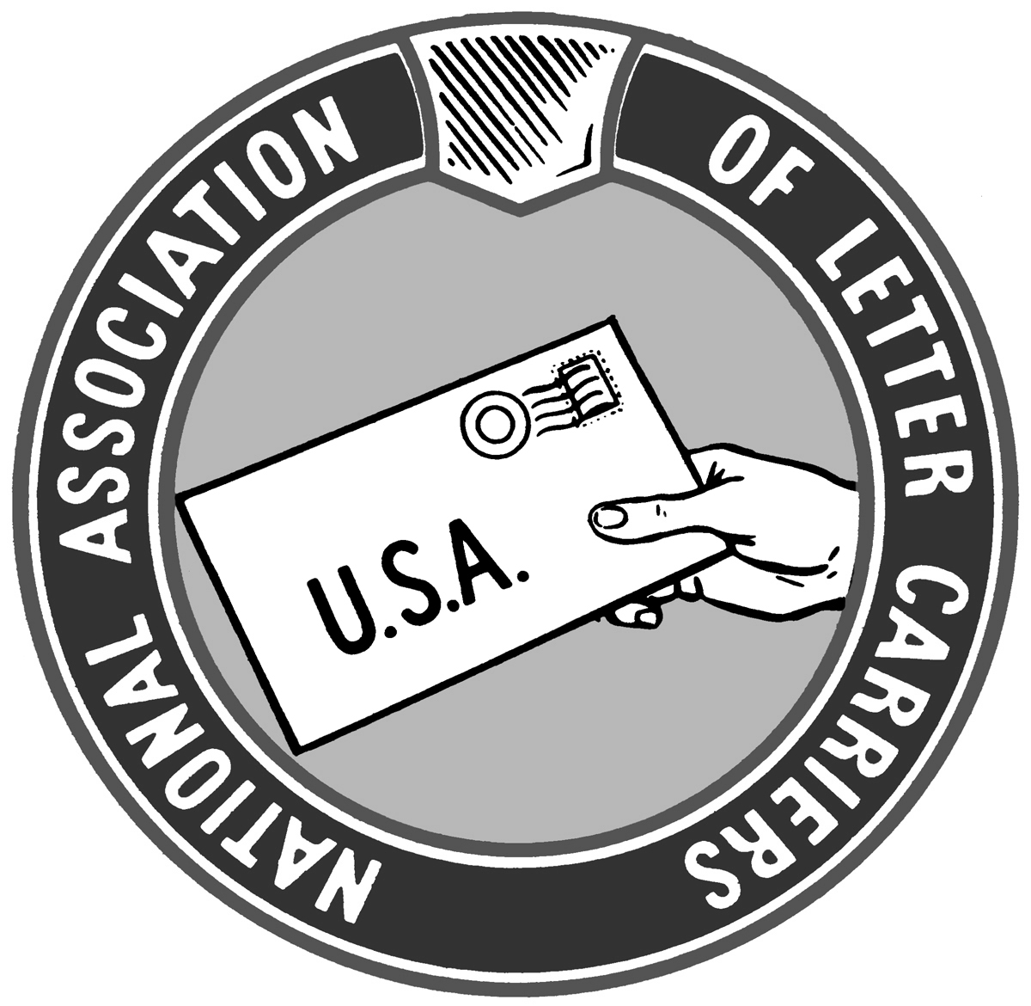

**VISIT US @KSALC.ORG**

**President’s Article, Andy Tuttle**

One strange thing about the postal legislation is that there are always a lot of grand plans and lots of noise, and yet nothing meaningful happens. The last major piece of postal reform legislation was the disastrous 2006 Postal Accountability and Enhancement Act (PAEA)which continues to hammer the USPS without end. Currently there are two bills in either house of Congress, HR 756 in the House and S. 2629, the Postal Service Reform Act of 2018, in the Senate. Sen. Jerry Moran is an original co-sponsor along with Sen.’s Carper, McCaskill, and Heitkamp. These bills are much better to the post office and its workers than past postal reform legislation introduced by the likes of Rep. Issa. Many serious question remain with both bills especially regarding Medicare integration for postal retirees. In reality neither bill is likely to gain much traction during the remainder of the 115th Congress.

The noise this time is unmistakable. President Donald Trump has put the USPS front and center. By tweeting angrily at Amazon and Jeff Bezos (who owns the Washington Post as a hobby) he used the USPS as a proxy in this battle. He also mistakenly stated that the USPS loses taxpayer money. He then empaneled a committee consisting of Treasury Secretary Steve Mnuchin, OMB Director Mick Mulvaney, and OPM Director Jeff Pon to study the USPS business model and practices. The committee is to release their findings and recommendations by August 10, 2018.

Then on May 4, 2018, OPM Director Pon, who also serves on the USPS committee appointed by President Trump, wrote to House Speaker Paul Ryan seeking dramatic increases to employee FERS contributions corresponding with huge reductions to FERS and CSRS pensions. We narrowly escaped a similar fate during the budget battle last fall. Most letter carriers don’t realize how close we came to taking a huge hit to our retirements. The plan to make federal employees pay far more into our FERS/CSRS retirements and collect far less in retirement keeps hanging around and has widespread support in conservative circles. It must always be taken seriously..

The regressive elements in proposed CSRS/FERS cuts include:

---Increase employee contribution to FERS from current percentages of 0.8, 3.1, or 4.4 to 7.25% over the course of several years. This would cost letter carriers thousands of dollars a year, every year for the rest of our lives.

---Eliminate COLA for FERS retirees and greatly reducing COLA’s for CSRS retirees. Again, costing letter carriers thousands of dollars, every year, for the rest of our lives.

---Eliminate Social Security supplement paid to eligible annuitants who retire before age 62. This would cost eligible retirees tens of thousands of dollars every year until they turn 62 (provided the age for Social Security eligibility isn’t also raised).

---Calculate CSRS and FERS retirements on High-5 earning years rather than the current High-3. This would cost letter carriers thousands of dollars over the course of our retirements.

To me it also embodies the petty nature of the attempts to nickel and dime millions of federal retirees and future retirees. The savings to government are minimal in the big picture but would come at a great price to a large group who chose careers in public service.

Things got even crazier on May 25, 2018 when President Trump issued a series of three Executive Orders aimed squarely at the federal workforce. These orders make it easier to fire employees, greatly reduce the amount of time that can on union representation duties, and require existing Collective Bargaining Agreements to be renegotiated. The NALC came out today and announced that these orders will not apply to the USPS and NALC. Still, several million federal employees other than us had their unions gutted by the stroke of one man’s pen.

Then on June 21, 2018 the White House recommended the privatization of the USPS among other changes to government structure in a report overseen by the aforementioned Secretary of Treasury Mnuchin and OMB Director Mulvaney. Thankfully this plan has been widely panned by a large and bi-partisan group of US Senators including both Senators Moran and Roberts of Kansas. However, this proposal once again reinforces the pettiness of the attacks on postal and others in the federal workforce coming from the Trump Administration.

Yet another bomb was dropped on the entire labor movement on June 27, 2018 when the Supreme Court ruled by 5-4 margin in Janus V. AFSCME the First Amendment rights of plaintiff Janus were violated when he was compelled to pay “fair share” fees. While this ruling doesn’t apply to the federal government (which has been right-to-work for decades). Still, many states governments remained “At Will”, where non-members were required to pay “fair share” fees spent on union activities that directly benefit those non-members. Those benefits include Collective Bargaining agreements with the superior wages, benefits, and job protections that they provide an employee. In the Janus ruling, the Supreme Court overturned more than four decades of precedence (in 1977 SCOTUS ruled 8-1 in favor of “fair share” fees in the Aboud V. Detroit Board Of Education).

The upshot is that all state and municipal employees covered by Collective Bargaining Agreements are now RTW. There were also powerful and well-financed business interests manipulating the effort to support Janus. National RTW is funded by wealthy individuals and corporations who oppose unions. They remain behind the scenes, Think tanks such as the Heritage Foundation provided the scholarly veneer to rationalize this act of theft.

The situation is fast moving, more so than ever before. We do have a KSALC page on Facebook and our website, KSALC.org. I do administer both pages and take great effort to insure that the information provided is accurate, topical, and important to know. Please keep yourselves informed. Please get involved. We need each other to do our parts!

**President Emeritus Article**

**June 2018**

I was recently presented with my 40-year service award. With that memory still in my mind, I thought this would be a good time to answer a couple of questions that most of my co-workers have asked. Why would anybody want to work for the Post Office for 40 years and how did you ever make it to 40 without going crazy? The answers are remarkably simple, at least in my own mind.

I have made it to 40 years, and plan to work at least a couple more, because I still feel honored to put the uniform on every morning. Through the years, I have probably served tens of thousands of customers on all the various routes I’ve held. Though they were all different in many ways, they all had at least one thing in common. Some of their most prized possessions passed through my hands. In the early years, I handled everybody’s paychecks and helped get most of their bills paid. But there was much more than that.

I’ve delivered hundreds of babies’ first Social Security cards. I’ve made kid’s birthdays happier by making sure that cards from Grandpa and Grandma got there on time. Christmas wouldn’t be Christmas without that very last present being delivered just in time to be wrapped before making the trip over hill and dale to visit family. I’ve delivered prom dresses and diplomas. College acceptance letters and professional sports contracts. Wedding dresses and that first new car title.

After a tornado in 2008 flattened ¼ of my route, I delivered insurance checks and rebuilding estimates. I’ve had the privilege of delivering letters from soldiers reassuring their families back home they were safe and sound half a world away. I’ve also delivered the cremated ashes of loved ones to their final resting places, including those of one of my own sons. What keeps me something that means the world to them and, after 40 years, I still feel humbled when they tell me they wouldn’t want anyone but me making the delivery.

As to how you make it through 40 years without going crazy, that has a simple answer too. Develop good work habits early in your career. If you get in the habit of doing the things you are supposed to be doing in the way you are supposed to be doing them, your career will be relatively stress-free. Your route counts and adjustments will be fair, and the following expectations will be achievable. If you develop bad work habits and either not do things the way you are supposed to do them or do a lot of things you shouldn’t be doing, then your career will probably be stressful most of the time and you will probably be counting the days until you can get the hell out.

Looking back, I never dreamed I would be delivering mail for 40 years, but I’m sure happy that it worked out the way. Here’s to 40 (months maybe) more!

**Director of Retirees Mike Wamsley**

**RETIREMENT KANSAS**

Hello to all my NALC Sisters and Brothers. Both those who have taken the plunge and retired and those who are still working toward that goal. This is some information for those WANNABE RETIRED LETTER CARRIERS!!! There are 2 forks in the retirement road for Letter Carriers: CSRS and FERS.

CSRS-Civil Service Retirement System is for old farts, like me. It is a defined benefit system where the amount you receive is based on your qualified years of service and your high-3 years of salary. CSRS Carriers can receive Social Security if through other jobs, both before, during and after working for the Post Office, you meet the 40 credit threshold that Social Security requires. However, you will lose about 2/3 of the amount that you would normally receive because you are Federal Worker and covered by the Windfall Elimination Program. This only affects CSRS federal workers.

FERS has been around since the mid-80s. It is made up of 3 parts: 1.) a defined benefit (this part is about 1/3 of the CSRS pension); 2.) A Social Security payment for those retiring at age 62 or higher (if retiring before 62, it has a special annuity supplement to act as the Social Security payment); and 3.) Your Thrift Savings Plan. Again, the amount of your pension depends on years of qualified service and high-3 years of salary. A couple of notes to remember. First, you don’t initially receive Social Security if retiring before 62. That is the reason for the special annuity supplement. Once you get to 62, the supplement drops off and you can start Social Security or you can wait until later to get a larger Social Security payment. Second, the Thrift Savings plan. This is an investment plan with the Federal Government. It has a number of plans which vary in the risk to your investments. The more aggressive the investment, the higher the return but you have to remember it also has a higher risk of loss to the amount you invest. There are very conservative investments in this program that also have very modest returns. The key to remember is that the Post Office will match your contributions to the Thrift Savings Plan, up to 5% of your salary. So, if you aren’t investing that 5%, you are throwing away money from the Post Office. At a minimum, try to make that 5% investment. Again, FERS is made up of all 3 of these parts. You need all 3 to reach your maximum retirement amount.

Here are a couple of suggestions for everyone who wants to retire (either tomorrow or someday!). Get a good financial advisor (unless you are very good at understanding the financial world and know when and where to invest)! Talk to them about your retirement plans—when you want to retire, how much do you need to retire and do the things you want to do, do you want to leave something for your children, and other plans you have made. Talk to your advisor at least yearly to update your plans and get advice on what you need to do to meet your goals. Talk to your spouse, if you have one, about your retirement plans. You can get Survivors annuity for them if you die before them but it does have a cost. Both of you need to be open and honest about your retirement goals.

This is a very simplified look at retirement. You need to take a detailed look at your plans and set you goals accordingly. If you have any questions on retirement that you want help on, call me. I will either have the answer or get it for you. Until then, Happy Retirement.

**First District LCCL**

Greetings from the Big 1st District. I am always amazed that people in government that want Federal Employees to pay more for insurance , Pay more for retirement and get less back and all of the other things that are being proposed all the time by the president or congress ,I am amazed that these people believe they are not federal employees. Maybe the reason is because so many of these people are being bought through campaign donations that they believe they are there to only represent the interests of their rich bosses. The midterm elections will be here soon, and many in congress have chosen not to run for office again. Some of our friends we have had in congress will not be back after the elections. Now maybe some of the Letter Carriers out there are super rich and can buy the people that will see things our way. I don't know of many super rich carriers so I think we may need another way of getting these people to listen to us. I believe that many carriers out there that pay union dues believe that carriers not paying dues, should not be getting the same pay and benefits that those of us that pay get. But many of these same carriers that think non-dues paying carriers are not doing their part to support the union will not give to the NALC political Fund to help keep those benefits that can be taken away by congress. Because we are not super rich individually we have to collectively work together to get both those trying to get elected, and those already in congress to listen to our concerns, the sad truth is we have to have money. The money is insurance to keep what we have including the right to even have collective bargaining. All carriers need to work together to make our voices heard above the rich Fedex and UPS lobbyists. We need support not excuses.

**Second District LCCL**

Seems like we didn’t have any spring this year. Summer arrived in April. No doubt you have noticed those messages on your scanner each morning warning of the signs of heat stroke. It’s very nice of the postal service to be concerned about our welfare. I’m sure it has nothing to do with the fines and lawsuit settlements from carriers dying and getting sick due to management’s negligence.

I was especially amused by the message that said to make sure to take your ASSIGNED breaks. If you’re out working and you feel sick or any signs of heat stress, taking care of the problem immediately is an assigned break. Take care of yourself, call management and 911 if necessary. You can deal with management actions surrounding assigned breaks later. Those non-productive people sit in climate-controlled offices all day and try to tell us how to do our jobs haven’t a clue.

Did you fill out your survey? If you did were you thanked by management for helping them with their bonus formula? Surely you don’t think they really care about what you say or what your suggestions may be. If they did, they wouldn’t continue to initiate ways to make our jobs harder and the atmosphere would have improved by now, don’t you think?

Years ago when they used their survey against carriers during contract negotiations I refused to fill one out. They get credit for turning in your survey even of you don’t fill it out. Mine goes in the trash. Take precautions against heat stress and have a nice summer.

Terry P. Miller

2nd District LCCL

**Greg Wilson, Third District LCCL**

The era of Trump. How do you define it? It’s hard to pin the tail on the donkey with this guy.

One minute he’s separating children from their parents by his own order, the next minute he’s tweeting it’s the fault of a former president, No not a democrat. He threw George W. Bush under the bus. Former First Lady Laura Bush penned an op-ed that ran in the Washington Post that calls his border policy “cruel”. And the White House threw her under the bus. It’s never this clowns fault.

He has shown his true colors for years. You must see through the smoke screen, pick through the web of deceit, unpeel the layers of paint, or bluntly put, Walk through the Bull Shit! And put your waders on, because this shit is getting deep. A renowned and proven bigot, misogynist, dishonest, self-centered and the biggest flaw, Incompetent.

Two years the United States of America was the leader of not only the free world, but THE world. Today, just another in a long list of wanna-be’s. Why the change? Just ask the “Donald?”

Tariffs on European cars, metal tariffs to Canada and Mexico, chocolate to Belgium and pretty much anything electronic that comes from China. (goodbye big screen TV)

And now, comes another twist. Although we can’t really call it a twist. Because the stage has been set for a while. It was just a matter of time.

And that time is now. The time was yesterday, 06/21/18. The Trump administration announced a proposal to privatize the United States Postal Service. Yup. PRIVATIZE. Read it again. PRIVATIZE.

I’ll boil PRIVATIZE down for you. The “Donald” wants to take over a quarter million jobs away from National Association of Letter Carriers and throw them down the drain.

Bye-bye the NALC. So long your rights. Bye-bye your TSP account. Adios your retirement. Farewell your 30 and done. Adieu your life. The life you worked your ass for and broke your back, knee, toes, shoulder, elbow and god knows what else we injure daily. The toll we take on our bodies has got to be worth something.

Again, I will say, “The time is now” Please consider contributing to the Letter Carriers Political Fund. It’s our defense against this one man wrecking crew that wants to take away your career as a Letter Carrier. Signing up to contribute is easy using PostalEase. You can select a payroll deduction, a direct bank withdraw or an annuity deduction.

Your future depends on it!

**Bob Davidson, Fourth District LCCL**

Greetings from Newton! I hope everyone is having a great summer. First of all, I want to thank Lawrence for hosting state training this year. Great job! Secondly, I want to apologize for not getting to Congressman Estes office this time as my fell last month and broke her foot in three places. Between a hospital stay and doctors appointments time was limited.

I did however, call his office and spoke to staff. I talked to them about H. Res 28 and the importance of keeping door delivery and shared with them the many times letter carriers come to the rescue of those in need. The other issue that I shared with them is the plan to reduce federal retiree benefits while raising employee contributions towards CSRS/FERS retirements.

I told them how unfair it is to those who chose careers in government service. I have not as yet had the opportunity to meet Rep. Estes in person but he will be in state in the month of August and we will try to arrange a time when we can meet. Until next time be safe and have a great summer.

Bob Davidson

4th District LCCL

**Chris Mayo, At-Large LCCL**

We currently have 245 Co-sponsors for H.Res.28- Urging the House of Representatives to take all appropriate measures to ensure the continuation of door delivery for all business and residential customers. This bill was introduced by Democratic Rep Susan A. Davis from California in January 5, 2017. We also currently have 253 Co-sponsors for H.Res.15-Urging the House of Representatives to take all appropriate measures to ensure the continuation of its 6-day mail delivery service. The bill was introduced by Republican Rep Sam Graves from Missouri. Both bills have a bipartisan majority of at least 218 Co-sponsors. These two bills are very important not only to Letter Carriers but to the millions of customers across America. Our customers depend on us to deliver to their doors 6 days a week. Let’s continue to contact our Congress to push important legislation that supports Letter Carriers. There are roughly 45 seats in the House of Representatives that will be heavily contested for the November 6, 2018 election. There are also 33 seats in the Senate being contested in regular elections and 2 seats being contested in special elections on November 6, 2018. So let’s also make sure we are pushing to get a people elected that support a thriving Postal Service and support Letter Carriers nationwide.

Please Go Vote!

Chris Mayo

At-Large LCCL