KANSAS STATE ASSOCIATION OF LETTER CARRIERS

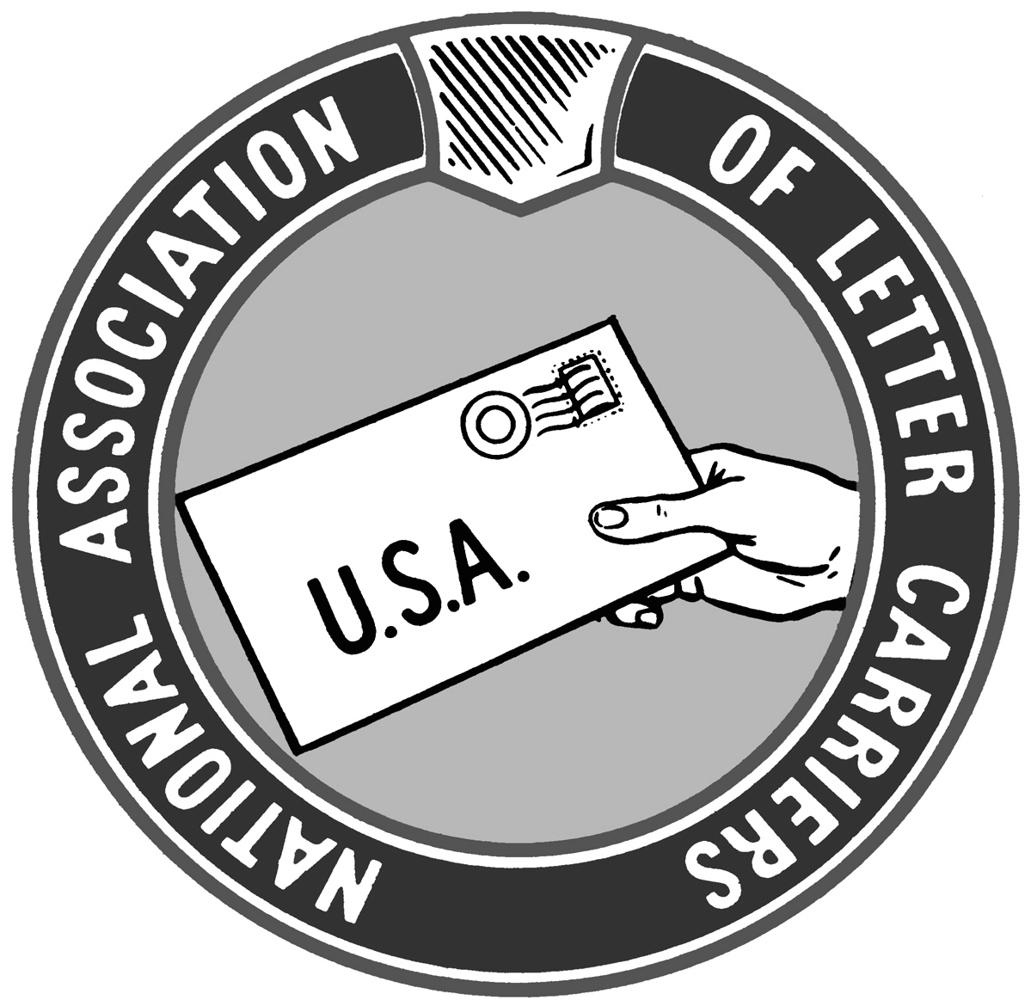

KSALC.ORG

That’s the web address of the new KSALC website. Since we are no longer publishing a newspaper due to the cost, we have finally entered the internet-age with our own website. I am new to the website business but will strive to make it as informative and accessible as possible.

Within the website we will also have a quarterly digital newsletter where elected state officers as well as anyone wishing to contribute will submit articles for online publication. The newsletter will be sent via e-mail to any KSALC member who wishes to receive it. There will be an easily identifiable sign up link on the website. For those KSALC members who do not have internet access and wish to receive the newsletter, you will need to contact your local NALC branch who will provide you a printed copy of the online newsletter.

I thank everyone for your patience during this transition. While the internet has in essence, taken away the KSALC newspaper, it has given us a real time tool and source for information. We will strive to keep it up to date, relevant, and packed full of important resources and news of significance to NALC members.

It is a given that change will come. That change happens more and more rapidly all the time. This is our best effort at keeping up with the change and keeping the membership informed and up to date.

---Andy Tuttle

KSALC President

Elections Have Consequences

The 2018 elections are on the horizon. It is vital for us to elect people at the state level who support labor and the working people of Kansas. Many issues are at stake that will have an impact on our quality of life. A few of those issues are expansion of Medicaid, prevailing wage, teacher’s due process, K-12 school funding, and safety in the workplace. These issues affect all of us, either directly or indirectly, through loved ones and friends. Educate yourself before you vote. Education does not come from memes on Facebook or the news. How have the candidates voted on the issues in the past? Look at their voting record by easily researching it online. Get involved. We must stop putting people in the state house who vote against our way of living. Start educating yourself now and be ready when it comes time to vote!

---Michelle Jellison

KSALC Vice President/Director of Education

THE PRICE OF RETIREMENT!!!
Hello to my Sisters and Brothers, Active and Retired, Short and Tall, Skinny and Rotund (this is politically correct terminology), Young and Old of the National Association of Letter Carriers!!! We are currently going through an interesting time. On one hand we are struggling with an over-abundance of packages and seeing our carriers work long hours 7 days a week. But still we are accused of losing money and going deeper into debt. Now the President has set a commission to review all parts of the Post Office’s finances. Is he doing this to help us out? My short answer is NO!! He and his fellows are looking at us to see how we can be privatized. THE MAIN REASON FOR THIS IS THE MANDATE THAT THE POST OFFICE PREFUND THE RETIREES HEALTH BENEFITS FOR THE NEXT 75 YEARS! We have all heard this before and so we let it go. But we can’t just let it go!! As it stands, this is a real cost of having our letter carriers retire. One that we are paying now at a cost of over $5 Billion a year. This one item, which no other government agency or private industry has to contend with, is responsible for almost 90% of the losses that we have shown. All because of Congress!! We need your help in getting this changed in Congress.
Retirees, it is easy to say that we have done our share and now can sit back and watch the rest struggle. But it isn’t right. We benefited from those before us who walked out in 1970. We benefited from those who negotiated the collective bargaining contracts in the years following that gave us better wages, health benefits, annual leave and A GOOD RETIREMENT!! We are RETIRED LETTER CARRIERS but we are still LETTER CARRIERS. We owe it to ourselves and to our active Letter Carriers to help them ensure that they will have good middle class jobs and a good retirement when they reach that time.
Help them do this by joining me and other Retirees in donating to the Letter Carrier Political Fund. It can be $5 a month or $4 or $3 or $2, but help. I know it is a cost that hurts, but it is our responsibility to step up and help in these times. Remember, the only thing that we look at to donate to a political candidate is DO THEY SUPPORT OUR JOBS AND RETIREMENT? We need a seat in the game in Washington. This is how we can change this prefunding anchor around our necks. And this is how we have to get the money to be heard. Also, help by making sure that you have put the NALC App on your phone and/or computer so you get the latest updates on what legislation is coming and how it helps or hurts your retirement. Thank you for listening to me and please help us HELP OUSELVES!

Mike Wamsley, KSALC Director of Retirees

President Emeritus Article
April 2018
FAKE NEWS! Though President Trump has managed to insert those two words into almost every tweet he sends or question he answers, it sometimes seems hard to determine what really is fake and what is real news. When it comes to news about the Postal Service, the union, the contract, or situations on the workroom floor, it can also seem difficult to know what is “fake” news and what is real news.
What might seem to be a very recent dilemma (deciding what is true and what is not) is really one that is as old as civilization itself. Every democratic justice system is designed to use the only reliable method of separating true from untrue. It is called the “weight of evidence”. When two parties have different versions the truth, whether in civil or criminal lawsuits, the judge or jury will hear evidence presented by both parties. Whichever side presents the evidence that is most believable will be considered to have presented “the truth”.
I try to follow postings on the NALC’s social media platforms in an effort to understand how the new generation of letter carriers communicates with one another. I am always amazed how trusting this “new generation” seems to be. Though “I read it on the internet, so it must be true” is by now an old joke, it really seems to be the creed by which many new letter carriers form their impressions of the NALC.
Log on to Facebook at any time of any day and you can find a posting from a new letter carrier asking for an answer to a problem. Shortly after, someone whom the original poster has never heard of will proclaim the absolute right solution to the stated problem. The one making the ask usually says thanks for the help and that’s it. No “what are your qualifications”, or “can you refer me to the appropriate document that governs that situation”; just believe a total stranger. There is a clear way to avoid “fake news”. Learn from the professionals who have done the research required to know fake from real.
At the upcoming Kansas State Training in Lawrence, NALC experts will be presenting not only the solutions to the problems we all face but “the weight of evidence” that will give those attending the complete confidence to know that what they will hear and see is the truth. That’s what we have always done and what we always will do. Join us!

KSALC President Emeritus Rod Holub

Greetings from the Big 1st District. Carriers in the great state of Kansas should be happy to learn that years of working to educate our legislators is paying off. Sen. Jerry Moran (R-KS) is one of the Senators to introduce the Postal Reform Act of 2018. This is far better bill than many proposed in the past. The proposed legislation would strengthen the Postal Service. Some of the improvements in this bill have long been advocated by the NALC:

---Securing our country’s universal delivery system by protecting six-day delivery.
---Rejecting unnecessary changes to door delivery service for business and residential customers.
---Calling for a two year moratorium on changes to service standards, giving the legislation time to work in a way that will relieve the pressure of misguided service cuts.
---Granting the Postal Service the ability to innovate, including the shipment of beer, wine, and liquor.
---Exempting annuitants and their eligible spouses from the proposed mandate to enroll in Medicare Part B at age 65 if they can derive no benefit from enrolling ( veterans with full VA care, Native Alaskans, etc.) or if enrollment would cause extreme financial hardship.

Letter Carriers should let Sen. Moran know we appreciate his listening to carriers. This is an ongoing effort that is far from over but it is a good start. We need to continue to educate our leaders in Washington. The best way to keep informed is to get the NALC app which sends out notices when something important is happening.

Kent Chestnut

1st District LCCL

4-13-2018

Today our President assigned the Secretary of Treasury to look at the fiscal health of the USPS and give him a report with options in 120 days. You were told this stuff was coming and some of you laughed it off and said it would never happen.

No doubt some of this has to do with Mr. Trump’s jealousy toward the head of Amazon and the Washington Post, Jeff Bezos and he’s looking to raise prices Amazon pays in order to hurt Besoz. He was silent about UPS.

They will also likely be looking to cut benefits, pay, and tking away collective bargaining rights. But not to worry, we can offset our losses with that gracious $1.57 a week tax cut. If the USPS raises prices Amazon will take their business elsewhere sooner rather than later. That would give the USPS the ammunition it needs to make us all part time with no benefits.

We better hope this drags out and Mr. Trump has his hands full with porn stars, Playboy bunnies, Russians, and impeachment talk until the election.

Terry P. Miller

2nd District LCCL

Time. Mick Jagger told us, "Time is on my side", Jim Croce sang about "Time in a Bottle" , Styx had "Too Much Time on my Hands" , Cyndi Lauper had "Time after Time" and The Rocky Horror Picture Show sang "The Time Warp."
I'll get to the point. Times change. Time marches on. We must change with the times. We can't live in the past. What may have been relative 9 years ago, is now antiquated. Time is not constant, but the only thing that is constant is change, Our jobs as letter carriers have changed over time. We still deliver 6 days a week, but what and how we deliver have evolved. Our postal vehicles have changed and another change is coming , in time.
Our message to the members of the Kansas State Association of Letter Carriers will remain, but the method of delivery has changed over time. Our new website will give us information, but will do so in a timely matter and more cost effective.
Multiple methods of reaching out to our members will exist. We have The Postal Record from the NALC. NALC has a website. Also, don't forget the NALC app for your phone. It's a great tool.
Time has also changed the political landscape. The current president is a huge user of Twitter. He tweets all the time. And mostly, his tweets are biased and erroneous. But, he does it. This is a quote from the president. "My twitter followers will soon be over 2 million--& all the "biggies." It's like having your own newspaper." This post was from Oct 17, 2012. He has over 41 million now.
So when he attacks the USPS about Amazon, which he has done multiple times, that message is swallowed by 40 million people. Now, we know that message was full of wrong information, but the other 39,750,000 people don't. It's hard to swim against that huge wave.
How you overcome that? There is an old saying, Never argue with someone who buys ink by the barrel. We can get with the times by saying Never get into a Social media feud with someone who has 40 million followers. NALC has a team of people dedicated to raising awareness of our issues, directly to the people who can make a difference in our lives as carriers. The 100 US Senators and 435 House members. Think of it this way, rather than using a shotgun that has a scattering effect, we're using a rifle to hit our target directly.
The easiest way to help fight is to donate a small amount to the Letter Carrier Political Fund. Sign up on line. Instructions are on the NALC website. And it's all done through PostalEase.

Greg Wilson

3rd District LCCL

Greetings from Newton! I hope you all had a good winter and are looking forward to springtime---eventually! I went to Congressman Estes’ office and had a nice visit with them. I shared some concerns we have and they will share our concerns with Congressman Estes. I look forward to visiting them again soon. I understand there are a lot of changes coming down from management. Stay strong! I will see you all at State Training in May.

Bob Davidson

4th District LCCL

