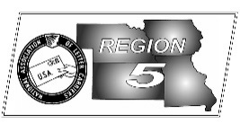
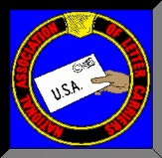
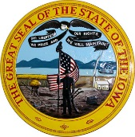
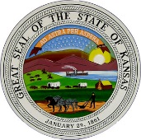
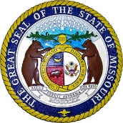
Region 5
NBA Report
Mike Birkett
February 2018 National Business Agent’s Report NALC Region 5 Region 5
Time Card Theft – It’s a shame that one of the first things we have to do as a union is to tell our new employees that they need to check their pay stubs to make sure their supervisor hasn’t stolen time from them, just to make DOIS projections. For those of you who aren’t new, it’s time to start checking your hours worked again as well. We recently caught a few more supervisor cheating carriers out of time worked.

Route Inspections – With no national route adjustment process on the horizon, I would suspect we will see more M-39 route inspections this coming spring. If you are told your office is going to be inspected, please contact this office immediately. I also want to warn locals about making agreements with management to make “joint” adjustments or inspections. This happened in a number of places this past fall, few turned out well. While you may trust your postmaster, remember that the people pulling the strings are miles away in a district office.

Cold Weather Injury Report – We are asking that carriers who are injured or become ill (falls and frostbite) this winter to complete a “Cold Weather Injury Report” and submit it to your steward/branch president or send it directly to us here at the Region 5 office. I’ve attached a copy of the form to this newsletter.

CCA Back Pay - Active city carrier assistant (CCA) letter carriers will receive their back pay in their Feb. 23, 2018, paychecks. A CCA’s back pay will cover the period from Nov. 26, 2016, through Sept. 15, 2017. This payment will include the 2.2 percent general wage increase and the addition of two $0.50-per-hour step increases in the new CCA pay scale where applicable. The two $0.50-per-hour step increases are payable at 12 and 52 weeks of service.

Leadership Academy – The NALC is now accepting applications for the 2018 Leadership Academy. The Academy consists of three week long sessions held over a five month period in Baltimore, MD. A fourth week is then spent in the regional business agent’s office. If you are interested in applying, you can find an application at the following link: https://www.nalc.org/news/nalc-updates/body/Leadership-Academy-Application-update-12-17.pdf

NALC App – As technology changes and advances, the NALC must do the same. For many years the NALC E-Activist network was the best and quickest way to communicate with letter carriers. That is changing. The E-Activist network will probably be slowly phased out over the next few years as more and more carriers sign up for the NALC Member App. The app was developed by the NALC and contains links to the National Agreement, JCAM, MRS, CCA resources and much more. The app is free and available in the Apple App Store or the Google Play Store…search for NALC Member App.

After 6 & 8 P.M Delivery – President Rolando has recently requested from all National Business Agents to collect data concerning mail and/or parcel delivery after 6 & 8 P.M. On any given day, if you have been out delivering after 6 or 8 p.m., please notify your steward, branch officer or this office.

Camera’s Everywhere – Anyone who follows the news, or is on social media, are well aware that there are cameras everywhere. We’ve all seen videos of delivery drivers, USPS, Fed-Ex and letter carriers, toss parcels, at times from great distances, in order to save a few paces or steps. Letter carriers have and will be disciplined for those actions. In business, public areas and at customers’ homes, just assume you are being recorded. Deliver those parcels as if they were your own. Ring the bell, attempt delivery, and follow instructions.

