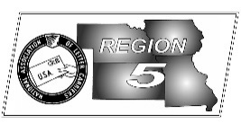
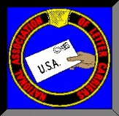
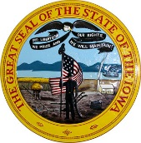
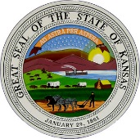
Region 5
NBA Report
Mike Birkett
November 2017 National Business Agent’s Report NALC Region 5 RRegion 5 Region 5
Thanksgiving – Let me start this month’s article by wishing everyone a very special Thanksgiving. I’m hopeful that you will all have the opportunity to spend some time with your families.

Amazon – As I mentioned in an earlier article, Amazon is not our friend and benefactor. Amazon recently withdrew from Sunday delivery in a number of markets within Region 5 and around the country. No notice, parcels just didn’t show up. The service was left with a lot of carriers scheduled to work, with no work. Amazon has bought their own vans and have “hired” people to work four hour shifts. Meanwhile, they shifted some of the work to our competitors. Worst, many of their parcels have the USPS barcode still on them. So, the service will take the blame for miss deliveries. Personally, I’ll be buying from Amazon competitors in the near future and from companies that use our services.

Route Inspections – This fall we were notified several Installations would be having 6-day route count and inspections and we suspect more may be considered next spring. When my office is notified we are able to reach out and provide assistance. There are many resources available to help letter carriers get a fair inspection, and others to help union representatives ensure inspections are conducted correctly. If your office has been scheduled, please let us know right away. We can help assess the needs of your specific branch and provide support. Management is inspecting offices where they feel time can be reduced. But, we know there are also offices where the carriers are overburdened. Right now we are starting to identify offices the union believes are out of adjustment or where carriers are requesting special inspections (M-39 section 271g). If you have either of these scenarios, please let us know so we can assist and ensure timely grievances are filed where needed.

Customer Connect – The Customer Connect (CC) program recently topped $2.3 billion dollars across the country. Region 5 has been a big part of this success. Both letter carriers and the USPS Districts have been stepping up. The four Districts we work with are Central Plains, Mid-America, Hawkeye and Gateway. The Gateway District has Letter Carrier Judy Bitzer, from Branch 343 as its District Customer Connect Coordinator and the Hawkeye District recently assigned Letter Carrier Michele Donnelly, from Branch 352 as its District Customer Connect Coordinator. These two letter carriers are a huge part of these District’s success. Also, the Gateway District and Mid-America District are currently in the top 20 (67 Districts) for generating CC revenue in 2017. This revenue is directly attributable to letter carriers who submit leads which turn into sales/revenue. Letter carriers like John Bonzo, from Branch 343 that generated a sale close to $1 million dollars or Paul Tray, from Branch 726 that generated a sale for almost $90 thousand dollars. Then there are letter carriers like Jeffrey Gradel, from Branch 5050 who have now generated three sales totaling almost $210 thousand dollars. With letter carriers producing sales such as these it will not take long for us to pass the $3 billion dollar milestone. Please keep submitting leads and sales will come. Keep up the good work.

Retirement Training Seminars – Retired NBA Mike Weir has just about completed his trip around the Region conducting Retirement Training. We will be in discussions on when to begin another cycle and where they will be held. If you and your branch are interested, please call and let us know. Thanks to Mike for all of his time and effort.

Region 5 Field Secretary – For the past ten years when you’ve called this office, your call was most likely answered by the Region 5 Field Secretary, Cheryl Stout. I’m both happy to announce and sad to say that Cheryl has decided to retire. I know that many of you became friends with her over the years and that she will be missed by all who call, as well by everyone here in this office. If you’d like to send her a card, mail it to this office and I’ll make sure she gets it.

