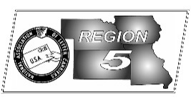
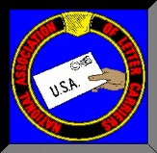
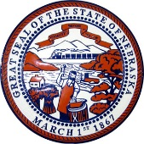
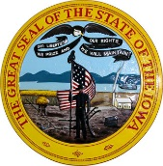
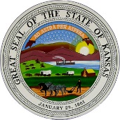
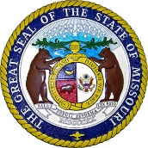
Region 5
NBA Report
Mike Birkett
May 2017 National Business Agent’s Report NALC Region 5 Region 5
New Contract – I’m hoping by the time you read this article, there will be a tentative agreement on a new contract being sent to all of you for your vote to ratify or turn down. As I write this article however, we are still waiting while President Rolando negotiates the last few items where we are still not in agreement. I know that he will not ask you to ratify an agreement that he doesn’t believe is better than we can get from a neutral arbitrator. Please remember, if a tentative agreement is reached, you will ultimately decide by casting your vote yeah or nay.

Route Inspections – I received numerous calls this spring concerning route inspections and the Co-Leader process. I heard that I had agreed to co-leaders; that I had refused to allow co-leaders; that the NALC had agreed to do away with “line items” and that we agreed that there was no need for carriers to count their mail during the inspection process. Let’s set the record straight. I have not received any calls from management concerning route inspections, other than notification of where and when they were conducted. In fact, most of that information was received in the mail. This office did not agree to a Co-Leader process, however if management wanted to have a process where the NALC & Management Co-Leaders were truly equals and with a defined resolution process, we might have been interested. There were no agreements that carriers could not count their mail or would not be allowed to complete their own 1838C’s. Once again, if the story or rumor doesn’t sound right, investigate, give us a call…see fake news item below.

Food Drive - 25 years. That’s a huge milestone and letter carriers all across the country and our region should give themselves a pat on the back and celebrate this year. Even though it makes the load heavier and the day seem longer, the good feelings and knowledge of how you are helping your communities will outweigh those things at the end of the day. We have a few more branches registered this year than last and always have room for more. If you’re not yet registered and want to take part in helping your community, there is still time. Contact our office immediately. Iowa also has another reason to celebrate this year, Hy-Vee has committed to a statewide sponsorship for food drive bags! Having food drive bags will typically double the amount of food collected and the number of families that we help to feed. Our goal is to have a sponsor for every state and branch in our region. We have many other branches with individual bag sponsors so this puts us well on our way. Great job everyone and have fun May 13.

Fake News – I have to admit I was truly amazed at a recent “60 Minutes” piece on fake news and how it is spread across the internet, Facebook and Twitter through the use of “bots”. Millions of these “bots” are being used by some unscrupulous characters to make a few dollars and in the worst case to scandalize politicians who don’t agree with their points of view. This is believed to be one of the ways the Russians became involved during the last presidential campaign. I have to admit, I prefer reading stories that coincide with my political and moral beliefs, as we all do. However, when you read an internet story that Clinton was running a child sex slave business out of a pizza shop, or see a photo of Trump with cocaine up his nose and a pile of it on the desk in front of him…it’s probably bullshit! The same holds true for some of the articles about the NALC. Since many of us are users of social media, I’m asking you all to think a minute before you share these articles that are pretending to be real news. If you want to spread these stories, spread them in your garden where it may do some good.

Region 5 Facts – We currently average nearly 9,200 active letter carriers within the region and about 13,500 members counting retirees. There are currently 221 active branches which range from 1 to 2625 members. Members by state (approx.): Missouri – 6,000; Iowa – 3,000; Kansas – 2,800; Nebraska – 1,750.
There are 4,616 Eactivists (highest % in the country) and 1,103 or 8.13 % who contribute to the Letter Carrier Political Fund (terrible).

