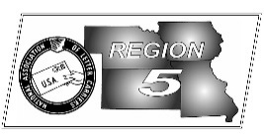
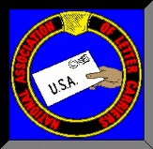
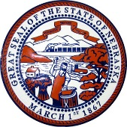
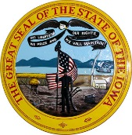
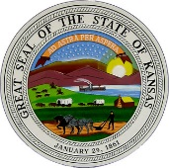
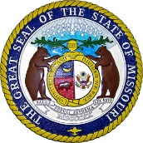
Region 5
NBA Report
Mike Birkett
March 2017 National Business Agent’s Report NALC Region 5 Region 5
New Address & Phone Numbers – Please make sure that you send all correspondence to us at our new address: 1828 Craig Rd, St. Louis, MO 63146. Phone #’s are: 314.985.8040 (8041) & (8042). Please reprogram your cell phones for the new numbers.

Falsifying Time Clock Rings – There have been a number of managers within Region 5 and nationally who have been caught fraudulently changing letter carriers clock rings. Make sure you verify your work hours against your pay checks. Make no mistake, these managers are stealing from you in an effort to make themselves look better and enhance their own paychecks. We need each of you to check your overtime and penalty overtime as well. Were you charged for a lunch you didn’t take? Some leave you didn’t use? If you have issues, contact your steward and/or your branch president. Branch presidents should immediately contact this office. We’re already aware of 11 offices within this region…yours could be the 12th.

Hiring Freeze – OMB & OPM have ruled that the USPS is exempt from the hiring freeze instituted by the new administration.

Food Drive – This year is a big year for the Letter Carriers and the “Stamp Out Hunger” food drive. This is our 25th anniversary of helping collect food and restocking our food banks to help people in need. The 25th annual food drive will be held on its traditional second Saturday in May—Saturday, May 13, 2017.The NALC has made it even easier to register and participate this year. Branch presidents can access the registration form and register through the member’s only portal on nalc.org. The first batch of Postcards have already been shipped, so please get your branch registered today and lets break records again this year for the total amount of food collected!

MDA - Region 5 raised a total of $79,943.53 in 2016 for MDA. Last year I challenged each branch to do just one more fundraiser. My challenge this year is for each branch who did not have an event in 2016 to add one into the branch calendar. MDA events can be big or small so every branch has the ability to raise money. If your branch schedules an event and notifies HQ in advance, the new NALC App has the ability to promote your event to the membership. It would be great if Region 5 could top the $100,000 mark in 2017.

Cold Weather Injury Reports – Although the cold weather is quickly coming to an end and we’ll soon be concerned about another hot summer, I’d like to remind everyone to turn in their “Cold Injury Reports” as soon as possible. Remember that the Cold Injury’s may be slips, trips and falls due to snow and ice as well as frostbite. If a carrier slips on “black ice” and gets injured, that should be reported to this office.

NALC Member App – Available now in the iPhone App Store and the Google Play Store for Android. Just search for “NALC Member APP”. The NALC has once again stepped forward in an effort to better serve our members, especially our newest ones. The NALC developed the app at headquarters with the needs of the average letter carrier in mind. Workplace resources, legislative tools and an interactive n/s day calendar are just a few of the resources you will be able to access from your phone. Once you install the app and enter your zip code (for correct legislative information), you can then sign up for notifications based on your interests. The home screen is where you will receive the latest news and media posts. Feel free to retweet and share. This is your social media. For more information, see the NALC Member App page at the NALC website, under the member benefits page.

Condolences – Special condolences go out to the family of Walter Besch. Walter was the Director of Retirees for Branch 343, former Missouri State Director of Retirees and an institution within Branch 343.

