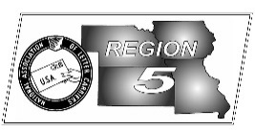
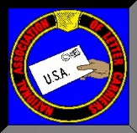
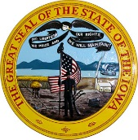
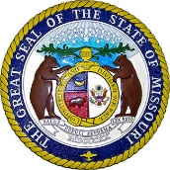
Region 5
NBA Report
Mike Birkett
July 2017 National Business Agent’s Report NALC Region 5 Region 5
LCPF – By now many of you are tired of branch leaders, state officers and me begging for you to get involved by contributing to the Letter Carriers Political Fund (LCPF). If you haven’t heard, the President has placed into his FY 2018 Budget Plan the following items which directly affect both active and retired letter carriers:
- Letter Carriers will contribute up to an additional $3600 annually towards retirement
- Eliminating COLAs for current and future FERS retirees.
- Reducing COLA’s by .05 percent per year for CSRS retirees.
- Basing future retiree benefits on their highest average pay over 5 years instead of 3 years.
- Eliminating the Social Security Supplement for Letter Carriers who retire before the age of 62.
- Reducing the frequency of delivery.
- Seems to give the Postal Service greater flexibility to set rates to cover future retiree health care costs instead of doing away with the draconian prefunding law.
- Reduces by 72 billion dollars the Social Security Disability program which many Letter Carries who take a disability retirement rely upon.

While the President’s budget is only proposed and many say it is “dead on arrival” with congress, Letter Carriers should be both concerned with the individual proposals and need to stay vigilant in our oversight. Any one of these elements could make it into an individual bill or an omnibus budget agreement. We cannot rely solely on those that support us, we may need to make phone calls, send emails, write letters, visit congressional offices and we should all be contributing to the LCPF fund. Your local, state, regional and national officers cannot do this alone, we need your help. For those of you who currently do not contribute, just call this office at 314.985.8040 and we can sign you up. The cheapest job insurance you can buy!

National Agreement – As I stated last month, the NALC Executive Council has unanimously recommended that the tentative agreement be ratified. The tentative agreement includes pay increases, a Grade increase, maintains Cost of Living adjustments (rare in most labor contracts anymore), it maintains the No Contracting out language and addresses many of the CCA issues which were presented at our last National Convention. For more information, go to: https://www.nalc.org/news/nalc-updates/tentative-national-agreement-is-reached

Food Drive Totals – We are still collecting totals for the food drive but so far we have seen an increase in lbs. collected in many locations within the region. We are hoping this trend continues until the final branch has reported and the 25th anniversary gives us something else to celebrate. If you still haven’t reported your collection totals, please do so right away. They are due back by June 9, which is right around the corner. Each year we try to get more branches involved in this great cause, this year was no exception. Another handful joined in which is great. So, I want to thank each of the branches that participated this year for the first time. This is how we keep the momentum going and continue to collect even more than in previous years. The state coordinators, Traci VanHyning, Larrissa Parde and Kathy Lamb, thank you. To Kelly Strottman, Vic McCuen and the volunteers in Des Moines who helped make sure the bags donated by Hy-Vee for the entire state of Iowa were split up and mailed out, thank you. And finally, last but not least, to every Letter carrier and volunteer that worked on the food drive, thank you.

By making a contribution to the Letter Carrier Political Fund, you are doing so voluntarily with the understanding that your contribution is not a condition of membership in the National Association of Letter Carriers or of employment by the Postal Service, nor is it part of union dues. You have a right to refuse to contribute without any reprisal. The Letter Carrier Political Fund will use the money it receives to contribute to candidates for federal office and undertake other political spending as permitted by law. Your selection shall remain in full force and effect until cancelled. Contributions to the Letter Carrier Political Fund are not deductible for federal income tax purposes. Federal law prohibits the Letter Carrier Political Fund from soliciting contributions from individuals who are not NALC members, executive and administrative staff or their families. Any contribution received from such an individual will be refunded to that contributor. Federal law requires us to use our best efforts to collect and report the name, mailing address, occupation and name of employer of individuals whose contributions exceed $200 per calendar year. Any guideline amount is merely a suggestion, and an individual is free to contribute more or less than the guideline suggests and the Union will not favor or disadvantage anyone by reason of the amount of their contribution or their decision not to contribute.

