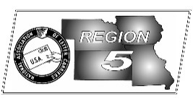
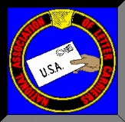
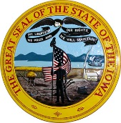
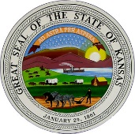
Region 5
NBA Report
Mike Birkett
January 2017 National Business Agent’s Report NALC Region 5 Region 5
Cold Weather – Seasoned letter carriers are well aware of the dangers involved with delivering mail in extreme cold weather. Frostbite is too often the result of not being prepared for the conditions or of the rapidly changing weather even during a single day. To you seasoned letter carriers, please reach out to your brother and sister CCA’s and make sure they understand how to protect themselves against the cold. The USPS also has responsibilities to protect its employees and should implement safe work practices which include: Providing proper tools and equipment; Scheduling workers in the warmer part of the day; Avoiding exposure to extremely cold temperatures when possible; Limiting time outdoors on extremely cold days; Providing warm areas for break periods; providing warm liquids; Monitoring workers who are at risk of cold stress; Monitoring weather conditions and having a reliable means of communicating with workers and being able to stop work when necessary; Acclimatizing new workers and those returning to work from extended time off, including more frequent breaks in warm areas. These are just a few of the recommendations of OSHA. A complete discussion of employer responsibilities as well as safety tips for workers can be found at the Department of Labor website: https://www.osha.gov/dts/weather/winter_weather/beprepared.html

Retirement Seminars – Branch Presidents should contact this office if they are interested in having retirement training in their offices. Training has already been held in Topeka and Des Moines and is currently scheduled for St. Louis & Cedar Rapids. The training is approximately 4 hours long which includes a question and answer period. We would like to have at least 50 members present so if you are from a smaller office, please coordinate with another office near you. Spouses and members only are welcome.

Mail Volume – At last report, parcel volume was up 18 % over the same period last year. That’s truly amazing considering last year was a record year as well. Congratulations to all of you who are working long hours and consecutive days in order to deliver America’s mail. Wasn’t it just a few short years ago the Postal Service wanted to cut delivery to 5 days per week and possibly 3 days?

2017 Food Drive Registration – While it may seem a little early, registration for the 25th annual “Stamp Out Hunger” food drive has begun. Branch presidents are encouraged to create their own Members Only portal account and register: http://208.88.165.235:8080/profoundui/start?pgm=PORTALPGM/LOG001@ or through the NALC website…click on the Members Only button, top right.

Legislation – Letter Carriers need to be alert and vigilant regarding legislation which may affect our jobs. There are numerous “enemies” of the service who would love to “privatize” us. Already there are calls (Forbes Magazine) to allow for our competitors to use mailboxes. Become an E-Activist!

National Appointments – On December 2, 2016, President Fredric Rolando appointed Director of City Delivery Brian Renfroe to the vacant Executive Vice President position. Chris Jackson, National Business Agent from California will become the Director of City Delivery. We here in the Region 5 office look forward to working with both Brian and Chris and wish them well in their new positions. Congratulations to Region 12 NBA Bill Lucini on his upcoming retirement and to his replacement, Dave Napadano as well as to Bryant Almario who will be replacing Chris Jackson as NBA in Region 1.

NEW ADDRESS – This is a reminder that the Region 5 office will be moving on February 1, 2017. Our new address will be 1828 Craig Road, St. Louis, MO., 63146. While we are moving only about a half of a mile, we also are being forced to change phone numbers. We will notify every one of the new numbers once they are assigned.

