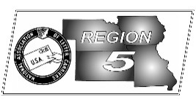
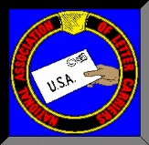
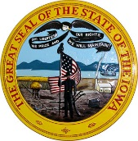
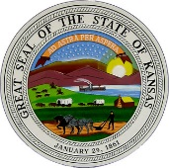
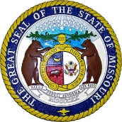
Region 5
NBA Report
Mike Birkett
April 2017 National Business Agent’s Report NALC Region 5 Region 5
2017 Region 5 RAP Session – I need to thank everyone that helped make the Region 5 Rap Session a success. It couldn’t have been accomplished without all of the volunteers who made the event look seamless. Special thanks from all of us here in Region 5 to President Rolando who made the trip to Overland Park where he spoke on numerous issues, including contract and legislative updates. The 2018 Rap Session will be held again next year in Overland Park at the same location.

Heat Illness/Injuries - We have made great strides the last couple of years in ensuring the Post Office is taking the necessary steps to protect workers from heat Illness, but there is still more work we can do. Last year within the region, over 135 accident reports were filed with USPS for heat related injuries. These are only the injuries that caused USPS to generate an accident report, how many more were there? Of the approximate 135, we were not aware of a large majority of those injuries until months after the incident date. We can do better and we need to do better. Going into the summer of 2017, I cannot stress this enough, we need to be notified immediately after an illness or injury. If there is a delay, it compromises our ability to follow up and address managements actions or inactions, file valid OSHA complaints, and it can also be the difference in an injured member getting the care they need or the workers compensation benefits they are entitled to. Please take action to protect yourself and be safe in the heat but if you do suffer a heat related illness, please complete the attached “Initial Heat Injury Report” and contact this office immediately.

LLV Wheels – We’ve had another wheel come off an LLV here in Region 5. Luckily the carrier was coming to a stop and only traveling around 10 miles an hour when it occurred. Tightened lug nuts mean absolutely nothing when the wheel around them rusts completely through. Please check the wheels during your morning vehicle inspections. Having a wheel fly off could be catastrophic.

Contract Negotiations – I know you are all wondering about the contract. We are receiving several calls & emails each week on the status of negotiations. President Rolando has committed to continuing negotiations with the postal service as long as he believes that an agreement can be reached. If not, we will proceed to Mediation/Arbitration. For newer members, it’s not that unusual for negotiations to extend well beyond the end of an existing contract.

Route Inspections – Several installations around the region are currently going through M-39 route inspections or are scheduled this spring. I’ve been asked by some if we could/would participate in a Joint “Co-Leader” process. The answer is NO! Unless the Service agrees to make it a completely joint process, where the co-leaders, NALC & USPS, are on equal footing we will not participate. There have been times in the past where management tried to involve the NALC into having co-leaders, but only during the inspection. When it came to route adjustments, they wanted no NALC input. We will not make an agreement where we are not part of the decision making process from start to finish.

Special Thanks – I need to remind everyone occasionally of how many members it takes to fully represent the letter carriers of this great union and thank them for their support and efforts on behalf of letter carriers. While we all have an understanding of how our local branches work, this region (Missouri, Iowa, Nebraska & Kansas) could not be successful without all of the members who participate in the various region wide and district teams. There are: 2 Regional Administrative Assistants; 1 Regional Workman’s Compensation Assistant; 4 State Chairs; 4 State Executive Boards, comprised of VP’s, Secretary’s, Treasurers, Trustees & CDL’s; Arbitration Advocates; Local Business Agents; Academy Instructors; Organizers; On the Job Instructors; MDA Coordinators; Food Drive Coordinators; 4 District Safety Teams; 4 District Employee Assistance Program Teams; and lastly, all branch officers. Truly a team effort.

